MSc Practice Placement Handbook

Practice-Based Learning: Core Handbook

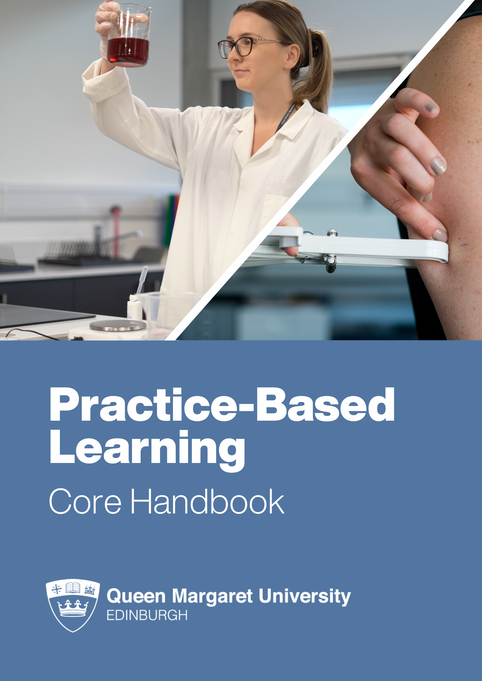
+
Speech and Language Therapy: Practice-Based Learning Handbook

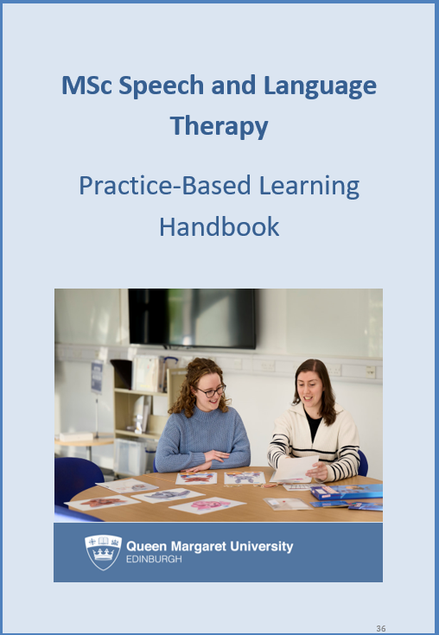

Contents

Introduction 4
Importance of PBL in Health Sciences 5
Preparing students for practice-based learning (PBL) 6
Fitness to Practise 12
Student support 14
Placement Allocation & Logistics 17
Attendance monitoring 21
Professional Conduct 24
Record keeping 28
Health and Safety 30
Roles and Responsibilities 31
Raising Concerns 34

Practice Based Learning (PBL) is the education of students with patients, clients and groups, in simulation, campus activities and real practice environments. Practice Based Learning is a core element of the curriculum that allows students to consolidate theory into practice and aligns with the Four Pillars of Practice. For many learners, Practice Based Learning (PBL) is the highlight of their programme.
Students need to finish a certain number of assessed PBL hours to complete their programme; these vary by professional programme. Additionally, each professional programme will have supplementary information tailored to the programme requirements. PBL can take place in a variety of settings, including:
- The National Health Service (NHS) in Scotland
- Social Care
- Private Organisations
- Voluntary Sectors
- Schools
- Care Homes
- At QMU within clinics held on campus

These opportunities can be found in Scotland, the UK, or even around the world!
PBL can be challenging, as it involves working in new and different contexts. This handbook is a student and Practice Educator guide for all things related to PBL and will help ensure that students have every opportunity for successful practice experiences.
As programmes of study vary across the School, the Handbook should be supported by a programme or subject specific document(s).
If you have any questions about any of the information contained within this handbook, please contact the PBL Coordinator or the placement team (placementadministration@qmu.ac.uk)

 Importance of PBL in Health Sciences
Placements occur at designated times and follow various patterns and durations, which differ by programme. These variations are influenced by the subject area and the specific professional requirements of each discipline. For detailed information, please refer to the Placement modules associated with your programme. Securing placements for students can be quite competitive. However, QMU offers robust and well-established systems to secure placements, and support to help students find suitable elective placements if this is a requirement of the programme. QMU has partnerships with a wide range of organisations across Scotland and beyond. This ensures that students have access to diverse opportunities that align with their career goals and professional requirements in urban and rural locations.
These experiences offer a range of learning opportunities, exposing students to a wide range of medical conditions and scenarios. Such placements enhance clinical skills, build confidence, and provide networking opportunities. Additionally, they help develop cultural competence, which is essential for providing effective care to diverse populations.
Interprofessional Education & Learning (IDEaL)
Practice placements provide many opportunities for students to evaluate the nature of interprofessional team working and collaboration, as well as their own contribution to the delivery of occupation-focused and patient-centred practice.
All students are required to attend IDEaL sessions which facilitate an understanding of the complexity of health and social care in Scotland and help students to develop an awareness of political and strategic developments influencing practice and how these impact on care provision.
These sessions ensure our students understand and reflect on their role and how they can effectively work with others to ensure individuals receive high quality, safe, person-centred care delivered by the right person, at the right time in the right place.
Information about IDEaL sessions can be found on programme canvas pages.
Quality Standards for Practice Based Learning
The Quality Standards for Practice Placements have been created so that students, and those individuals and organisations who support them, understand their responsibilities and expectations in relation to practice placement learning. The Standards apply to any structured placement learning in NHS Scotland that is accessed by nurses and allied health professions and supported through an educational programme.

 Preparing students for practice-based learning (PBL)

Placement Passport
All students maintain a Placement Passport (ePortfolio) on PebblePad, an electronic document to help students with all aspects of placement preparation and their continued professional development. In line with PBL agreements, the Placement Passport is a prerequisite for starting a placement with any education provider and must be signed off by the Programme Leader or Placement Coordinator at QMU.
The Placement Passport allows University staff to verify that students have completed all compulsory preparation tasks before starting their placement and to keep track of progress Students must collect and maintain documents and certificates that record the completion of mandatory tasks and activities required for placement preparation.
When students graduate, they can activate a free personal PebblePad Alumni account. Students can activate their personal accounts before they graduate. The alumni account enables students to continue access to the current PebblePad Assets and keep track of all placement information and continued professional development.
The Passport is assessed on a pass/fail basis. The mandatory elements of the practice placement passport are listed below. Some programmes may require students to complete additional elements, modules or reading prior to placement. The placement tutor/coordinator will guide students as to when and how these need to be completed. Announcements will be made via email or Canvas.
Checklist for the Placement Passport prior to placement:
- Signed Code of Conduct Declaration
- Signed Fitness to Practise Declaration
- PVG certificate confirmation
- Health Clearance (Fit for Course/Fit for Placement)
- Learning Modules – evidence must be uploaded to the passport.
- Adult Support and Protection – Practice Level 1 [informed]
- Adult Support and Protection – Practice Level 2 [skilled]
- Basic Life Support (Turas module and practical)
- Child Protection – Practice Level 1 [informed]
- Child Protection – Practice Level 2 [skilled]
- Dementia Informed Practice – Level 1
- Duty of Candour
- Equality and Diversity: equality and human rights
- Fire Safety Awareness
- Manual handling (Turas module A and practical)
- Preventing Hazards in the Workplace - module 1
- Safe Information Handling
- Scottish Infection Prevention and Control Foundation Layer of the Education
Pathway (13 modules or as advised by the programme)
- Prevention and Management of Violence and Aggression: Essential learning for AHP students.
- Whistleblowing – National Whistleblowing Standards
- Mandatory Skills sessions – pre-placement
Mandatory skills sessions
Prior to commencing placement, students must undertake the Mandatory training sessions as detailed in the practice-based learning module. These sessions are delivered through a variety of formats including lectures, seminars, practical sessions in the eLearning packages (e.g. Moving & Handling, Information Governance, Infection Control and Basic/enhanced Life Support).
Students will also have to complete and pass mandatory Core Skills eLearning packages via a platform called TURAS before they go on to their first placement experience. Some of the Core Skills eLearning packages are repeated on an annual basis. This evidence is held within the portfolio and signed off by the Placement Coordinator or Programme Leader.
Every student must complete mandatory education and training upon a range of health and safety issues before the first practice-based learning begins; students should check their Placement Module pages for any additional information.
Code of Conduct
Alongside QMU’s Code of Student Conduct, at the start of each academic year, students are required to complete a Code of Conduct declaration within the ePortfolio related to placement activities. This declaration outlines the professional standards that must be followed while on placement, ensuring they understand and commit to maintaining professionalism, patient safety, and legal compliance. All students must sign the Code of Conduct annually, which includes a declaration of fitness to study and practice.
Fit for Placement
In accordance with principles of NMC’s The Code: Professional standards of practice and behaviour for nurses, midwives and nursing associates (NMC 2018) and HCPC’s Standards of conduct, performance and ethics (HCPC 2024), student must declare any changes to good health, good character and fitness to practise status annually during the matriculation process or at any stage during the course when changes in status occur. If students fail to disclose any changes to their good health, good character or fitness to practise or study and subsequently the University or placement provider become aware of this, they may be withdrawn from placement and/or programme immediately without prejudice, pending an investigation.
Protecting Vulnerable Groups scheme (PVG scheme)
Students are required to declare whether they have a conviction or caution as part of the annual matriculation process. This includes all cautions and convictions unless they are ‘protected’.
All students undertaking PBL are required to join the PVG Scheme, or have their PVG membership linked to QMU at point of entry to the programme. Please note that only matriculated students with a current UK address can apply. Applicants from outside the UK are also required to provide QMU with a satisfactory police check from their home country.
Any students with concerns about disclosing previous cautions or convictions, or questions regarding the PVG process, should contact placementadministration@qmu.ac.uk
Conversations regarding PVGs are held in the strictest of confidence and without judgement.
Occupational Health Clearance
All students who have direct contact with patients must undergo a Standard Health Clearance Check before they are permitted to go on placement. Health Clearance checks take place on site at the QMU campus. Students are assessed and screened for Tuberculosis (TB), Hepatitis B and Mumps, Measles and Rubella (MMR).
Attendance at the Health Clearance Check is mandatory and the cost may need to be covered by the student (see the QMU website for current information regarding fees and Charges for current students).
All new entrants and students who are returning to study following a period of deferral, are sent a pre-placement questionnaire from Occupational Health via their online system. Students are asked to fully complete this and provide their vaccination history. Once Occupational Health have reviewed all the information, they will make an appointment for the student to meet with a nurse from Occupational Health. QMU do not make these appointments and we do not know when they are scheduled for each student.
Students will then receive two reports from Occupational Health during their first Autumn trimester which must be uploaded to their placement passport:
- Fit for Course: will detail the student's ‘Fitness for Course’. If a student indicates any potential health issue or disability in their pre-placement questionnaire, Occupational Health will investigate the details with the student and will then supply a written response. This may include suggested reasonable adjustments. The Occupational Health response may include a statement suggesting the student could benefit from support from QMU Student Services.

- Fit for Placement: issued after the student’s first face to face appointment with Occupational Health staff. Most students will receive this within 48 hours of their appointment, however, students who need blood work will receive their report around 10 days after their appointment due to the lab tests and results being reported to Occupational Health.
Students are responsible for providing Occupational Health with their personal e-mail address, telephone number and contact address. All communication regarding Occupational Health appointments and details must be directly between the student and the Occupational Health provider.
Should a student fail to attend an appointment with Occupational Health, without giving at least 48 hours' notice, they will be charged an administration fee for non-attendance. If a student is unwell, they should contact Occupational Health at the earliest opportunity to arrange a new appointment.
All information pertaining to the students' vaccination status is held by NHS Lothian's Occupational Health Service. QMU do not have access to this information.
Professional Indemnity Insurance
The University insurance only provides cover for the University's legal liabilities where the University undertakes direct supervision of the student on placement. Due to professional requirements, students are required to hold professional indemnity insurance as a pre-condition of progressing to practice-based learning. This is most easily gained through joining the professional body, and information on this is provided during the induction process into the programme. Professional Indemnity Insurance must be maintained throughout the period of study.
Insurance cover for motor vehicle use during practice-based learning
Students using their own motor vehicle during practice-based learning will be expected to obtain confirmation from their insurers that adequate cover is in place for all costs and claims and no liability is placed on the University and/or practice-based learning provider. The vehicle must be in a roadworthy condition with valid road tax and MOT (if applicable). A copy of the insurance policy certificate must be uploaded to the Placement Passport. Under no circumstance should student carry service users, service user family members, or carers in their own vehicle.
Overseas travel for placement
Where a student travels overseas for placement, the overseas placement provider should insure the student for public liability insurance as a minimum. The University has travel insurance and students proposing to travel outwith the UK for placement should complete and submit the online form, no later than four weeks prior to their proposed start date. This ensures that the University's Finance team have the required information and the student will be issued with the relevant Insurance Policy details and Emergency Contact information.
Name Badge
All Nursing, Paramedic Science, Audiology and AHP students will be issued with a name badge at the start of the programme. The name displayed will be their preferred name. In settings where name badges are worn, these must be visible at all times; some settings may also require an additional security pass. Students must also carry their QMU matriculation card while on placement, as this will identify them as a QMU student should they be required to confirm their identity.
Uniforms
Practice education providers will make these requirements known to students in advance of starting the placement. Some practice placement sites may require a uniform whereas in other settings smart, casual dress is the norm. When a scarf or a veil is worn, students should ensure that the flow of the garment promotes effective communication and safe moving and handling. Scarves or veils should be changed on a daily basis. Students need to adhere to all of the placement sites’ infection control and uniform requirements.
Students are reminded to be mindful of personal safety, infection control, and being a representative of the University and the professional programme they are undertaking in addition to any practice-based learning provider policies and guidelines.
The official National Health Service uniform is issued to all Nursing and AHP students prior to their first practice-based learning placement (this may incur a cost to some students).
How should I launder my uniform?
Students should follow the guidance as detailed by The Scottish Government: National uniform policy, dress code and laundering policy
Uniform swaps
If students require an alternative sized uniform during their programme, they may be able to exchange it for pre-worn items, which incur no charge. However, if these are not available, students can purchase replacement uniforms. In the unlikely event a uniform is in a state of disrepair, students will be expected to purchase replacement uniforms.
If a new uniform is required student should report this at PPSO@qmu.ac.uk This will be ordered and co-ordinated by the Placement Team and student will then be invoiced for the cost of replacements.
If a student becomes pregnant then they should contact the Placement Team who will arrange for the student to have replacement uniforms; please note these may be pre-worn.
Uniform for Nursing and AHP programmes
Information on the NHS guidelines regarding uniforms can be found on the QMU website. Students will be emailed, during September, with instructions on how to place their order via the supplier's website. Please note that uniforms are gender neutral (with the exception of paramedic science). Those who require a uniform for placement will be issued with four tunics and four pairs of trousers around four weeks before their first placement. Students will need to ensure that all trousers are suitably hemmed as they are made with a long leg!
Uniform for Paramedic Science programme
Students will be emailed during September with instructions on how to place their order via the supplier's web portal. Paramedic Science students will be issued with the following items at a core class in mid-October:
4 * Polo Shirts QMU Crest & Paramedic Student
2 * Trouser Ambulance
1 * Softshell c/w Paramedic Student Embroidery
1 * Hi Vis Jacket c/w Paramedic Student Print
1 * Green A7A Helmet c/w Student Transfer (one size)
1 * Magnum Safety Boot
1 * Debris Glove (one size)
1 * Chemical Glove (one size)

 Fitness to Practise

The fitness to practise policy covers students on healthcare programmes at QMU. The University recognises that individuals in an early stage of their healthcare career need to be supported to develop a full understanding of the standards of professional conduct, performance and ethics that apply to the health profession which they are seeking to register in. Fitness to Practise procedures should provide support to students to enable them to learn from mistakes but must also identify those who give cause for concern. Cases will be treated on an individual basis, and with due consideration for fairness and equity. Queen Margaret University has a duty to the public to ensure that students and graduates of its professional healthcare programmes are fit to practise.
If the University becomes aware of an issue regarding a student’s behaviour it may initiate Fitness to Practise proceedings. Where there are serious concerns a Fitness to Practise (FtP) Panel may be convened by the University. The FtP Panel has the delegated authority to impose a range of sanctions including requiring a student to suspend study or withdraw from the programme as stated in the Fitness to Practise Policy.
Standards for Fitness to Practise
The QMU standards for Fitness to Practise align with the Health & Care Professional Council (HCPC) and the Nursing & Midwifery Council (NMC) standards of proficiency. The HCPC standards of proficiency include common standards, which apply to all 15 of the professions they regulate. The HCPC & NMC standards of proficiency describe what professionals must know, understand and be able to do in order to join and remain on the relevant register. They set expectations for professionals and help make clear to the public what they should expect of a HCPC or NMC registrant. HCPC & NMC hold professionals to these standards at the point of registration, renewal, and when fitness to practise concerns are raised.
Monitoring students' fitness to practise
Fitness to practise at QMU is monitored through the following procedures: Fitness to Practise Policy | Queen Margaret University
On commencing the programme, each student must join the Protection of Vulnerable Groups Scheme and must fully and truthfully complete the Occupational Health Pre-Placement Questionnaire.
During the programme, students are required to declare whether they have a conviction or caution as part of the annual matriculation process. Students are required to work within the framework of the Health and Care Professions Guidance on Conduct and Ethics for Students, the NMC, National Whistleblowing Policy, and local organisational and University policies.
Records of absence will be kept for each student noting the duration and the reasons for absence. Students must inform both the PE and University of any absences from placement. A supporting medical certificate must be obtained to cover absences of five working days or more from placement
Students intending to return to placement following illness or injury must be suitably assessed by a qualified professional external to QMU (see section 4.5).
All students must also complete a QMU fitness to practise form annually (Appendix 1). It is the student’s responsibility to inform their practice placement Tutor or Coordinator if/when their circumstances change. It may be necessary to ask a student to attend an assessment via Occupational Health and this is actioned via completion of an Occupational Health Management Referral form.

Student support

During placement, students will be assigned a Placement Educator/Supervisor who will be their primary point of contact and will guide the student through the assessment process, providing support and supervision throughout the placement. Additionally, the QMU Placement Coordinator, Personal Academic Tutor (PAT) and the Placement Team are available to offer further assistance and support.
When students are on Practice-Based Learning (PBL) placement, they are still QMU students and have access to the full support of QMU staff and support mechanisms Students experiencing any personal difficulties while on practice-based learning are encouraged to use the Counselling Service https://www.qmu.ac.uk/study-here/student-services/counselling-service/ or the Wellbeing Service https://www.qmu.ac.uk/study-here/student-services/wellbeing-service
Students should also continue to use QMU’s report and support function to raise any issues or concerns. Report + Support - Report + Support - Queen Margaret University
Disability and health-related issues
Queen Margaret University is committed to equality of opportunity and believes in a culture of diversity and inclusion. All students should experience the same broad range of practice settings to enable them to demonstrate that they have achieved the learning outcomes for each placement.
Practice education involves a range of relationships, rights and responsibilities, some legal and others negotiable between the student, University and placement provider. The University acknowledges information relating to a student’s disability or health condition may be relevant to placement providers but cannot be disclosed without the permission of the student. Students are strongly encouraged to disclose relevant information to their PE and this should normally be provided on a need-to-know basis.
Individual Learning Plans (ILPs)
Information about student ILPs, including: what is an ILP; who sees ILPs; and sharing an ILP can be found on the Disability Services website. The ILP template can be found in Appendix 2.
Returning to placement after illness or injury
Students returning to placement following an absence due to illness or injury are required to provide confirmation that they are fit to return to placement.
If the student is recovering from a recent injury e.g., fracture, recent uneventful surgery/ treatment or has a self-limiting condition they will recover from shortly, a GP should be able to guide.
If specialist Occupational Health advice is required, this is likely to relate to a deterioration in a known condition (Equality Act 2010), a complex injury or a new diagnosis that is likely to continue to impact in the medium to longer-term. Students are referred to Occupational Health using the Occupational Health Management Referral form for further assessment and support. This is completed by QMU staff, with the student, and is submitted to HealthClearance@qmu.ac.uk and is sent on to Occupational Health via agreed secure methods.
Students should be signposted to student support services if appropriate.
Reasonable adjustments on placement
For students who have a disability, the placement provider is responsible for putting reasonable adjustments into place. What is deemed reasonable on placement might vary from what the student has been used to in the educational setting. Students who have an individual learning plan (ILP) are advised to share their ILP with the placement provider as this will help the placement provider to make decisions about any reasonable adjustments. If a student chooses not to disclose their disability to the placement provider the student cannot expect the placement to put any reasonable adjustments in place.
Before starting the programme of study, students will have undergone occupational health clearance, which is a requirement for all pre-registration students. If there are any changes to the student’s physical or mental health during their studies, including pregnancy, that may affect the student’s ability to learn in practice, they must inform their Programme Leader. If there are concerns about the students’ health during the programme, the University may ask the student to attend an Occupational Health assessment. In some cases, if the student’s health is likely to impact their placement performance, the student may need to take a temporary break from their studies and provide a fit-to-return note from their GP/Healthcare professional.
Student Visa whilst on placement
International students on a Student Visa can undertake placements if they are an assessed and integral part of their degree programme. The university must report the placement to the Home Office, and students must continue to comply with the conditions of their visa. Students must s keep the Placement Team up to date with any changes to their placement dates.
If the placement is outside the UK, students will need to obtain the appropriate immigration permission for the country where the placement will take place, unless it is their home country.
For more detailed information, please refer to the UKVI guidelines or consult the University's international student support services (international@qmu.ac.uk).
Supporting Failing Students on Placement
Sometimes a student may experience difficulties on placement. Early intervention can often mean that actions and support can be put in place to allow for the successful completion of the placement. Students and PEs should be encouraged to contact the placement tutor/coordinator at QMU as soon as there are signs that a student is struggling on placement and may not meet their learning outcomes. Each programme should have its own process identified in its programme handbook.

 Placement Allocation & Logistics

Practice placements will be located in community and hospital settings throughout Scotland. This is essential to ensure the student meets professional body requirements and are exposed to a wide range of service users and specialisms within different demographics. Students should expect their placements to be at any of the locations across Scotland as identified by their programme and are asked to carefully consider travel arrangements, including finance and childcare support.
Due to the wide geographical dispersal of practice-based learning, it is expected that every student will complete practice-based learning involving significant daily travel to and from the site (normally, up to 1½ hours of travel time each way) and/or moving into temporary accommodation.
Students are normally notified a minimum of 4 weeks before the commencement of placement. Please note that notification may be delayed, or changes made to practice placements, at very short notice for many reasons, i.e. changes in service/care provision or other factors which are beyond the control of Queen Margaret University. As such, students may be required to go to a practice placement within a different setting or location than originally published, at short notice. The Placement Tutor/Coordinator will support students with this if it should happen
Finding out placement allocation
Students can find the published placement allocation via InPlace. Depending on the subject areas, a draft placement rota may be published for students to check for errors and substantive issues for a limited time before the final placement allocation is published.
Students should take a few days to consider their placement allocation and the arrangements they will need to make. Any unreasonable refusal of the allocated placement may be deemed as refusing the curriculum offered. Students do not have the right to challenge their practice-based learning allocation on the grounds of, for example, time, travel, or financial resources.
When should students contact their placement provider?
Depending on the programme students may be asked to contact the placement provider before the placement is due to commence; students are guided by their placement coordinator as to the timeframe. On initial contact, students can introduce themselves, find out the name of their Practice Educator and possible rota or working week. Students can also ask any questions that will help them prepare for their placement experience; for example, is there any preparatory reading that would be helpful?
Calls from students on a Friday before placement on a Monday may delay placement commencement, as a placement cannot be arranged in this limited timeframe.
Travel
Given the wide geographic range of our placement providers, some students may need to relocate or travel further than others to reach their placement. This can be a valuable opportunity for networking and building links in a different health regions. We understand that this can sometimes be challenging, but unless there’s evidence of exceptional circumstances or a sudden change in a student’s situation, we kindly ask that all students attend the placement they’ve been allocated.
All students will have to use various modes of transport (i.e. a combination of walking, buses and/or trains, private car) to get to their placement. Students should expect and plan to have placement experiences anywhere within Scotland.
Students under 22 are eligible to apply for a Young Scot NEC with under 22s free bus travel: https://young.scot/the-young-scot-card/ if they have lived in Scotland for at least 6 months.

Use of own vehicle by students for practice learning activities
Students may use their own vehicle for activities directly related to their practice placement. It is the student’s responsibility to ensure that they have suitable vehicle insurance for activities directly related to their practice placement and be able to provide proof of suitable vehicle insurance upon request by the practice placement and/or the University. If the student is entitled to claim mileage as part of their travel expenses with SAAS they must have business insurance.
There are various travel planners that can assist with this but note that Google maps is the only route planner accepted by finance for calculating mileage claims. https://www.google.co.uk/maps
Please note that students must not use their own car to transport patients under any circumstances.
Accommodation
If a placement is too far for daily travel (90 minutes each way, in line with current SAAS guidance available at SAAS guidance - Practical placement expenses) students should consider staying in local accommodation.
Students should choose the most cost-effective option within the accommodation offered in the area, or they can opt to stay with family and friends in the area. Some students may be able to claim some of the accommodation costs form SAAS. Please see the SAAS guidance.
Students are responsible for organising their own temporary housing while on placement. Some accommodation resources can be found on the programme’s PBL area on Canvas.
Placement Changes
In the event that a placement is changed, students will be e-mailed by a member of the QMU staff. This may be followed up with a telephone call/voice message using the telephone number in on the student record. Students must keep their personal details up to date on the Student Portal to facilitate this. If the student’s address and telephone numbers are not kept up to date this may have a detrimental impact on the organisation of the placement.
Requesting a change to placement allocation
The change of placement allocation process is dependent on the subject area. If a student requests a change in placement, the student should email the Placement Coordinator in the first instance, who will either support or decline the request. While the change of placement allocation request will be considered, there is no guarantee an alternative placement will be found.
If the student declines an allocated placement, they may be placed at the bottom of any existing waiting list for an alternative placement. A new offer will only be made once all other students on the waiting list (including those from other universities) have been allocated placements. It is strongly recommended that the student discuss any decisions with their Placement Coordinator or Personal Academic Tutor (PAT).
If the student experiences a change in their circumstances that qualifies them for an individual matching (reasonable adjustments), they can decline the placement and will be offered an alternative placement, subject to availability. The student must provide the necessary evidence before a new placement can be arranged.
Keep in mind that any delay in placement can affect progression. Therefore, it's strongly advised that students consider making any changes to allocations and that they do not make travel or holiday plans until they have been allocated a placement and notified of a start date by the Practice Educator.
Student Access to IT on Placement
Different Health Boards and Organisations have different systems and policies in place for student access to their IT systems. Students must refer to the organisational policy regarding this. It will usually involve the student completing a form to request appropriate access.
TRAK and Sunray Cards (NHS Lothian only)
Within NHS Lothian, desktop computers are operated using the ‘Sunray’ system. The NHS e.Health Department will issue each member student with a personal IT ID card for use on this system. Cards are sent to QMU and issued to students in advance of placement. However, it should be noted that the turnaround for issuing both TRAK and Sunray cards can be very tight. Students should expect to collect their details from QMU campus days prior to commencing placement.
Students must collect their TRAK and Sunray cards themselves, in line with NHS regulations. The University cannot provide this information to anyone else. Students should not request that someone collects their ID card on their behalf as this will not be permitted.
Students should contact NHS LOTHIAN number/email if they have any issues with their login details. Please note QMU does not have any control over the issuing of the login details from NHS Lothian.
Expenses Claims
Students on pre-registration Nursing or Paramedic Science courses who receive a bursary can claim expenses from the Student Awards Agency Scotland (SAAS). AHP students do not receive a bursary and can only claim SAAS expenses if their tuition fees are paid by SAAS or they are in receipt of a loan which has been verified by SAAS.
All claims must be submitted within 6 months of the placement end date and there must be no breaks in the claim period. Expenses cannot be claimed for placements outwith Scotland.
Full details from SAAS can be found here: Paramedic, nursing, midwifery and AHP
Students who are in receipt of an award from the Student Awards Agency Scotland (SAAS) may be eligible to claim back practice-based learning expenses either for additional accommodation or travel from SAAS. Currently, there is no direct financial remuneration available to students on the 2-year MSc (pre-registration) accelerated programme for the funding of travelling or accommodation costs associated with practice-based learning.
Students should retain all receipts and submit these to SAAS. Claims are subject to the travel element already included in the Standard Maintenance Allowance. Further information is available from the SAAS website: http://www.saas.gov.uk/index.htm
If a placement is cancelled or changed at the last minute, students are expected to try to get a refund for any prepaid accommodation. If students can’t do this, they may be able to get reimbursed for those costs from SAAS, along with reimbursement for any new accommodation required. The student will have to provide evidence that the original placement provider confirmed their placement and then cancelled it short notice.
International and self-funding students are not eligible to claim expenses from SAAS.
Information about the University Student Funding Service is available here QMU Student Funding Service.

 Attendance monitoring

Identity checking
Student identity must be confirmed at the start of each practice placement. To do this, students are asked to bring their student matriculation card, which shows the photograph and name of the student with them on placement and they must show this to the PE responsible for their training.
In the unlikely event that the student's identity cannot be confirmed from their matriculation card, an alternative official photo ID (i.e., passport or driving licence) can be used to confirm identity. If the student’s identity cannot be confirmed, the Practice Educator should contact the Placement Coordinator urgently.
Attendance Monitoring
Every student is required to inform the practice placement site and the University should they be unable to attend their placement on any given day.
In the event that a student has an authorised or unauthorised/unexpected absence from placement which lasts for more than 48 hours we ask that the PE informs the relevant university contact of this absence immediately.
Attendance should be monitored throughout the placement and all absences from placement should be recorded in the appropriate section of placement report or via a similar recording system. The final placement report should be submitted to the university in line with normal practice.
The University needs to be able to record the attendance of students on placement for the following reasons:
- To aid the retention of students by allowing early identification of those students at risk and allow timely interventions to be made in terms of academic and personal support.
- To comply with the requirements of UK Visas and Immigration (UKVI) under our licence that requires us to accurately record the attendance of those students subject to visa restrictions so that an attendance return can be made within specified timescales required by the agency.
- To comply with the requirements of the Student Awards Agency for Scotland (SAAS) who require attendance confirmations to be made on a regular basis for those students who are in receipt of SAAS financial support.
- To enable timely notifications of withdrawals and deferrals to external stakeholders (e.g., UKVI, SAAS).
- To meet the demand placed on the University to report absences to employers, Professional Statutory Bodies, or other sponsors where they are funding/partially funding programme tuition fees.
Pre-authorised absence
We completely understand that life is full of important moments, weddings, family events, and other special occasions. However, QMU are unable to accommodate placement absence outside of the weeks outlined in the four-year undergraduate or two-year MSc (pre-registration) programme plan. Placement leave cannot be taken during theory or placement weeks, so it is essential to keep to the designated times allocated for leave. We appreciate students’ understanding and commitment to staying on track with their programme.
However, if and when things do come up, the student must have the approval of their Placement Coordinator (and Programme Leader) before taking time off placement as it will have an impact on placement hours and potentially the ability to graduate and qualify when expected.
In order to avoid the unnecessary declining or swapping of a placement allocation, students are strongly advised not to make travel/holiday plans until they have been allocated a placement and a start date has been confirmed with the individual Practice Educator.
Unauthorised absence
Any failure to report for duty when on placement, that has not previously been negotiated/authorised and is not sick leave, demonstrates unprofessional behaviour. This reflects negatively on the student in terms of professional accountability, ability to communicate, show respect for others and meet professional standards. It could result in failure to meet programme requirements and/or referral to a fitness to practise panel.
Students must not negotiate holidays, or other leaves of absence during practice-based learning, directly with Practice Educators. The student must contact their Placement Coordinator/Programme Leader.
Sickness / absence on placement
If a student is sick or absent they must:
- contact the placement provider (before the shift commences) on the first day
- email the relevant contact in QMU
- complete a Student Absence form via the QMU student portal.
Attending personal appointments
Students are expected to arrange personal appointments e.g. G.P. appointment, dental appointment, during the hours they are not on duty in their practice placement. It is at the discretion of the Placement Coordinator/Tutor whether to grant the student authorisation to attend a personal appointment when they had been expected to be on duty. Authorisation must be sought prior to the personal appointment. If time is to be made up, this will be negotiated by the Placement Coordinator. Students who need to attend an emergency Occupational Health appointment during practice hours e.g. following a needle stick injury, must not be prevented from doing so and will not be required to make up lost time. Students are also allowed to attend pre-authorised scheduled antenatal appointments as required.
Part-time Work Commitments
If students have a part-time job, they will need to ensure that placement hours take precedence over any part-time work. Students are expected to work the shifts/hours planned by the practice educator.
Please note, students are not permitted to work as a healthcare support worker in the same area as their current placement.
Religious holidays
If students require time away from practice placement for a religious holiday, the time off is negotiated with the QMU Placement Coordinator as far in advance as possible to see how this can be accommodated. However, please note that any agreed practice time off may be required to be made up.
Pregnancy
Students are asked to inform their Programme Coordinator/PAT if they are pregnant so that an essential risk assessment can be undertaken. Further details can be found here: Student Pregnancy and Maternity Policy | Queen Margaret University
Making up placement hours
The placement team records and monitors sickness/absence hours and will alert students when practice hours need to be completed.
Students who have not met the sufficient hours needed to meet the programme requirements (i.e. if hours have been lost through sickness or absence) are required to make up the time.
The process to make up placement hours is dependent on the subject area; please refer to the subject specific documentation. In some areas, the additional placement is negotiated by the Placement Coordinator; in other areas, the student negotiates directly with the practice educator. If the student cannot make up time during their current placement, placement will be organised at another point in the academic year. Whilst making up placement hours, students are required to remain within the EU working time directive.

 Professional Conduct

Students are expected to uphold the highest standards of professional behaviour while on clinical placement, ensuring they represent themselves, the university, and their future profession in a positive and professional manner. Both the Health and Care Professions Council (HCPC) and the Nursing and Midwifery Council (NMC) set clear expectations for professional conduct, which all students are required to follow throughout their placements.
Professionalism and Attitude
Students are expected to:
- Act with honesty and integrity at all times.
- Demonstrate respect towards patients, service users, carers, colleagues, and the wider healthcare team.
- Comply with any local dress code or uniform policies and maintain a professional appearance.
- Attend placement punctually and be prepared for each shift or learning activity.
- Respond positively to feedback and actively seek guidance and support when required.

Patient-Centred Care
Students are expected to:
- Treat all patients and service users with dignity, kindness, and respect.
- Communicate clearly and effectively, ensuring they listen to patient concerns and involve them in decisions wherever appropriate, in line with their role as a student.
- Maintain professional boundaries at all times, ensuring relationships with patients, carers, and colleagues remain appropriate.

Confidentiality and Data Protection
Students are required to:
- Adhere to GDPR and all relevant policies regarding patient confidentiality and data protection.
- Access only the information necessary to perform their duties and never share confidential information inappropriately.
- Refrain from discussing patient information in public areas or outside the clinical setting.
Accountability and Scope of Practice
Students must:
- Work within the boundaries of their role and level of competence at all times.
- Recognise when a situation exceeds their knowledge or ability and escalate appropriately to a supervisor or mentor.
- Take responsibility for their own learning and professional development, including engaging with feedback and reflecting on their practice.

Safety and Safeguarding
Students are expected to:
- Follow all relevant health and safety, infection control, and risk management policies.
- Remain alert to safeguarding concerns and understand how to escalate any worries about a patient’s welfare.
- Report any incidents, near misses, or safety concerns through the appropriate channels.

Professional Conduct Online and Outside of Placement
Students are reminded that professional conduct extends beyond the placement setting. They are expected to:
- Act in accordance with QMU Code of Student Conduct
- Be mindful of their professional image on social media and other online platforms.
- Avoid posting content that could damage the reputation of the placement provider, university, or profession.

HCPC Guidance for Allied Health Profession Students
Students following HCPC-regulated programmes are required to meet key standards, including:
- Promoting and protecting the interests of service users and carers.
- Communicating appropriately and effectively.
- Working within their knowledge and skills.
- Delegating safely and appropriately.
- Respecting and maintaining confidentiality.
- Acting with honesty and integrity.
- Behaving in a way that maintains public confidence in the profession.

NMC Guidance for Nursing and Midwifery Students
Students following NMC-regulated programmes are required to uphold the NMC Code, which requires them to:
- Prioritise people – placing the interests of those receiving care at the heart of their practice.
- Practise effectively – maintaining the knowledge, skills, and competencies necessary for safe and effective care.
- Preserve safety – recognising and managing risks to ensure the delivery of safe care.
- Promote professionalism and trust – upholding the reputation of the profession at all times.

Consent
Students must always seek the understanding and cooperation of the patient/service user before undertaking any clinical/care activity. A patient/service user or carer has the right to decline care by a student. If a student has any concerns about the ability of the patient/service user to give consent or is uncertain of their response, they should involve their Practice Educator or a qualified member of staff in establishing effective communication with the patient/service user.
Social Media
Social media is a constant in many of our lives and is an important communication tool that many of us use. Indeed, many employers are now also using social media channels to screen candidates, so it is important that students’ “digital footprint” presents a positive image and that they are aware of the positive and possible negative impacts social media can have on their lives.
Please remember that anything posted on a social media site is in the public domain. The University and the Professional and accrediting bodies have strong guidance related to students’ professional conduct within and outwith the campus. For further information please read the policy here: Social Media on Placement | Queen Margaret University, Edinburgh
Students should also read the guidance from professional bodies:
HCPC: Communication and using social media | The HCPC
NMC: Social media guidance - The Nursing and Midwifery Council
Students should consider everything they upload to social media channels. Any content found to be offensive, derogatory or putting the University or profession into disrepute could result in a formal complaint against the student, and a fitness to practice referral made.
Mobile Phones
Students should be mindful of the practice environment, the professionals they are working with, and, most importantly, the patients/clients in their care. To maintain professionalism, it is expected that students avoid texting, making phone calls, or using phones in any way when in the presence of patients, clients, or their families.
To stay focused and professional in practice settings, we recommend switching off mobile phones when arriving at placement to avoid any distractions. However, we do encourage students to use PebblePocket, the ePortfolio app, to record skills achieved during placement, as needed. If students need to use PebblePocket, please inform the Practice Educator in advance so they are aware of the need to have a mobile phone active in the clinical environment. Always turn the phone to airplane mode if the practice educator is completing PebblePocket forms.
The student must adhere to Health Board or placement provider policies with regard to personal mobile phone use. The student must never take audio/visual recordings or images of a patient/client/carer or relative in the placement environment.
Artificial Intelligence (AI) Tools
To ensure ethical, safe, confidential, and professional practice in clinical settings, students must only use AI tools at the direct instruction of your practice educator AND only if they have been approved for clinical use. Otherwise, AI tools must NOT be used for any clinical activity, including informing or supporting clinical decision-making, direct patient care, or any activity requiring clinical judgement. Users must not request, generate, or act upon AI outputs in any clinical context.

In other PBL settings (Leadership, Education and Research for example) students should also only use AI tools with the permission of their practice educator.

Professional Relationships
Students should always maintain clear professional boundaries in the relationships they have with others. Therefore, students should never arrange to meet patients/clients, their family members or carers socially, either during or after the placement. Students should not accept any gifts, favours or hospitality that might be interpreted as an attempt to gain preferential treatment.

 Record keeping

Whilst on placement, all the written and electronic records must be countersigned by a qualified staff member. Documentation used during placement (care pathways, policies, and procedures) plays a role in assessments, so permission from the Practice Educator before using or photocopying any materials is advised.
If students need to reference patient care plans, they must also obtain permission from the patient, service user, carer, or their legal guardian and never copy any patient related materials. When completing assignments, student must ensure anonymity for staff, patients, service users, and the placement provider (including all staff members).
No documentation, whether paper or electronic, should ever be removed from the practice placement. Additionally, handover notes must be disposed of securely at the end of each shift (e.g., by shredding or confidential waste stream) and never removed from the placement site.
Students should keep a copy of all their own placement records (hours completed, supervisor reports, competencies and skills achieved), as these are important for assessment purposes. Students may also need details of placements for future job opportunities. While the University can provide a basic outline of the placements complete, this is limited by data protection rules and may come with an additional cost.
To ensure students have access to their records after graduation, we strongly recommend downloading PebblePad ePortfolio before finishing the programme or creating an Alumni PebblePad account.
Confidentiality
As a healthcare student and, after graduation, as a health care professional, students are committed to handling information safely and securely. Students are required by law to protect the personal or confidential patient information used on placement and when providing care. This means ensuring it is only accessed by those that need it, providing only information required for that purpose, and ensuring consent or another legal basis to view and share the information.
Students must respect a person’s right to confidentiality at all times in accordance with The NMC Code (NMC 2018) and HCPC Guidance on Conduct and Ethics. Students must not disclose information to anyone who is not entitled to it and particularly outside of the placement area in public places, travelling on buses/trains, in the student’s own home or on social networking sites.
Students must have read guidelines on confidentiality with programme handbooks, completed the relevant electronic recording system training (e.g. TRAK in NHS Lothian) and TURAS modules, and reviewed any local policies by the placement provider. This includes anonymising any information in coursework or assessments that may otherwise directly or indirectly identify people, staff, relatives, carers or placement providers.
Students should also think carefully about what personal information is disclosed to patients/clients, or carers/relatives about themselves.
Students should never look up any information about themselves, a friend or family member, or any person with whom they have not had direct clinical contact with while on placement as this could lead to disciplinary action and removal from the programme. Such data breaches are taken very seriously by the University. This behaviour is defined as professional misconduct and can be escalated to a Summary Hearing under the Regulations Governing Discipline.

 Health and Safety

Students must always adhere to health and safety policies that apply to the area in which they are working. If an incident occurs, the student must inform their QMU link person (e.g. their Placement Coordinator or PAT or placement tutor) and adhere to local reporting mechanisms. As part of the Practice Placement Passport, all students are required to complete the Scottish Infection Prevention and Control Foundation Layer of the Education Pathway.
Sharps or splash injury
If a student sustains a sharps or splash injury while on duty, they should immediately inform the staff member in charge of the Practice Educator. Depending on the circumstances, the student may be referred to the PP’s Occupational Health Department or an Accident & Emergency Department. Students must also complete the appropriate incident report on placement and keep a copy for their records. In NHS Scotland this is called a ‘Datix’ incident report
Infection control
Students must not attend placement if they are unwell. It is important that students adhere to the NHS/University/ Health Board/Placement provider policies in relation to diarrhoea and vomiting. Check with the Practice Education and follow their advice. Please follow the sickness absence process and stay at home until symptoms of these infections have ceased for at least 48 hours.

 Roles and Responsibilities

We expect students to behave professionally and seek support whenever needed throughout their studies. Before starting placement, students should ensure they have the necessary funding and have completed all required reading and training. Depending on the programme of study, students should complete the Advance Information for Practice Educators Form, within six weeks of starting their placement.
Students should: continue to follow the QMU Code of Conduct and local placement site policies; always represent QMU with professionalism; keep up to date with QMU emails and Canvas announcements for any updates from the programme team and ensure they attend all QMU and Placement mandatory briefings and activities.
Students must engage respectfully with staff, develop a Learning Agreement/Learning Objectives with the practice educator, and promptly address any significant issues with their PAT/Placement Coordinator.
During placement, students should come prepared for supervision sessions and actively participate in reviews and evaluations. They should reflect on their experience for personal and professional growth, complete evidence for their Continuing Professional Development, and submit all required forms at the end of their placement in good time.
Students are asked to report any unresolved concerns whilst on placement with the Programme Leader/Placement Coordinator or PAT and inform the University of any changes in placement circumstances.
The role of the Practice Educator
Practice Educators (PEs) play a crucial role in the professional development of QMU students. They are experienced professionals responsible for assessing students’ learning outcomes during practice-based learning. Before the placement begins, PEs undergo appropriate training and are provided with programme information.
PEs will provide students with essential information in advance of placement, including an overview of the service, travel directions, recommended reading, and other helpful details. Students will find a copy of this on Canvas or InPlace. They also prepare an induction for the student’s first day to confirm their identity (students must bring their student card every day to placement) and outline any local policies and facilities. Students will be given their contact information and/or a named member of the multidisciplinary team to refer to.
The PE will develop a schedule that reflects the learning requirements and identifies relevant learning opportunities. Students will have formal supervision sessions (mid-way and end of placement), and should document them appropriately, and plan dates for midway and final reports to be submitted to their EPortfolio.
PEs monitor attendance, sign off on timesheets, and inform the University of any significant absences or concerns regarding the student’s wellbeing, behaviour, or performance.
QMU Personal Academic Tutor role during PBL
A student’s Personal Academic Tutor (PAT) continues to play a vital role in supporting students during their placement. They offer timely advice and support, responding to initial requests from both practice educators and students as soon as possible. The PAT will contact students after the midway review or completion of a placement block to discuss the performance, wellbeing, and professional behaviour. The PAT is involved in negotiating an appropriate plan of action if any concerns are raised and maintain accurate records of all interactions. The PAT will raise concerns as appropriate within the subject-specific team.
QMU Professional Practice Tutor/Placement Coordinator responsibilities
The Professional Practice Tutor (PPT) or Placement Coordinator (PC) is crucial in managing, developing, and reviewing practice education within their programme. They ensure that academic, regulatory, and professional standards are consistently implemented by collaborating with placement providers. The PPT/PC engages with various networks to sustain and promote practice-based learning education and the broader allied health profession programmes at QMU. The PPT/PC also contributes to the preparation of practice educators by organising and delivering inter-professional education and training events. These events are advertised on the QMU website.
The PPT/PPC will organise all placement agreements and allocate students to a suitable placement based on circumstances. They will monitor engagement and progress whilst on placement and coordinate communication and support for all stakeholders. They will address any concerns about student wellbeing or performance and ensure quality assurance by responding to complaints and incorporating feedback for continuous improvement.
Practice Education Co-ordinator responsibilities
The Practice Education Coordinator is an external partner who plays an essential role in fostering a positive culture around practice-based learning, and contributing to staff development and recruitment within the service. They collaborate with the University to identify new learning opportunities and coordinate responses to university requests for placements. They also address any potential issues that may arise, including those not reported by practice educators or students, and use feedback from student evaluations to improve the process. Additionally, the Coordinator participates in meetings, workshops, and other events related to practice-based learning, ensuring a constructive and supportive environment for all involved.

Placement Administrators (the Placement Team)
Placement administrators play a key role in managing the logistics of practice-based learning. They forward request forms for placements, coordinate and collate returned forms, field queries, and manage assessment paperwork. They also distribute relevant information throughout the year to the practice-based learning coordinators’ network.
The Placement Teams ensures that all students are allocated a placement and act as the liaison between students and the placement site. They make sure all necessary preparations are in place before students begin their placements. This includes checking and countersigning Protection of Vulnerable Groups Scheme Record membership applications, organising health clearance appointments, mandatory training and ensuring students have professional indemnity insurance. They organise name badges and NHS Scotland uniforms and are happy to discuss any pre-placement requirements with students.
They also collate data for practice-based learning agreements and offer secretarial support to the Health Science Practice-based Learning Advisory Group and Placement Liaison meetings.

Key QMU contacts:
Placement team phone number: 0131 474 0127
Emergency out-of-hours number: 0131 474 0999
placements@qmu.ac.uk

 Raising Concerns

If a PE or student is concerned that a member of staff or students is behaving inappropriately or witnesses unsafe, unprofessional or poor practice, they must raise their concern by informing one or more of the following:
1. Practice Educator
2. Placement Co-ordinator /Tutor
3. Personal Academic Tutor
4. Programme Leader
5. Head of Division
If there is an immediate risk of harm to a patient/service user/student/staff the HCPC and NMC requires that it is reported immediately to anyone listed above to protect the health, well-being and safety of a patient/service user or others.
We encourage students to speak with someone at the practice placement first if they feel comfortable doing so. However, the most important thing is that students and PEs share their concern with a relevant person, either at the placement site or the University, as listed above (preferably both).
Every placement provider has its own policies and procedures for raising and escalating concerns, including safeguarding patients and service users. These policies will be followed whenever a concern is raised.
Report & Support
The QMU Report and Support platform Report + Support - Report + Support - Queen Margaret University allows you (students/PEs/third parties) to report various forms of harassment and violence. It also provides access to advice and support. There are two ways you can report something, either by reporting anonymously or reporting with contact details. All reports are triaged and confidential. Students can also access support directly through our student counselling and wellbeing service. Students can self-refer into our counselling and wellbeing service or email CWS@qmu.ac.uk'
Whistleblowing
Queen Margaret University supports and encourages an environment where students can raise concerns about derogatory behaviour (including microaggressions) or patient safety and malpractice. The procedures for raising and handling whistleblowing concerns are detailed in the National Whistleblowing Standards. Where the student remains dissatisfied, the concern can be escalated for external review to the Independent National Whistleblowing Officer. The student must be reassured that following the whistleblowing procedure will not have a negative impact on their placement experience.
NHS Scotland organisations are required to handle whistleblowing concerns according to the National Whistleblowing Standards. Arrangements for student can be found here : NationalWhistleblowingStandardsPart09_Students.pdf (spso.org.uk)
Non-NHS Placement sites should have their own policy for raising concerns. Students are expected to familiarise themselves with this policy as part of their induction to placement.
If a student experiences an incident, accident, or personal injury while on placement, such as physical abuse from a patient, they must contact the Placement Coordinator/Placement Tutor so a copy of the incident details and action plan can be kept. Students should follow the Practice Placement’s policy and seek guidance from their Practice Educator. The Practice Educator will complete a placement incident report; the student may be asked to be part of this process but will not be named.
Withdrawal/removal from practice-based learning
If a student chooses to withdraw from practice-based learning without prior discussion with the Practice Educator and approval of the University, normally the student is deemed to have failed the practice-based learning module. If extenuating circumstances occur which preclude prior discussion (such as serious illness, or a sudden family bereavement) then a course of action will be mutually agreed.
There may be occasions when Practice Educator(s) deem it appropriate to remove a student from the area immediately, and they have the authority to do so. The practice-based learning site will report the matter at its earliest convenience to the University. The student is also required to inform their Personal Academic Tutor immediately if any such event occurs.
Appeals procedure
A student wishing to appeal against a decision about a summative outcome for a practice-based learning assessment may do so by following the procedures and practices set out in the Academic Appeals Regulations https://www.qmu.ac.uk/about-the-university/quality/committees-regulations-policies-and-procedures/regulations-policies-and-procedures/academic-appeals-regulations/student-guide-to-academic-appeals/
Complaints
The University has a Complaints Handling Procedure and has three stages: frontline resolution, investigation and external review. A Guide for Students is also available on the QMU website.
Complaints relating to practice-based learning should be discussed with the Programme Leader, Personal Academic Tutor or Professional Practice Tutor in the first instance.

MSc Speech and Language Therapy
Practice-Based Learning Handbook

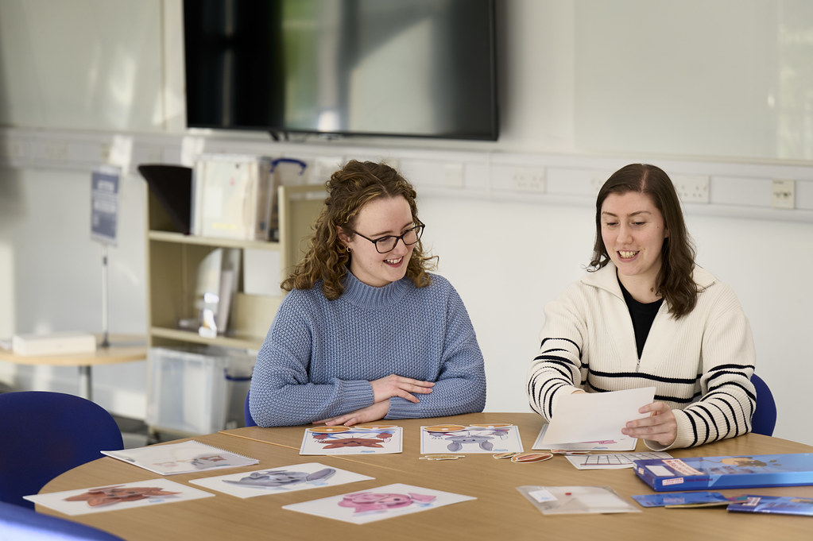

Contents

1. Contact Information 38
2. Programme and Placement Overview 39
3. Organisation of Practice Placements 42
4. The Student’s Responsibilities 46
5. Assessment of Development and Performance 51
6. The Role of the Practice Educator 53
7. The RCSLT Pre-registration Eating, Drinking & Swallowing Competencies 59

Appendix 62
1. RCSLT – Practice-based Learning Roles and Responsibilities Framework 62
2. Session Plans 73
3. Reflective Writing 82
4. CPD Activities 85
5. Examples of Competencies Mapped to Placement Levels 92
6. Process of Supporting Students at Risk of Failing Placement 96

 1. Contact Information

Practice Educators and students are encouraged to contact the placement team via the appropriate central email address for any queries or concerns. The mailboxes are monitored Monday to Friday, 09:00–16:30. Please note that the placement team manage these emails alongside their teaching and other commitments and will aim to respond as promptly as possible.
Semester Placements | SLTSemesterPlacements@qmu.ac.uk
Summer Placements | SLTSummerPlacements@qmu.ac.uk
Community Partnership Placements | SLTcommunityplacements@qmu.ac.uk
Eating, Drinking and Swallowing Competencies | EDScompetencies@qmu.ac.uk
Peer Enhanced Electronic Placement | SLTPEEP@qmu.ac.uk

 2. Programme and Placement Overview
SLT practice is underpinned by the integration of knowledge and understanding from a range of disciplines, including linguistics, biological and medical sciences, sociology, psychology, and speech and language pathology. The curriculum is therefore designed to balance a strong applied scientific foundation with a robust skills base, in line with the expectations of all HCPC registrants.
To reflect this balance, all SLT programmes at QMU are structured around four strands:
- Foundations for SLT
- Research
- Scope of Clinical Practice
- Professional Practice
Modules within each strand build progressively, with the programme shifting from foundational knowledge in the early stages to a strong focus on professional practice as students approach graduation.

2.1 Overview of the Professional Practice strand by programme level
The Professional Practice Strand, which includes all the practice-based learning experiences and associated teaching, focuses on the development of professional skills to prepare the students for SLT practice.

Level 1
Professional Practice in Level 1 begins with the introductory module ‘Clinical and Professional Practice 1’ which introduces students to the RCSLT’s Four Domains of Practice, the HCPC Standards of Conduct, Ethics and Performance, and the HCPC Standards of Proficiency - all of which provide the foundation for teaching and practical experience throughout the programme.
As part of this module, students complete the pre-placement passport of mandatory training activities, shared through the IDEAL strand, and are introduced to the Continuing Professional Development (CPD) diary, using the RCSLT CPD diary.
Practice-based learning in Level 1 begins in the Autumn Trimester with a Peer Enhanced Electronic Placement (PEEP) and clinically related activities. In Spring Trimester, students undertake their first clinical placement, followed by a further clinical placement in the Summer Trimester between Years 1 and 2. At some point during their first year, students will start their Community Partnership Placement, an unpaid elective in a third-sector organisation.

Level 2
In Level 2, students undertake two further clinical placements (one in the Spring Trimester and one in the Autumn Trimester), and another Summer Trimester clinical placement.
Running alongside these are the professional practice modules ‘Clinical and Professional Practice 2’ and ‘Applied Clinical Decision-Making in Speech and Language Therapy and Audiology’, which are designed to consolidate the autonomous and reflective thinking skills required for graduation and progression onto the NQP competency framework.

2.2 Placement Structure
The content and structure of the professional practice strand ensures that, on completion of the programme, students will have met the mandatory placement hours required by RCSLT. Placement hours are recorded in full days (7.5 hours) or half days (equivalent to 3.75 hours).
In total, learners need to complete a minimum of 75 days of practice placement opportunities across the duration of their pre-registration training. These comprise a minimum of 50 days of clinically based practice placement under the direct supervision of a qualified SLT, of which at least 15 days must be with paediatric clients, 15 days with adult clients, and 20 days can reflect local service delivery needs.
In addition, a further 25 days are required which may include: observation days as part of a formal placement period in settings where an SLT is not present; further SLT supervised practice placement sessions; practice placement related activities; and HEI based learning, not in a formal placement period.
The allocation of practice placement days is outlined below:
Level 1 | 8 days of peer enhanced e-placement and clinically related activities
Level 1 | 10 days of trimester clinical placement
Level 1 | 15 days of summer block clinical placement
Level 2 | 20 days of trimester clinical placement
Level 2 | 15 days of summer block clinical placement
Across the programme | Community partnership placement (80 hours)
Total | 78.5 days

The placement structure and associated paperwork are outlined below:
 | Autumn Trimester | Spring Trimester | Summer
Year 1 | Placement Passport  (E-Portfolio – PebblePad) | Placement 1  (PPR form – Canvas dropbox) | Placement 2  (PPR form – Canvas dropbox)
Year 1 | Clinically Related Activities*  (E-Portfolio – PebblePad) | Placement 1  (PPR form – Canvas dropbox) | Placement 2  (PPR form – Canvas dropbox)
Year 1 | PEEP*  (Attendance form – Canvas dropbox) | Placement 1  (PPR form – Canvas dropbox) | Placement 2  (PPR form – Canvas dropbox)
Year 2 | Placement 3  (PPR form – Canvas dropbox) | Placement 4  (PPR form – Canvas dropbox) | Placement 5  (PPR form – Canvas dropbox)
 | Placement Passport Updates  (E-Portfolio – PebblePad) | Placement 4  (PPR form – Canvas dropbox) | Placement 5  (PPR form – Canvas dropbox)
Community Partnership Placement* (runs throughout both years)
(Organisation details entered to InPlace, E-Portfolio – PebblePad for everything else)

*These placements are ‘Core Skills Placements’, not clinical practice placements. Please see the Core Skills Handbook for further information about these.

 3. Organisation of Practice Placements
Placements are all organised through the placement team in consultation with local Placement Coordinators (PCs). PCs are SLTs nominated by individual health boards to oversee the local management of student placements and are responsible for requesting and collating placement offers from their SLT team(s). Additional roles of the PC vary between health boards to accommodate local policy, practice and need.
To preserve the integrity of the process, students should never make direct contact with a PC or individual SLT to seek a placement.

3.1 Offers
Planning for the placement cycle commences in January each year and continues until February/March of the following year, ending when summer placements have been secured for all students. Services that offer placements are asked, via PCs, to make their offers for the year ahead to allow for timely allocations across the year. This is in line with guidance from NHS Education for Scotland (NES). Placement offers are collected collaboratively with the University of Strathclyde, as some health boards host students from both universities, which helps make the process more streamlined.
Both ongoing placements (on individual days per week) and block placements (typically 5 days per week for three weeks) are sought in order to provide students with a range of learning opportunities. In addition, alongside the traditional 1:1 model of student supervision, the RCSLT and NES supports a range of models of practice placement including: peer; long-arm; role emerging; and interprofessional placements. We are keen to work with placement providers to develop models of practice placement that are of benefit to both the students and the hosting services and students may experience a range of placement types over the duration of their studies.

3.2 Allocations
Placement availability is dynamic and complex, and services are changing rapidly. Therefore, it is difficult to predict the exact pattern and nature of placements that will be available throughout a student’s programme of study, and it is not necessarily possible to accommodate individual students’ preferences for location or clinical group.
The allocation process is based on a set of guiding principles, developed to ensure equity of placement provision and experience. These include:
- Fairness to each student/cohort in the allocation process
- Ensuring that every student exits the programme with a well-rounded placement profile that meets the RCSLT requirements (including EDS competency requirements)
- Consideration of previous placement locations and experiences
- Extenuating/special circumstances, including specific caring responsibilities
- Capacity of practice areas

Due to the geographical dispersal of placements, it is expected that every student will complete placements involving significant daily travel and/or in the case of summer placements, moving into temporary accommodation. It is acknowledged that some students may have particular needs which in exceptional circumstances can only be supported by the student undertaking their practice placement(s) in a specific location. This may apply to:
- Students with young/school age children, or with other significant family responsibilities such as being the sole carer of a disabled relative
- A disabled student as defined by the Equality Act (2010) who requires a placement within daily travelling distance. This will be specified in their Individual Learning Plan (ILP) agreed with the QMU Disability Advisor.

In these situations, placements are allocated using the guideline that travel from the student’s term-time address should be no more than about 1.5 hours each way, with a maximum of 2 hours. However, this remains dependent on placement availability and cannot disadvantage other students with regards to their required placement balance.
The predictability of the offer/allocation model also enables better balance of individual student experiences across the year. In addition to ensuring that students meet the balance of client group experience/EDS competencies required by the RCSLT, the allocation model supports students to experience a range of different service models and locations, thus better preparing them for variations in clinical practice. Given the above constraints on allocations, it is not possible to offer students free choice regarding placement location or clinical group. However, wherever possible, student preferences for clinical group and location of their final year and/or summer practice placement are considered as part of the allocation process.
Once a specific placement has been allocated, this becomes part of the curriculum offered to the student. Students cannot contest their placement allocations on the grounds of time, travel or financial resources, as the placement team cannot make a judgement on one student’s needs being greater than another. Occasionally there may be last minute alterations to allocations due to changes in Practice Educator availability. In such circumstances, the placement team do all that they can to minimise the impact on the student/students.
Allocations for Autumn Trimester are typically released in August once a student’s progression to the following academic year has been confirmed by the meeting of the Board of Examiners. Allocations for Spring Trimester are typically released to all students in November/December with summer placement allocations following in February/March. Typically, this means that students and Practice Educators have at least a month’s notice of their upcoming allocation and are therefore able to be prepared for the experience. The placement team will alert PCs and students where any delays to the usual schedule are anticipated.

Students can access their placement allocations via InPlace, QMU’s online placement management system. Information about how to use InPlace and view allocations is sent directly to students.

3.3 Locations
Placements which take place during the Autumn and Spring trimesters are based within the local catchment area of the Borders, Fife, Forth Valley, Lothian and the closer parts of Tayside, to facilitate feasible travel demands.

Map of Catchment Area (circled in red) for Autumn and Spring Trimester Placements
Summer placements take place both within local catchment and in some more distant parts of Scotland including Dumfries and Galloway, Grampian, Highland, Orkney, Shetland and the Western Isles. Students should be aware that we do not source placements in England, Wales, Northern Ireland and Eire that already have a commitment to provide placements for local SLT programmes, so students cannot typically expect to be placed in parts of the British Isles beyond Scotland.
Sometimes a summer placement can be sourced in a student’s home country by special arrangement. Some practice placement providers outside of Scotland require a bespoke legal contract to be signed regarding liability. This applies particularly, but not solely, to placements in North America and Australia, and limits the feasibility of seeking placements in these areas, as the QMU legal team advise that there is a high risk of QMU being unable to underwrite the conditions of the contract.

3. 4 Travel and Accommodation

See Placement Allocation & Logistics.

3. 5 Expenses

See Expenses Claims.

 4. The Student’s Responsibilities

Please see Appendix 1 for a helpful framework designed by the RCSLT which outlines the roles of both students and Practice Educators.

4.1 Communication
Communication is a key aspect of the profession, and SLTs are able to modify and adapt theirs appropriately to the situation. This demonstrates an understanding of the social and cultural context, the appropriate register or tone to demonstrate professionalism, and the level of complexity to support understanding.
Both written and verbal communication should therefore be clear and professional. Language continually evolves, and much online written communication now mirrors informal spoken language. As sophisticated users of language, it is important that SLT students recognise the difference between more and less formal written registers.
Therefore, in emails to other professionals, students should avoid less formal written language, such as slang, abbreviations, or emoticons. The first interaction SLT students will have with their Practice Educator is through email, and this is an opportunity to demonstrate interest in and enthusiasm for the placement and to present as a developing professional.

4.2 Documentation
Students are required to take responsibility for the documentation relating to their practice placement. All documentation is now available on the QMU Speech and Language Practice Based Learning website. Documentation must be submitted to the Canvas course site in a timely manner in order for students to successfully complete the placement module. The submission of placement documentation provides some evidence that students are able to meet the standards set out in HCPC’s Standards for Conduct, Ethics and Performance. Therefore, failing to submit the required paperwork on time may impact a student’s progression on the programme.

4.3 Prior to Starting Your Placement
Students should make prompt contact with their confirmed Practice Educator/s (or PC if appropriate), as soon as they receive their placement allocation. This is a matter of professional courtesy and allows the student to introduce themselves and gather specific information about the placement, including any preparatory work as recommended by the Practice Educator. Practice Educators and students are also advised to discuss the best way of notifying each other in the event of a last-minute emergency.
The Placement Team provide a placement induction class before every placement. All students are expected to attend these classes and must notify the Module Coordinator if they are unable to, so that they can ensure they have information from the missed class.
In addition to completing any preparatory work that their Practice Educator has requested, students should also prepare the ‘Student Information for PEs’ form, ready to discuss with their Practice Educator on their first day of placement.

4.4 On the First Day of Placement

4.4.1 ID Check
On arrival, students will need to show their QMU smartcard so that Practice Educators can verify their identity.

4.4.2 ‘Student Information for PEs’ Form
As part of the placement induction, students should be prepared to discuss their ‘Student Information for PEs’ form, highlighting their learning objectives. This can also be a good opportunity to share information about any reasonable adjustments which they require to support their learning. Sharing this information with the Practice Educator before the placement begins, if the student feels comfortable doing so, can be helpful and allows time for planning appropriate support.
This form can be downloaded from the Practice Based Learning website.

4.5 Placement Activities
The duty of care for all clients lies with the Practice Educator, who holds full responsibility for case management. Students undertake assessment and treatment only under the direction of the Practice Educator. It is therefore inappropriate for students to take decisions regarding admission, discharge or referral of clients to other agencies, other than in consultation with the Practice Educator. However, students are responsible for preparing for and undertaking all clinical activities as directed by their Practice Educator.

4.5.1 Confidentiality
Students are advised that it is essential to respect the confidentiality of people with whom they come into contact when on placement. Information which could lead to the identification of a client or other people with whom the student is interacting on placement (e.g. children, carers, placement hosts, other associated professionals) should never be mentioned in any discussion which could be overheard.
Similarly, any written work produced by students on placement including in paper copy or in electronic format (e.g. on hard drive, memory stick, Dropbox, Google Drive and other cloud-based storage) must not contain any confidential information. It is important that students do not write anything that could identify an individual in any way. This includes, but is not limited to, information such as names, dates of birth, address, and clinical location. There are practical ways to record such information (e.g. use of pseudonyms in place of names, chronological age instead of date of birth, ‘primary school’ instead of the name of the primary school etc.). Students should consider recording only the information that is deemed important. Due consideration should be given to the possibility of ‘jigsaw’ identification, in which information provided may cumulatively lead to identification of an individual (e.g. medical diagnosis – especially if rare, occupation, date of hospital admission etc.) Where pseudonyms are used, these should not be the initials of an individual. All pseudonyms must be clearly marked as such. It is not sufficient to cover over information in order to anonymise it.
Further details are provided in the NHS Code of Practice on Protecting Patient Confidentiality booklet which has been provided by NHS Scotland.
http://www.wdhscp.org.uk/media/1256/revised-code-of-confidentiality-final.pdf
Modules on information governance, data security and confidentiality are included in the Placement Passport students complete before all clinical placements.

4.5.2 Clinic Organisation and Administration
Students must make themselves aware of, and abide by, protocols covering service delivery in their placement setting and establish with their Practice Educator their appropriate role within that setting. Discussion will typically cover the Practice Educator’s recommendations about duties such as:
- Answering the telephone
- Writing clinical notes
- Filing
- Keeping clinical statistics
- Other administrative duties

4.5.3 Client Records
Client records, or parts thereof, should never be removed or copied without permission from the Practice Educator. Information obtained from clinic files is confidential and must be appropriately anonymised prior to leaving the clinical setting.

4.5.4 Session Plans
Within the practice-based learning and clinical and professional practice strands, students are supported to learn how to develop aims and session plans. When attending their clinical placements, students are expected to prepare written plans for each intervention in which they will be involved and to discuss these with their Practice Educator before the session begins.
Current SLT models of practice mean that an intervention may involve direct 1:1 assessment or therapy with a client, but may equally involve delivery of an indirect, universal or targeted approach. The student should complete a session plan wherever possible, irrespective of the nature of the intervention, to demonstrate their understanding of the session aims, as well as their ability to plan, identify appropriate contingencies and evaluate the session.
Guidance on the standard QMU structure for session plans is provided in Appendix 2. However, we also recognise that individual Practice Educators may feel that a different approach is better suited to the particular type of service delivery or to a particular student’s learning needs. Students are advised to seek guidance on which type of plan the Practice Educator recommends and be aware that their Practice Educator might suggest changing formats as the placement continues, to meet the student’s developing learning needs. Students should adapt to this and embrace the learning opportunity that this offers to expand their experience. Students should be proactive in developing session plans and in sharing them with their Practice Educator for feedback.
Students should be aware that any academic submissions based on clinical work (e.g. assignments which include session plans) will always need to include the basic academic requirements outlined in class. This is particularly applicable if the student has learned other ways of session planning on placement which omit some of the core requirements.

4.5.5 Reflection
Reflection is an integral part of professional practice. The theory and practice of reflection is embedded throughout the professional practice strand of the programmes to support students in their development of this skill. A range of reflective tools are explored to enable students to identify those which best match their learning style. Reflection can be a deeply personal process, exploring complex emotions and situations, therefore students are not required to share their reflections with QMU staff or with their Practice Educator. Appendix 3 provides guidance on reflective writing.

4.5.6 Continuing Professional Development (CPD)
From the beginning of the programme, we want to foster in students the desire to be life-long learners, whereby professional maturity is achieved through both the work itself and the opportunity to reflect on the learning that has taken place.

4.5.7 CPD Days
Occasionally, it may not be possible for Practice Educators to provide the full number of days required on a placement and they may not be able to arrange alternative activities or supervision for the student. In this instance, the student can spend up to the equivalent of one day of placement undertaking additional CPD activities. Students should present their completed work to their Practice Educator on the next placement day, unless an alternative arrangement is agreed in advance.
CPD days can only be offered at the discretion of the Practice Educator and planned in advance. Students should not request, nor can they take, a CPD day on the same day as any sickness (or other) absence.
Appendix 4 includes a list of suggested CPD activities. This list is not exhaustive, and the Practice Educator may have different ideas for activities that could be used to support the development of the student’s knowledge and skills in a particular area of practice.

 5. Assessment of Development & Performance
Assessment should be a dynamic and shared process. In developing professional autonomy, students should be proactive in engaging in the process of assessment rather than simply recipients of feedback.
Students should familiarise themselves with the Practice Placement Report (PPR) form and use it as the basis for self-monitoring of their learning and development. The student and Practice Educator can also use the report as a framework for supervision and feedback throughout the placement. The PPR is used formally at two points during the placement, at the midway review and on the final day of placement.
Prior to the midway and final reviews, students should complete a copy of the document themselves to self-assess their development and performance. Any differences between the student’s self-assessment and the Practice Educator’s review of their development and performance can form a useful basis for discussion. On completion of the midway review, students should ensure that they request a copy of the form so that they can use it to guide their learning and objectives for the remainder of the placement.
On the Practice Based Learning website, there is a short training video on using the PPR form, as well as a link to download it. The PPR form is used jointly with the University of Strathclyde’s Speech and Language Therapy programme, supporting a consistent national approach to student assessment.

5.1 On the Final Day of Placement

5.1.1 Assessment and Feedback
The final day of placement should involve discussion between the student and their Practice Educator of the PPR. This is the final opportunity for students to receive feedback on their development and performance during the placement. It is also an opportunity for the student and Practice Educator to identify possible learning and development objectives for the student’s next placement or first job, depending on their stage of study.
On completion of the placement and the final review, students should ensure that they have a completed copy of the PPR signed and dated by the Practice Educator, which they should then upload to the relevant Canvas site no later than one week after completion of the placement.

5.1.2 Failing the Placement
As per the RCSLT practice-based learning guidance, if a student does not reach the expected level to pass their placement, they have one further opportunity to pass their placement, and this will be with a similar client group to the failed placement. Students can have the opportunity for one resit practice placement for each specific failed placement. With additional time and experience, it is hoped that the learner will successfully complete the resit placement.
As, then, the student’s placement pattern will not align with the rest of the cohort, the Placement Team will agree with the student on the timing of their trailing placement.

5.1.3 Attendance Form
Students should complete the attendance form as part of the PPR to reflect the true pattern of attendance at placement, so dates of any absences should be noted as well as the dates on which they attended. On the last day of placement, the student should ask their Practice Educator to sign and date the form as verification that it is a true record.

5.1.4 Gifts
Students often wish to give Practice Educators a token of their appreciation for the support that they have received during their practice placement. However, in line with NHS and QMU policy and procedures, QMU asks that students do not give gifts to Practice Educators. Students are however welcome to write a card for their Practice Educator, expressing their thanks, should they wish to do so.

5.1.5 Evaluation
Opportunities to provide feedback about student placements will be provided during placement seminars. HCPC standards require that students complete an evaluation following completion of their placement. This will be provided by the Placement Team via an electronic link. It is intended that student evaluations are considered as a whole body of feedback in the continual monitoring of the programme’s practice placement provision. Individual Practice Educators or services may also ask for the student’s feedback on the placement; students are encouraged to provide this after completing the placement and receiving their final report.

6. The Role of the Practice Educator

RCSLT stipulate that all practicing SLTs have a responsibility to engage in practice-based learning and should provide a minimum of 25 placement days per year whole-time equivalent (pro rata). This includes all bands (or equivalent) and includes leadership and managerial roles, and Band 5 (or equivalent) SLTs. Band 5 SLTs may be involved in practice placements but should not take full responsibility for learner assessment until they have after gained their NQP competencies.
SLT-specific Practice Educator training is offered by QMU; this should be completed every three years. Details of upcoming training can be found on the Practice Based Learning website. Training can be provided for clinical teams if an update or refresher is felt to be helpful.
The RCSLT encourage Practice Educators to consider offering peer placements where possible. Supporting two learners together can provide valuable opportunities for peer learning, collaboration and reflection, which can enrich the placement experience for students. For the purposes of recognising Practice Educator contributions to practice-based learning, supervising two learners for two full weeks would be recorded as 20 days of an SLT’s practice-based learning contribution.

6.1 Placement Induction
Practice Educators are asked to provide the student with an induction to the placement. It is helpful for students to understand the model/s of service delivery they will encounter and the opportunities and experiences likely to be available on the placement. The induction is an opportunity to make students aware of specific requirements of the placement and direct them to any additional service specific policies that they need to read. The placement induction should also include health and safety information appropriate to the setting.

6.2 Inclusive Learning
Practice Educators are asked to have a discussion with the student to ascertain the student’s learning goals and objectives for the placement. Students at later stages of the programme may be able to articulate this independently, whilst less experienced students may require the Practice Educator’s support to get the most benefit from the discussion. The ‘Student Information for PEs’ form should be used as a guide for this discussion. Talking Mats is also a useful tool to engage students in setting goals.
Students with identified disabilities are encouraged to share this information with their Practice Educator at the beginning of the placement in order to explore the reasonable adjustments available that the student may find helpful during the placement. The placement team, and our departmental Disability Advisor, are available to support Practice Educators who have any queries about this, along with resources on the Practice Based Learning website.

6.3 Managing Workload
Placement is also an opportunity for students to develop skills in balancing clinical tasks with wider workload. There is an understanding that students will be completing placement-related tasks while not at placement. This may be continually negotiated throughout the duration of the placement between the student and Practice Educator to ensure that demands are not excessive, but that sufficient preparation is being carried out.
Where there is more than one Practice Educator, the student and Practice Educators are asked to maintain open lines of communication so that all parties are aware of the range of demands on the student. Shared placements involve a student being supported by Practice Educators across different teams or services during a single placement. For example, during a summer block placement, the student may spend two days per week in one setting and two days in another. One Practice Educator should be identified as the lead to coordinate and provide the main feedback to the student.

6.4 Placement Educator Availability
Wherever possible, Practice Educators are asked to adhere to the prescribed structure and duration of the placement. We recognise that sometimes additional learning opportunities, such as specialist assessment clinics or training sessions, may be available on days other than a placement day and that Practice Educators may want to make this opportunity available to the student, or that a Practice Educator’s availability may become more restricted than anticipated and that they may wish to negotiate an alternative model of provision. In order to ensure that changes do not impact negatively on other aspects of the student’s learning, Practice Educators are asked to discuss any such changes with the Placement Team before agreeing them with the student.
In the event of a planned Practice Educator absence, the student can be permitted to carry out any activity which reflects the work of an SLT provided that the Practice Educator feels that this is not putting the client, the student or any other people with whom the student is interacting, at risk. What is appropriate for a student in their final placement may not be appropriate for a less experienced student. The student should be provided with clear, written information about who on the premises they can contact in case of difficulties. Where possible the designated contact person should be another SLT. However, another qualified professional who has knowledge of the client and/or knowledge of procedures that apply in the setting would be appropriate (e.g. teacher, day centre manager). Where the site is spread over several buildings, the student should be able to request assistance without having to leave a potentially dependant client on their own and that assistance should be able to reach them quickly.
Please note, it is not appropriate for students to carry out home visits on their own (i.e. in the absence of a qualified professional) at any stage of the programme.

6.5 Supporting Students’ Acquisition of Clinical Skills
Throughout the practice-based learning and clinical and professional practice strands, lectures, workshops, and seminars support students to develop the clinical knowledge and understanding required for practice. Placements provide the opportunity to translate that knowledge and understanding into practice with the guidance and support of the Practice Educator.
The role of the Practice Educator is key to fostering the student’s growing confidence and development as an SLT in a safe and supportive environment where ‘mistakes’ are viewed as part of the learning journey.
Every placement will offer different opportunities, and every student will have differing strengths and needs. However, all students will benefit from their Practice Educator:
- Supporting the student’s confidence by providing a period of observation followed by a gradual inclusion of the student in an increasing direct role in clinical activities.
- Supervising, as appropriate, the student’s direct assessment and intervention with clients and/or others.
- Reading and discussing the student’s session plans and other requested preparatory work, including providing verbal feedback on the CPD activities completed during the placement.
- Discussing the student’s observations and conclusions and providing feedback about the student’s interaction with clients and/or others.
- Supporting the student’s acquisition of clinical administration/management techniques including all aspects of record keeping.
- Providing some opportunity for discussion of specific issues in client management, case prioritisation, time management, clinical effectiveness, models of service delivery and professionalism as relevant to the setting.
- Supporting the student in the development of a professional relationship with the various members of the service delivery team.
- Introducing students to the administrative procedures of the setting, for example, for managing requests for assistance, referrals on to other services, reports and letter writing, ordering equipment, discharging and statistics.
- Supporting them to evaluate the session and their own performance. Discussions regarding evaluations of the session and the student’s performance are a key part of the development of clinical skills. Please note however that these evaluations are different to a student’s reflection on their feelings about a session, which students should not be required or expected to share.
Depending on their level of study, students may have a related piece of academic work to complete based on a placement experience. In these instances, the Practice Educator is asked to provide only the kind of guidance and support that they would for any other placement experience. The Practice Educator should not be involved in providing comments or direct guidance on the planned submission.

6.6 Assessment of a Student’s Development and Performance
The learning outcomes for clinical placements are competency based and assessed by Practice Educators.
Students are required to demonstrate different levels of competence depending on their placement stage and programme. The expected level of competence for each placement reflects the progression across placements, enabling students to demonstrate their development and, by the end of the programme, meet the requirements of a graduate SLT.
Practice Educators can find these competency levels clearly mapped within the PPR form. The levels of competence are outlined below:
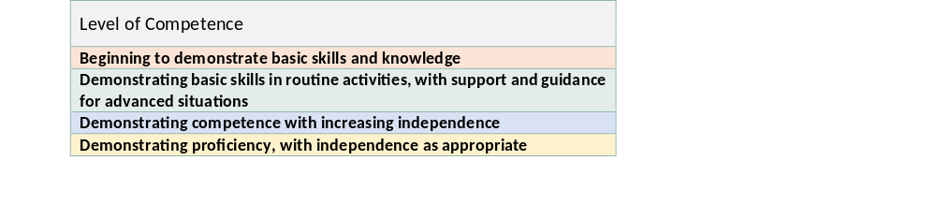
Levels of Competence
See Appendix 5 for some worked through examples of four different competencies mapped to the different levels of competence.
Competencies are recorded using performance descriptors based on the student’s level of achievement: Enhanced Development, Developing as Expected, Emerging, Area for Development, or Not Applicable to this Placement, as illustrated in the diagram below:
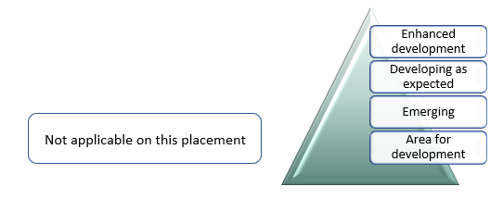
Competency Achievement Descriptors
Practice Educators are to marked the placement as either a pass or fail. The student is required to have all of their competencies marked as either ‘developing as expected’ or ‘enhanced development’ in order to pass their placement.

6.6.1 Practice Placement Report (PPR) Form
The Practice Placement Report (PPR) is based on the competencies described in the RCSLT core capabilities and HCPC’s standards of proficiency and provides a guide for students and Practice Educators about the capabilities a student should be aiming to achieve, and a record of the student’s development on placement. The RCSLT has recently transitioned from structuring lifelong learning around the five core capabilities to four domains of practice. Consequently, the form will require updating to reflect this change. However, as the current form is not yet long-established, it is considered premature to place the additional burden of change on Practice Educators at a time when services are already under significant pressure. This approach also allows time for any future national paperwork changes to be implemented efficiently.
The PPR should be used throughout the placement as a basis for discussion between the Practice Educator and student. Students should use the PPR to self-evaluate their capabilities at both the midway and final points of the placement and to share this evaluation with their Practice Educator as part of the assessment and feedback discussion.
The PPR should be used to provide feedback at both the midway and final points of the placement. It provides guidance to the Practice Educator on determining the outcome of the placement based on the competences the student has demonstrated.
The new PPR was launched in September 2023, and both the form and some video guidance on its use are available on the QMU Speech and Language Practice Based Learning website.

6.6.2 Midway Review
At the midpoint of the placement, Practice Educators are asked to provide students with formal feedback on their progress and to set aside dedicated time for this discussion. The PPR should be used to indicate the student’s level of development in the target competencies. Objectives for the remainder of the placement should be mutually agreed and recorded. Students and Practice Educators should sign to indicate they have taken part in the midway discussion and objective setting for the remainder of the placement. Students should be provided with a copy of the full PPR after the midway review to support them to take ownership of their objectives for the remainder of the placement.

6.6.3 Concerns about Student Development and Performance
In the event of Practice Educator concerns that a student is struggling and/or that they may be at risk of failing the placement, or receiving only a borderline pass, then the Practice Educator should contact the Placement Team at QMU as soon as possible. It is not necessary to wait until the midway review to do so, contact from concerned Practice Educators is welcomed at any time in the placement cycle as it ensures prompt action is then taken to support the student. It is also essential that the Practice Educator informs the student of their concerns and that QMU have been/will be notified.
Where the student is at risk of failing, the Practice Educator must give the student written guidelines about which PPR competencies are causing concern and require to be addressed before the placement can be passed. For reasons of governance, the Practice Educator should also tick the midway section of the PPR to indicate that risk of fail has been clearly discussed with the student. The Placement Team can support students and Practice Educators to determine an appropriate action plan for the remainder of the placement, which may include tutorial support from QMU.
The Placement Team acknowledge the challenges in offering this type of difficult feedback to students and are available to support these discussions. Practice Educators are encouraged to use very clear language (e.g. “you are at risk of failing this placement”) and avoid any ambiguity (e.g. “you may not reach the required level for this placement”) to support students in their ability to understand the implications and take ownership of the action plan. Please see Appendix 6 for what to do if a student is at risk of failing.

6.6.4 Final Day Review
At the end of the placement, the Practice Educator completes the PPR, indicating whether the student has passed or failed the placement.
The PPR should be discussed with the student during a final meeting. The completed PPR should be checked and signed by both the Practice Educator and the student as a record of the discussion. Students are responsible for submitting copies of the completed PPR (which includes the Attendance Record) to QMU via Canvas dropboxes immediately upon completion of the placement. Therefore, students need to leave the placement site after the final review with either an electronic or hard copy of their completed and signed PPR.

6.7 Placement Evaluation
Should a Practice Educator wish to receive feedback from the student, the student should be invited to provide this only after the final day review has been completed, and the student has received confirmation of having passed/failed the placement.

 7. The RCSLT Pre-registration Eating, Drinking & Swallowing Competencies
The RCSLT pre-registration eating, drinking and swallowing (EDS) competencies have been developed to ensure that SLT pre-registration learners are acquiring the same entry-level knowledge and skills of dysphagia, regardless of where they are undertaking their pre-registration education and training. The competencies were published in February 2021, updated in December 2025 and now form a mandatory part of pre-registration training for all students.
The full competency document can be found on the RCSLT website.
The competencies are designed to reflect all aspects of an SLT episode of care with a service user with EDS difficulties.

7.1 The Pre-registration EDS Competency Requirements
There is one mandatory element to the pre-registration EDS competency requirements:
- Specific competency achievement evidenced by sign-offs by Practice Educators

There is also a secondary, recommended element:

- Accumulation of EDS exposure hours, also evidenced by sign-offs

7.1.1 Competencies
There are 20 pre-registration EDS competencies in total.
For a specific competency to be signed off, students must demonstrate that competency on two separate occasions, achieving a signature each time. Students must achieve this ‘double sign-off’ for a minimum of 16 competencies to graduate. Which competencies make up the 16 minimum is not stipulated by RCSLT, so students may have different competency profiles.

7.1.2. EDS Exposure Hours
In late 2025, RCSLT updated the pre-registration EDS competency document.
RCSLT now recommends a total of 60 EDS exposure hours across the duration of the pre-registration programme, with at least 30 hours from clinical practice with adults and at least 10 hours from clinical practice with children. Hours devoted to EDS experience form part of the existing requirement for practice-based learning in the RCSLT Curriculum Guidance (2025). In comparison to the previous version of the pre-registration EDS competencies, the hours component has been changed to ‘recommended’ as opposed to mandatory. This is in response to practice placement availability. This recommendation applies to all programmes, regardless of duration, mode of delivery or structure. The change from mandatory to recommended hours aligns with the removal of the hour’s component from the post registration SLT EDS competency framework.

7.1.3 Competency Focus on Placement
We suggest a focus on aiming to achieve one signature for the following competencies with students on their placements:
1 | 5 | 8 | 9 | 10 | 11 | 13 | 14 | 15 | 19 | 20
Support for other competencies will be provided on campus so the above competencies constitute placement priority.

7.2 The EDS Competencies Handbooks
The QMU EDS competencies team have developed handbooks for Practice Educators which contain guidance for EDS competency assessment and EDS exposure hours sign-off on placement. There are separate handbooks for PEs working with an adult caseload and PEs working with a paediatric caseload.
EDS Guidance for Paediatric Clinical Placements
EDS Guidance for Adult Clinical Placements
The overall QMU placement handbook includes additional CPD tasks focussed on EDS/dysphagia that can be used for students to help evidence their competency in specific areas. These tasks are also included in the QMU EDS competency handbooks.
QMU students will collect EDS competency and hourage sign-offs electronically using the PebblePad/PebblePocket website. All signatures will be collected via the students’ own accounts.
Please see our FAQ page for more information.

7.3 Health and Safety

7.3.1 Hand Washing, Oral Exercises and Intra-Oral Exercises

It is imperative that an appropriate hand-washing regime is observed before and after contact with clients. The Practice Educator should advise on specific requirements for each placement. Students will also have also completed modules in this area as part of their studies in the Scottish Infection Control and Prevention Education Pathway as part of their Placement Passport.
- Surgical gloves should be worn for any oral examination or intra-oral exercise programme.
- Students should seek and comply with advice on the management of non-disposable equipment (e.g. feeding utensils, prostheses, PNF brushes, and tympanometry seals).
- Students should seek and comply with local policy and procedure on the management of disposable equipment (e.g. gloves, spatulas, gauze, tissues, feeding utensils).

7.3.2 Dysphagia – Eating and Positioning
Assessment and management of eating and drinking skills is a part of many SLT’s roles with certain client groups.
- As part of undergraduate training, students may be expected to participate in helping with eating or drinking under supervision at all times.
- The level of participation is decided by the Practice Educator.
- Teeth cleaning is sometimes regarded as an extension of mealtime oral training with some client groups. Students may be requested to assist with this as part of a therapist led programme.

APPENDIX 1: RCSLT – Practice-based Learning Roles and Responsibilities Framework (2021)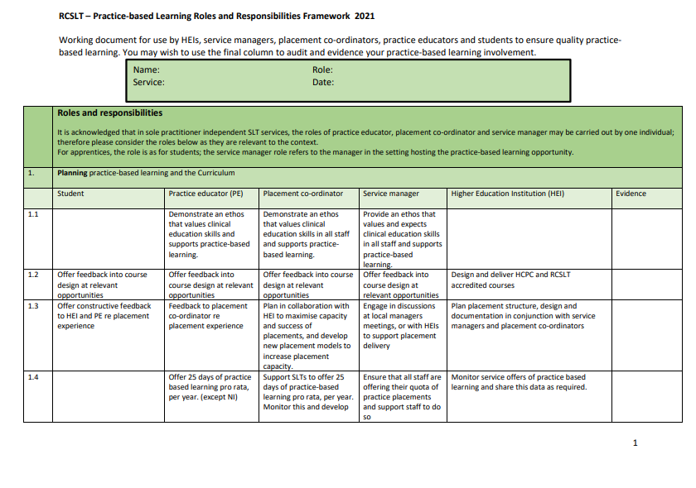
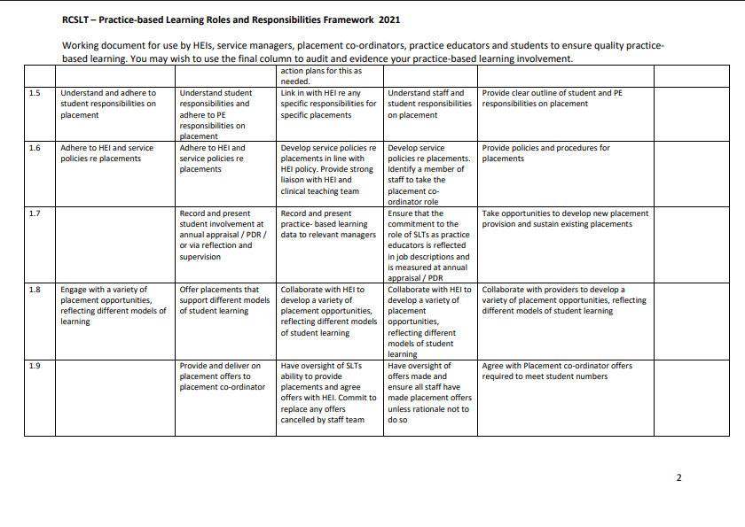
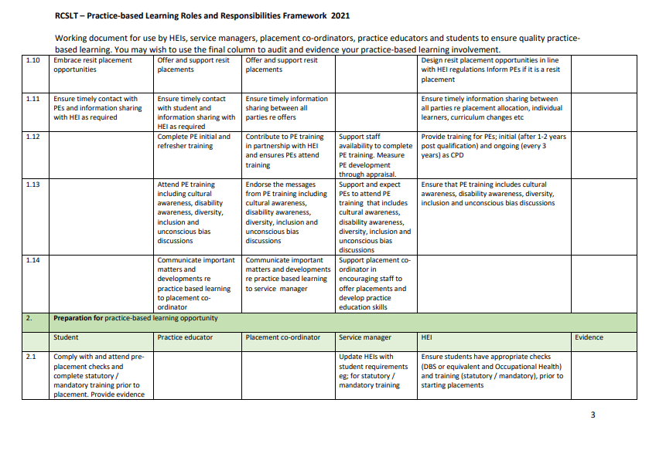
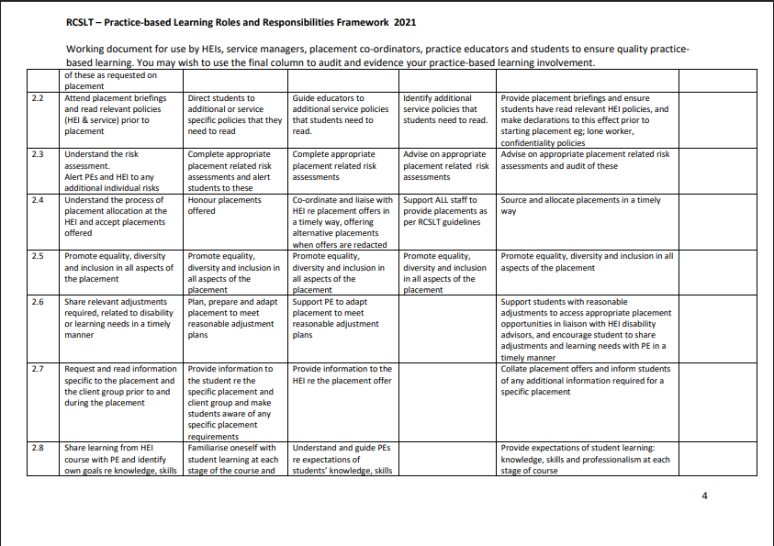
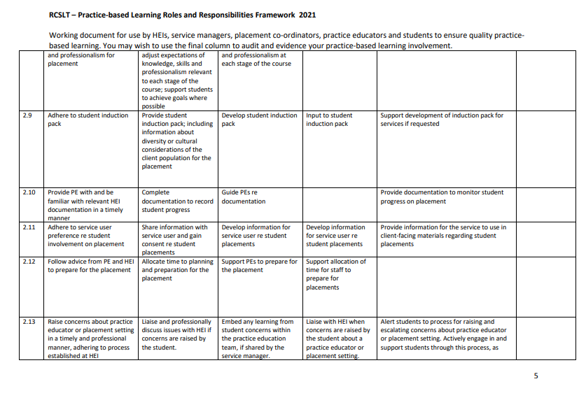
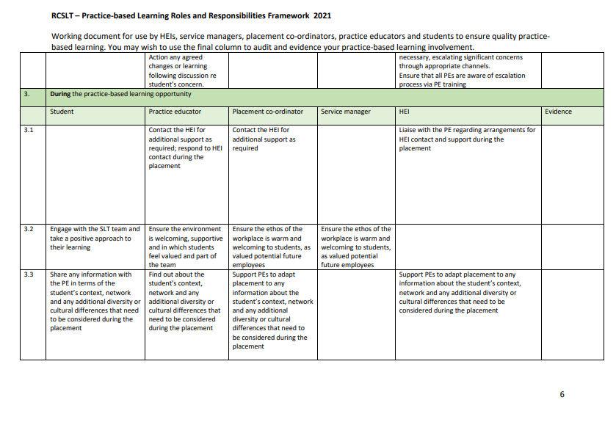
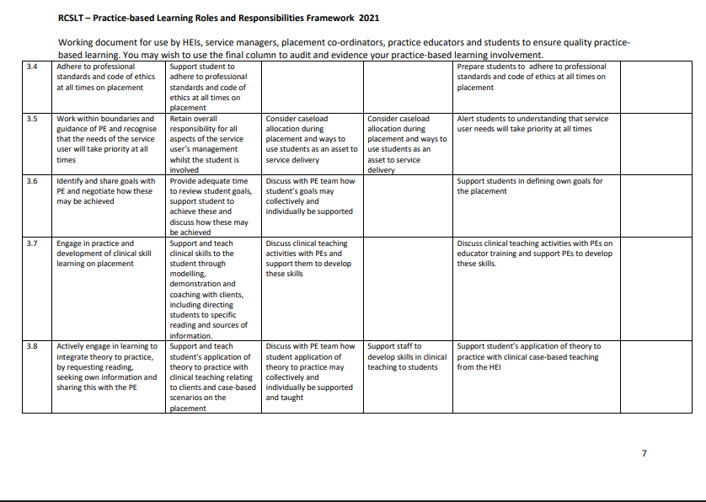
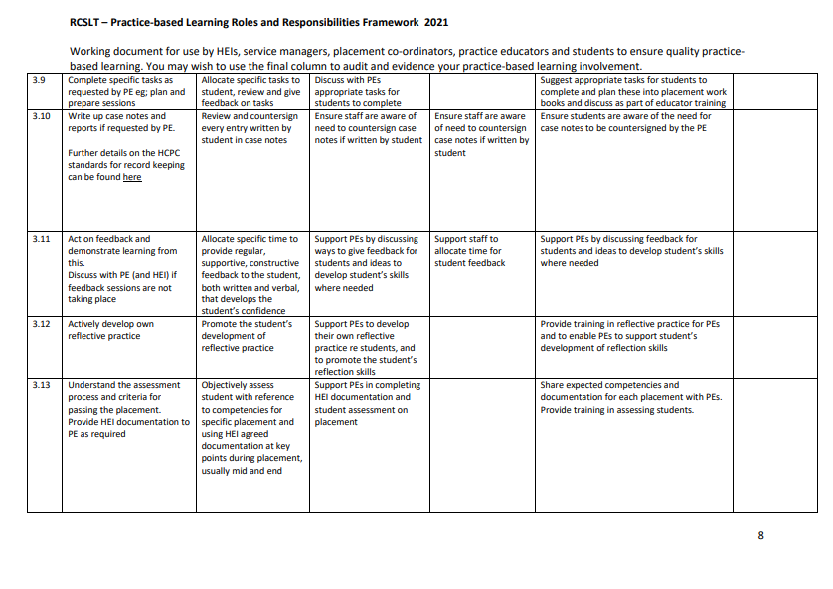
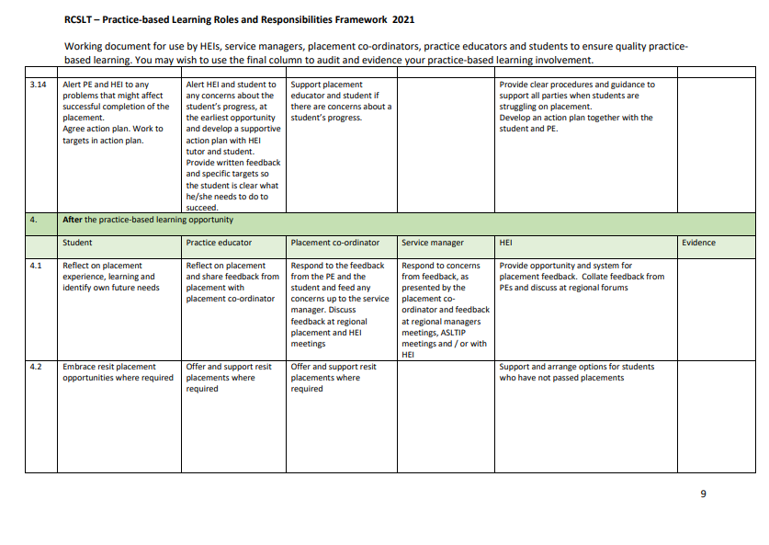
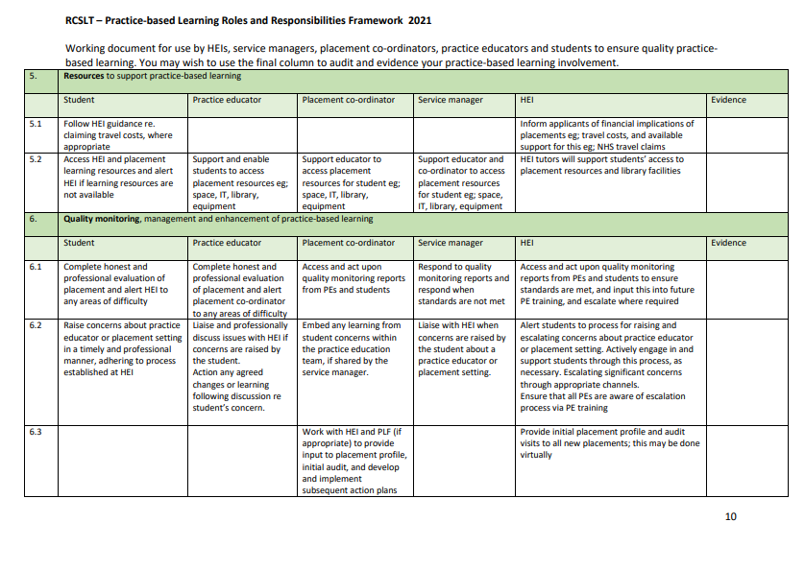
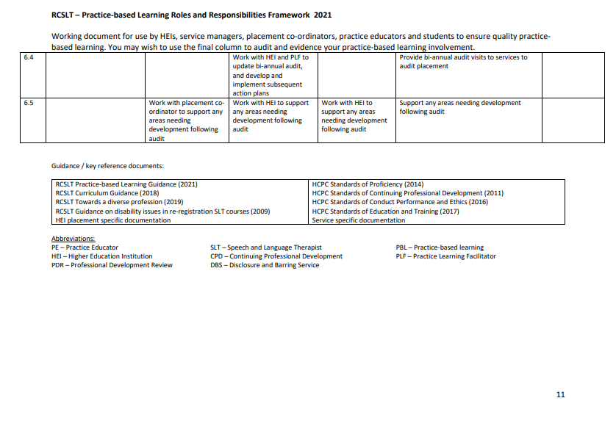

APPENDIX 2: Session Plans

Students on placements are expected to prepare a session plan for any intervention activity they are leading. Session plans should normally be available for the Practice Educator to review on the day of placement, unless an alternative arrangement has been agreed (e.g. submitting plans in advance by email).
In some circumstances, a new plan may not be required (for example, where a session closely follows a previous session). This will be at the discretion of the Practice Educator.

An Overview of Terminology
The term ‘session plan’ is used to describe a specific period of time working directly or indirectly with a service user. Within this appendix, a “session plan” refers to a time-limited interaction that supports the communication needs of a service user or group of service users. This may include:
- direct work with a service user (e.g. individual or group intervention)
- indirect work with people supporting the service user (e.g. family members, carers, teachers)
- preparation for professional activities such as training sessions, meetings, or collaborative work with other professionals.

Students may also encounter different terminology relating to the intended purpose of a session (e.g. aims, goals, or objectives). In this handbook the term “aims” is used throughout. However, students should adopt the terminology preferred by their Practice Educator or placement setting where appropriate.

What is a Session Plan?
A session plan is a structured outline that supports the delivery of effective, person-centred speech and language therapy. It demonstrates the student’s clinical reasoning, preparation and understanding of the service user’s needs.
Session plans typically begin with key background information about the service user (using pseudonyms to maintain confidentiality). Relevant information may include:
- age
- diagnosis or reason for referral
- relevant medical factors
- sensory or mobility considerations
- social factors
- other professionals involved in the service user’s care.

The session plan then outlines:
- the long-term, short-term and session aims guiding intervention
- the tasks and activities that will be used to work towards these aims
- how activities may be adapted or graded (e.g. increased or reduced in difficulty)
- the demands of each task (e.g. cognitive, linguistic, physical)
- the therapeutic techniques that will be used (e.g. modelling, cueing, feedback)
- any environmental considerations (e.g. seating, noise levels, lighting or timing).

Planned activities may involve direct intervention with a service user or indirect work that supports communication outcomes.
For example, a student might:
- Deliver a one-to-one therapy session with a service user.
- Work with teachers, carers, or staff to adapt communication supports in the environment.
- Provide guidance or training to family members or staff to support communication in everyday interactions.
All of these activities are part of effective speech and language therapy practice and contribute to the development of professional competence.
Session plans may also include space for the student to record the service user’s response to tasks and reflect on the effectiveness of the session.

Writing Aims
Effective session planning begins with a clear understanding of the purpose of the interaction. Writing aims helps to communicate the intended outcomes of speech and language therapy and demonstrates the clinical reasoning.
When writing aims, students should focus first on the question “What communication outcome are we working towards for this service user?” rather than simply “What activities will take place in this session?” Aims describe the intended outcome for the service user. Activities, tasks and strategies describe how the aim will be addressed.
A common difficulty for students is confusing aims with activities (e.g. describing the therapy task rather than the communication outcome). Developing the ability to distinguish between the purpose of intervention and the activities used to support it is an important professional skill.

Types of Aims
Speech and language therapy intervention typically includes three levels of aims:
- Long-term aims
- Short-term aims
- Session aims
Each level of aim supports planning, delivery and evaluation of intervention.

Long-Term Aims
Long-term aims describe the overall intended outcome of speech and language therapy for a service user. They reflect the broader communication goals that intervention is working towards.
The timescale for long-term aims may vary depending on the service context and the needs of the service user (for example a block of intervention lasting several weeks or months).
Long-term aims should clearly reflect why intervention is being provided.
Example
John (pseudonym) is a 6-year-old child with a phonological delay characterised by velar fronting of /k/ and /g/. Intervention is planned to address these patterns.
Long-term aim:
In six months’ time, John will use speech sounds that are typical for his age so that he can be understood more easily by familiar and unfamiliar listeners in everyday communication.
Long-term aims should focus on the intended change in the service user’s communication, rather than the therapy process itself.
For example, the following are not appropriate long-term aims:
- “John will complete a block of speech and language therapy.”
- “The SLT will deliver therapy to target John’s phonology.”
These describe the activity of therapy, rather than the intended outcome for the service user.

Short-Term Aims
Short-term aims break down the long-term aim into smaller, achievable steps. They describe the specific skills the service user is working towards during a block of intervention.
Short-term aims often include:
- the skill the service user will demonstrate
- the context or conditions in which it will occur
- the level of performance expected
Short-term aims are typically achieved over multiple sessions.
Example
Continuing with John’s case:
Short-term aim:
John will produce velar consonants contrastively in word-initial position during structured tasks with 100% accuracy.
This aim supports progress towards the long-term aim of developing an age-appropriate phonological system.
Short-term aims should describe the intended communication skill, rather than the therapy task. For example, the following is not an appropriate short-term aims:
“John will take part in therapy exercises targeting velars.”
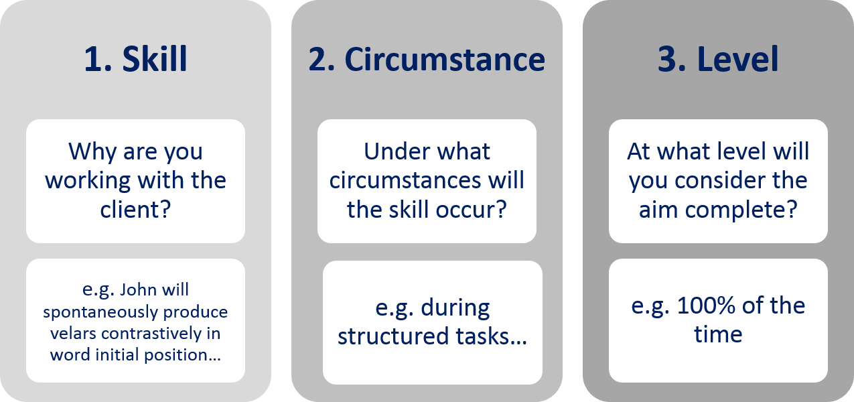
This describes an activity rather than a measurable outcome.

Session Aims
Session aims describe the specific focus of a therapy session. They contribute to progress towards the short-term and long-term aims.
There may be one or several session aims depending on the needs of the service user.
Session aims should clearly describe:
- the communication skill being targeted
- the context in which it will occur
- the expected level of performance.
Speech and language therapy aims may relate to different aspects of communication. In some cases, aims focus on developing specific speech, language or communication skills. In other situations, aims may focus on supporting participation in everyday activities, developing communication strategies, or enabling communication partners and environments to better support the service user. Students should consider the wider communication context when identifying appropriate aims.
Example
Session aims
- John will discriminate between word-initial velar and alveolar minimal pairs produced by the SLT in a structured task with 90% accuracy.
- John will produce velar and alveolar minimal pairs contrastively in a structured task with 50% accuracy.
These aims clearly describe the intended outcome of the session, rather than the activities used to achieve it.
Examples such as the following should be avoided:
- “John will complete a discrimination exercise.”
- “The SLT will show John pictures.”
These describe tasks rather than the intended learning outcome.

Writing Effective Aims
The following principles can support effective aim writing:
- Aims should focus on the communication skill or outcome, rather than the activity used.
- Aims are usually written from the service user’s perspective (e.g. “John will…”).
- Avoid beginning aims with “to…”, as this often describes an activity rather than an outcome.
- Consider using clear action verbs such as produce, demonstrate, use, discriminate, request or describe.
- Aims should be specific and measurable where possible.
- Aims should be written in clear, positive language, focusing on the skill being developed.
In some cases (for example during assessment), aims may focus on information gathering to inform clinical decision-making. For example: “The session will enable the SLT to gather further information about Mary’s strengths and needs in conversational interaction to inform intervention planning.”

What are SMART Aims?
SMART is a framework commonly used in healthcare and education to support the development of clear aims
SMART aims are:
- Specific – clearly describing the skill or outcome
- Measurable – progress can be evaluated
- Achievable – appropriate for the service user’s current abilities
- Realistic – achievable within the context of intervention
- Time-bound – where appropriate, linked to a timeframe.
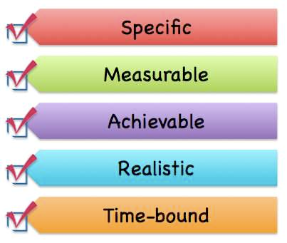

Additional Components of a Session Plan
In addition to aims, session plans should outline the clinical reasoning behind the planned intervention. This typically includes:
- the tasks and activities that will be used to work towards each aim
- materials required
- therapeutic techniques (e.g. modelling, cueing, feedback)
- the demands of each task (e.g. cognitive, linguistic, motor)
- how the activity may be graded (e.g. increased or reduced in difficulty)
- environmental considerations (e.g. seating, noise, timing)
- outcome measures to evaluate the effectiveness of the session.
Session plans should demonstrate that intervention is planned, purposeful and responsive to the needs of the service user.

 | SESSION PLAN  Use this pro forma as a template for your session plans

ADMINISTRATIVE / BACKGROUND info
(All information should maintain service-user confidentiality. Use a pseudonym for all documentation.)

☐ | Service user name: (pseudonym)
☐ | Age: (do not include date of birth)
☐ | Diagnostic information / reason for referral:
☐ | Relevant medical factors:
☐ | Sensory considerations:
☐ | Mobility / physical considerations:
☐ | Social / environmental factors:
☐ | Other professionals involved:
☐ | Current setting: (e.g. nursery, school, community clinic, acute hospital)

SESSION PLAN

long-term aim(s)
(The overarching communication outcome for speech and language therapy.)

short-term aim(s)
(Steps towards the long-term aim that guide intervention over a number of sessions.)

session aim(s)
(The specific outcomes for the session. These should be measurable and clearly linked to the short-term aim.)

(1)

(2)

(3)

people present
(e.g. SLT, student, parent/carer, teacher, support worker)

task / activity 1
(Describe the aspects outlined below.)
☐ | Description of task / activity
☐ | Materials required
☐ | Environmental considerations (e.g. seating, noise levels, positioning, lighting)
☐ | Therapeutic techniques (e.g. modelling, cueing, scaffolding, feedback, reinforcement)
☐ | Task demands on the service user (Consider the skills required to participate in the task e.g. linguistic, cognitive, motor / physical, sensory.)
☐ | Grading the activity  Step-up (increase challenge if task is easier than expected)  Step-down (reduce challenge if task is more difficult than expected)

Outcome Measures and Evaluation
☐ | How will you measure whether the session aims have been achieved?
☐ | Examples may include:  Accuracy levels  Frequency of target behaviours  Level of prompting or support needed  Qualitative observations

(Repeat the above section for each planned task or activity.)

session evaluation
(Completed after the session)
☐ | Were the session aims achieved?
☐ | What evidence supports this?
☐ | What worked well?
☐ | What could you change next time?
☐ | Implications for future sessions

relevant supporting literature

Hierarchy of Prompts
Scaffolding
Providing structured support that is gradually reduced as the service user develops skills.
ELICITED IMITATION
Encouraging the service user to imitate speech, language or communication behaviours.
Enhancing the Salience
Highlighting key features of speech or language to make them more noticeable, and therefore potentially easier to learn.
Metalinguistic and METACOGNITIVE Techniques
Supporting the service user to reflect on language, communication or thinking processes.
PHYSICAL MANIPULATION
Supporting physical positioning where appropriate to facilitate communication.
Modelling
Providing clear examples of the target communication behaviour.
Providing Feedback
Providing information to support learning and improve performance.
Practising AND REPETITION
Supporting the development of skill through repeated opportunities.
Prompting and Cueing
Providing verbal, visual or gestural cues to support the desired response.

APPENDIX 3: Reflective Writing

What is Reflective Practice?
Reflective Practice is an expectation of all AHPs, and is written in to HCPC’s Standards of Proficiency (SOPs) for speech & language therapists, which states that all SLTs must: “10.1 understand the value of reflective practice and the need to record the outcome of such reflection to support continuous improvement”. Practicing reflectively means not just engaging in the process of self-reflection, but also keeping a record of your learning in the form of reflective writing. Reflective writing is woven in across the speech & language therapy programmes through direct teaching as well as application of reflection in practice-based learning.
As well as meeting professional standards, reflective writing helps you:
- Connect theory to real clinical practice
- Understand your decision-making and communication style
- Take control of your own learning by identifying your own strengths and areas for development
- Build confidence and professional identity
- Prepare for supervision discussions and future interviews

What Should I Reflect On?
Reflection is a skill that can be applied to any situation. It does not need to be something dramatic, any situation that you feel you can take some learning from can be used. Some topics include:
- A session that went well (and why)
- A session that felt challenging
- A communication breakdown with a client, parent, or colleague
- A new assessment or therapy technique
- Ethical dilemmas or safeguarding considerations
- Interprofessional teamwork
- Feedback from your educator
- Your emotional responses to clinical work
- If something made you pause, feel uncertain, or feel proud then it’s worth reflecting on.

How to Structure Your Reflection?
There are many ways to structure reflective writing and students will learn about these in reflective practice classes. You are free to choose the structure that works best for you but many people find that one of the following options works well:
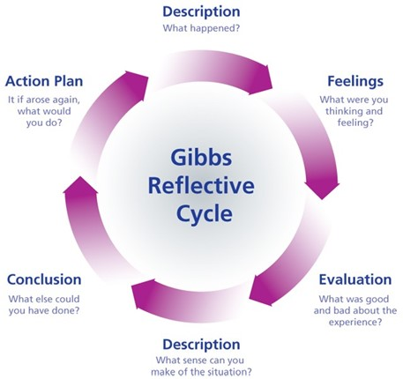
Gibbs Reflective Cycle (1988)
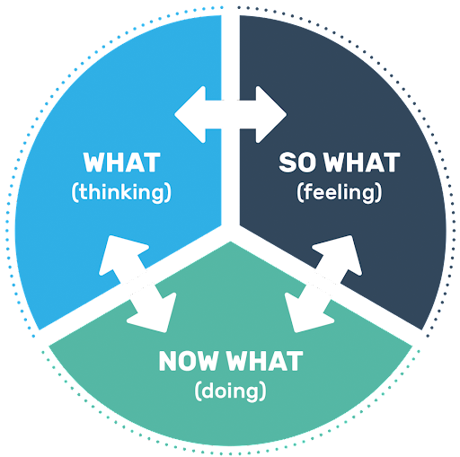
Driscoll Model of Reflection (1970)

Examples of Prompts to Get You Starter
The following general prompts are a useful starting point for reflective writing:
- What surprised me today?
- What challenged me?
- What did I learn about myself?
- What assumptions did I bring into the session?
- How did I adapt to the client’s needs?
- What feedback did I receive, and how will I use it?
- What would I do differently next time?

Tips for Writing High-Quality Reflections
- Write soon after the event while details are fresh
- Be honest — reflections aren’t judged on perfection
- Keep any client details anonymous, use pseudonyms if you need to
- Focus on learning, not self-criticism
- Use “I” statements
- Keep linking back to your development as a clinician
- Bring reflections to conversations with PEs, academic staff and supervisors to deepen the discussion
Remember that reflective writing isn’t about documenting mistakes, it’s about cultivating curiosity, confidence, and growth. It is as important to reflect on positive situations as it is negative ones.

APPENDIX 4: CPD Activities

The activities suggested below are designed to directly reflect the type of work that one might expect to come across in the clinical setting and should be completed within 500-1500 words unless otherwise specified. In recognition of the introduction of the RCSLT eating, drinking and swallowing (pre-registration) competencies, the list has been expanded to incorporate activities which could contribute to sign-offs for competencies. Alternative activities, of equivalent value can be done, if recommended by the Practice Educator.
Students should always discuss and agree the activity to be undertaken and show the Practice Educator the completed activity prior to the end of the placement.
- Note the additional information (excluding that from further assessment) which it would be useful to obtain about a client with which you are involved, linking your ideas to the information which you already have. Write a plan of action to obtain the information (for example, interview / phone call with parent / carer / school / colleague / College Adviser / other professional, letter to the Bulletin). Carry out your plan (in part or whole) and write a summary of the information you have gained.

- Write a draft report on a case you have seen following their initial assessment. Bear in mind that the report will be sent to the referring agency and other relevant parties, including carers/parent. They will require an overview of your findings to date, a clear statement about future management intentions and, where appropriate, the aims of any further intervention.

- Write a draft report on a client who has completed a course of treatment. Include a summary of response to therapy so far and a clear statement about future management. Where appropriate include an advice sheet which can act as a reminder for the carers about the suggestions and activities which you have already discussed to promote continuing progress.

- Carry out a literature search which will support the management of a case selected by your clinician. Provide a brief bibliography of not more than 6 references (including authors, title of the article, journal/book, volume and page numbers) and summarise the points which could contribute to the future management of the case.

- Write a request for materials necessary for a therapy session you have planned, including sufficient detail to allow them to be prepared by a Speech and Language Therapy Assistant. Bear in mind that you must try to eliminate any possible ambiguities in your request and consider how much initiative you are requiring of the SLTA (e.g. a general request for 12 pictures of household objects versus a detailed list of specific objects which have particular relevance to the case). Evaluate how successful the material proved when you used it in practice and suggest any modifications which could have improved the efficacy of the session.

- Make an audio/video tape of yourself carrying out a formal assessment with a client. Note and evaluate the information you have gained from the assessment itself and comment on the usefulness of the additional information you have derived from the taped record (including your own conduct of the session).

- Many people/carers/parents now have access to the internet. Carry out an internet search on a topic that has arisen in clinic and summarise the information which was obtained in this way. Write a brief critique of the usefulness of this resource for both client and clinician highlighting any useful or misleading information it generated. Consider what response you could give if presented with the results of such a search by a client, taking into account the need to support professional credibility.

- Discuss a service offered at the clinic (for example, specific client group or age group) which your clinician feels would benefit from extra resources. Prepare a ‘wish list’ for the clinic, recommending 4 items of equipment/books which would be a useful addition to meet this need. Include all the information necessary to comply with Trust (or other employing agency) procedure for applying for resources (e.g. name, catalogue/ordering/ISBN number, price, whether requires VAT) and give a brief rationale to support your choices.

- Devise an ‘observation sheet’ for use in evaluating any change in behaviour which is being targeted during a group you are helping to run. Carry out the observation, after noting your decisions about the following issues:
- the feasibility of conducting the observation during a session or from a video recording
- the length of the observation time (i.e. a whole session or a sample time/s within a session)
- are you observing change over the course of the session or between two sessions
- inter-rater reliability
Comment on the usefulness of your findings and note any changes you would like to make to the protocol following the experience.
- Devise a method of obtaining information about the level of language to which a client is exposed during a regular part of their life (for example, a session at a day centre or during a college school class). Carry out your plan and from your knowledge of your client’s strengths and weaknesses comment on any difficulties which your client might experience in this setting.

- Evaluate the level of language in two reading/subject text books which form part of the curriculum which your client is accessing in an education setting. Comment on any problems that they might present given your knowledge of the client’s strengths and weaknesses. Using bullet points, devise an information/advice sheet for education staff involved with the client.

- Prepare a short report outlining the information which you have gained from conducting both a formal assessment and from carrying out and analysing a language sample from the same client. Comment on the usefulness of each procedure in contributing to a profile of the client’s strengths and weaknesses.

- SLTs are often asked to contribute to training days for other professionals (e.g. Health Visitors, school staff) or carers groups. Discuss a possible invitation, focusing on one topic, that your clinician might receive (e.g. service provision, appropriate referrals, case histories, specific client groups) and plan four overhead slides which could be incorporated into a short talk.

- If invited to a study session/day prepare a 2 to 3 page report reviewing the day which would usefully disseminate the information you have gathered to colleagues who were not able to attend.

- What resources (including services and other professionals) are available to your clinician when faced with a bi– or multi-lingual client? To what extent are the resources confined to certain languages? Give a bullet point list of information you would need to know if, after starting a new job, you are faced with a client who has a first language with which you are not familiar.

- For a client who requires (or uses) an Augmentative and Alternative Communication (AAC) approach: Prepare a survey prioritising which aspects of the client’s environment require inclusion in an AAC system (or could be added to an existing system).

- For a client who requires (or uses) an Augmentative and Alternative Communication (AAC) approach:
- Design an evaluation sheet listing pertinent factors when evaluating a new piece of AAC technology
Or
(b) Prioritise, giving your rationale, which aspects of the client’s environment require inclusion in their AAC system (or could be added to their existing system).
- Carry out an observation session of a client in a situation which is difficult for the client, briefly noting down any social skills weaknesses or other difficulties. Gather any other information which may be used as background for writing a Social Story (this may be information from clinician or other members of multidisciplinary team and/or information contained in the client's case notes).

- Devise a questionnaire to be sent to carers/family of a patient in order to obtain personal vocabulary you are going to introduce in a low tech communication book/chart.

- Devise a template for a communication passport for a child who is using AAC strategies to communicate for the child to take with him to a new school.

- Outline the top five resources you would recommend to a department wanting to purchase AAC equipment for Stroke patients. Explain your rational behind each selection and identify exact name of resource, price and where available.

- Identify specific vocabulary for a client going into hospital. Once vocabulary identified, make up a communication board which can be easily used in a hospital situation with nurses.

- Identify the team around the client including the natural supports within their environment. Outline and discuss role/responsibility of each. Identify the strengths of a multidisciplinary team working with the client.

- Make up information sheets and other training sheets necessary to carry out a 45-minute training course with family members on introducing a specific voice output communication aid. This might include information on programming, managing the device and vocabulary selection.

- Identify and describe five different voice amplifiers giving advantages and disadvantages for each. Outline the different types of client groups who might benefit from using voice amplification.

- Design a partner assisted scanning alphabet/phrase chart for a patient with a degenerative condition to be used at home with family and carers.

- Identify four community activities in which a young adult with a learning disability might take part. Devise a chatboard for each with a maximum of ten vocabulary phases. Make up the boards using Boardmaker.

- Research and identify communication aid resources/centres in Scotland that work with adult clients. Identify the services they provide. Make up a leaflet to be handed out to colleagues on the information you obtained.

Activities below have been linked to specific pre-registration EDS competencies, and successful completion of the related CPD activity can equate to one ‘sign-off’ on the student held record for each linked competency.

Activities in bold are linked to ‘priority’ placement EDS competencies.

Competencies in italics are existing examples from the Practice Placement Handbook which have been/could be tweaked to cover dysphagia

- Note the additional information (excluding that from further assessment) which it would be useful to obtain about a client with which you are involved, linking your ideas to the information which you already have. Write a plan of action to obtain the information (for example, interview / phone call with parent / carer / school / colleague / other professional). Write a summary of the information you require and why it is necessary.
Competency 3

- Write a draft report on a case you have seen following their initial assessment. Bear in mind that the report will be sent to the referring agency and other relevant parties, including the service user and/or their carer/family. They will require an overview of your findings to date, a clear statement about future management intentions and, where appropriate, the aims of any further intervention.
Competency 13

- Prepare a short report outlining the information which you have gained from conducting a clinical bedside swallow assessment with a service user. As part of this report you should synthesise information on psychological, social, and biomechanical factors with assessment findings to formulate a diagnosis.
Competency 15

- Prepare a report outlining the information which you have gained from conducting a clinical bedside swallow assessment with a service user. As part of this report you should synthesise information on psychological, social, and biomechanical factors with assessment findings to develop a person-centred and evidence-based SLT intervention plan. Your report should include reference to the published evidence base underpinning the intervention plan you have chosen.
Competency 16 Competency 12

- Make up information sheets and other training sheets necessary to carry out a training session with a service user/family members/carer on introducing specific swallow strategies, manoeuvres or exercises. This should include a rationale for the intervention and if an exercise programme, details on dosage and how to record or monitor adherence.
Competency 13

- With reference to a specific service user you have been involved with during your placement, summarise both the positive and negative impacts of SLT interventions you have observed which have involved modifying aspects of their EDS process. State what these interventions were, how the EDS process was modified, and then the potential pros and cons of each modification.
Competency 6

- With reference to a specific service user you have been involved with during your placement who has had a nasogastric tube, RIG, PEG, or other form of non-oral feeding, describe the indications for and against non-oral supplementation of nutrition and/or hydration in their specific case.
Competency 7

- Summarise the signs and symptoms of dysphagia you have observed during a dysphagia assessment session with a service user carried out by your PE and formulate a diagnosis based on the findings. Include a rationale/justification for your diagnosis.
Competency 8

- Summarise the signs and symptoms of dysphagia you have observed during a dysphagia assessment session with a service user carried out by your PE and formulate possible intervention options based on the findings. Include a rationale/justification for your choices with reference to the published evidence base.
Competency 11 Competency 12

- With reference to a case you have seen during your placement, identify relevant outcome measures that could be used to monitor the service user’s progress with the SLT intervention, and summarise how use of these would support review scheduling.
Competency 17

- With reference to a case you have seen during your placement, identify relevant outcome measures that could be used to monitor the service user’s progress with the SLT intervention, and summarise how use of these would support identification of an appropriate discharge point.
Competency 18

- With reference to a case you have seen during your placement, write a short report summarising and discussing the ethical issues associated with their specific EDS presentation and management.
Competency 19

- With reference to a person you have seen during your placement who has been for end of life care, write a short, patient friendly report on how family can help make the patient comfortable in terms of eating and drinking and the rationale behind these decisions.
Competency 13 Competency 16

- Families often ask what kind of foods and meals they can prepare for people with dysphagia if they are on a modified diet. Create a personalised document for a patient you have seen on your placement giving details of the kinds of foods and meals that they could try and internet page/links to appropriate sites (E.g. Graying with grace, Eating with dignity, Wiltshire farm foods etc).
Competency 13

- Prepare aphasia friendly patient information for some of the exercises/postures used when working with patients with dysphagia which can be left at their bedside (e.g. chin tuck, Masako, Shaker, tongue exercises etc).
Competency 13

- Research a progressive neurological condition, summarise the associated symptoms and consider how this may impact on the individual’s eating drinking and swallowing (considering physical, functional, cognitive and social factors). Use this information to develop a template for case history discussion for use in an initial assessment.
Competency 3

- Research the various eating, drinking and swallowing difficulties experienced by individuals with dementia. Reflect on how a hospital admission may exacerbate these issues and develop information to share with ward staff about how to optimise the environment for safe and effective eating, drinking and swallowing.
Competency 13

- Develop a leaflet for Nursing Home staff that explains the signs of symptoms of dysphagia and how best to support residents to eat and drink safely. This should include what to consider when optimising the environment to promote safe eating and drinking.
Competency 13

- Research the evidence base for currently used dysphagia therapy exercises/programmes/techniques and write a brief summary about each one you have chosen. Consider if they are rehabilitative or compensatory and discuss specifically how this will aim to improve an individual’s swallow function. You should also include any contraindicating factors listed or reflect on physical/cognitive/psychological/social factors which may impact on the appropriateness of each therapy.
Competency 11 Competency 12

- Research and reflect on service users’ eating and drinking with acknowledged risk to improve their quality of life. Consider how this may be complicated if someone does not have capacity to make informed decisions and what the Speech and Language Therapist’s role is in shared decision making/supporting someone to make an informed choice.
Competency 19

- Devise a mealtime observation checklist for a service user with dysphagia.
Competency 8

- What would be the basic information you would need to include in a training session on dysphagia for Healthcare Support Workers and how would you structure the training?
Competency 16

- The IDDSI system ( www.iddsi.org ) is used internationally to classify and describe food and fluid textures. Think about the pros and cons of using this system with service users with a learning disability.
Competency 6

- Following assessment of eating, drinking and swallowing with someone with a learning disability, which other members of the community learning disability team might need to be involved and why?
Competency 13

- What are environmental and social factors that might impact on a service user with a learning disability’s eating, drinking and swallowing and what adjustments could be suggested to mitigate this in the setting of their supported accommodation?
Competency 16

- What equipment is available for service users you are working with on your placement who have difficulty with eating, drinking and swallowing? How might different equipment be helpful (or not) depending on the nature of the problem?
Competency 6

- Many people with dysphagia will be on medication. Discuss some of the more commonly prescribed medications for service users on your placement with your PE, research them and identify what impact they may have on eating, drinking and swallowing.
Competency 4

- Compare the approach you might take when carrying out an EDS assessment with a service user with a learning disability in a day centre versus in an acute medical ward in hospital.
Competency 10

- Summarise the considerations, additional information and other people who should be involved during discussions with a service user who is not following Speech and Language Therapy EDS recommendations.
Competency 16 Competency 19

- Create a guide on how to use thickener successfully for a service user’s care staff or family.
Competency 6

APPENDIX 5: Examples of Competencies Mapped to Levels of Competence

Level of Competence | Identifies own learning and development needs and engages in self-directed learning
Beginning to demonstrate basic skills and knowledge |  | - Acknowledges feedback when given.  - Needs support from Practice Educator to identify development areas.  - Completes suggested reading/tasks when directed.
Demonstrating basic skills in routine activities, with support and guidance for advanced situations |  | - Identifies some learning needs after reflection.  - Seeks clarification following feedback.  - Completes learning tasks with structure provided.
Demonstrating competence with increasing independence |  | - Independently identifies gaps in knowledge.  - Links learning needs to specific clients.  - Brings evidence or resources to placement.  - Reflects with growing depth.
Demonstrating proficiency, with independence as appropriate |  | - Critically reflects on strengths and limitations.  - Adjusts practice based on learning without prompting.

Level of Competence | Engages in clinical discussions and uses professional language with colleagues
Beginning to demonstrate basic skills and knowledge |  | - Listens to MDT discussions.  - Contributes when directly invited.  - Uses emerging professional terminology (may need prompting/correction).  - Shares observations rather than analysis.
Demonstrating basic skills in routine activities, with support and guidance for advanced situations |  | - Contributes short updates about own clients.  - Attempts to justify clinical decisions with some prompting.  - Uses appropriate professional language in most routine discussions.  - Requires support in complex MDT conversations.
Demonstrating competence with increasing independence |  | - Initiates discussion about own caseload.  - Explains clinical reasoning with minimal prompting.  - Adapts language appropriately for MDT vs SLT colleagues.  - Participates confidently in routine case discussions.
Demonstrating proficiency, with independence as appropriate |  | - Leads discussions about own clients when required.  - Integrates theory, evidence, and client factors into reasoning.  - Uses precise, professional language consistently.  - Contributes thoughtfully to wider service or pathway discussions.  Participates confidently in routine case discussions.

Level of Competence | Identifies and collects relevant information through formal and informal assessment
Beginning to demonstrate basic skills and knowledge |  | - Observes assessments.  - Administers small parts with direct supervision.  - May collect excessive or unfocused information.  - Requires help interpreting findings.
Demonstrating basic skills in routine activities, with support and guidance for advanced situations |  | - Conducts routine assessments with guidance.  - Selects tools from options suggested by Practice Educator.  - Gathers basic case history information.  - Needs support synthesising findings.
Demonstrating competence with increasing independence |  | - Selects appropriate assessments for routine cases.  - Conducts formal and informal assessment independently.  - Gathers relevant case history efficiently.  - Begins to integrate findings into clear summaries.
Demonstrating proficiency, with independence as appropriate |  | - Justifies assessment choices clearly.  - Adapts assessment flexibly in real time.  - Synthesises multiple data sources coherently.  - Produces clear, clinically reasoned conclusions.

Level of Competence | Delivers direct intervention
Beginning to demonstrate basic skills and knowledge |  | - Delivers small parts of a session.  - Follows Practice Educator’s plan.  - Requires close supervision.  - Focuses on task completion rather than therapeutic interaction.
Demonstrating basic skills in routine activities, with support and guidance for advanced situations |  | - Delivers structured sessions for routine cases.  - Requires support to adapt when sessions deviate.  - Developing therapeutic rapport.
Demonstrating competence with increasing independence |  | - Plans and delivers sessions for routine cases independently.  - Adjusts activities in response to client performance.  - Demonstrates clear therapeutic rationale.  - Manages session timing and structure effectively.
Demonstrating proficiency, with independence as appropriate |  | - Delivers intervention independently for a range of cases (as appropriate to placement).  - Adapts flexibly and responsively in complex situations.  - Integrates client goals, evidence, and contextual factors.  - Demonstrates a confident and therapeutic manner.

APPENDIX 6: Process for Supporting Students at Risk of Failing Placement

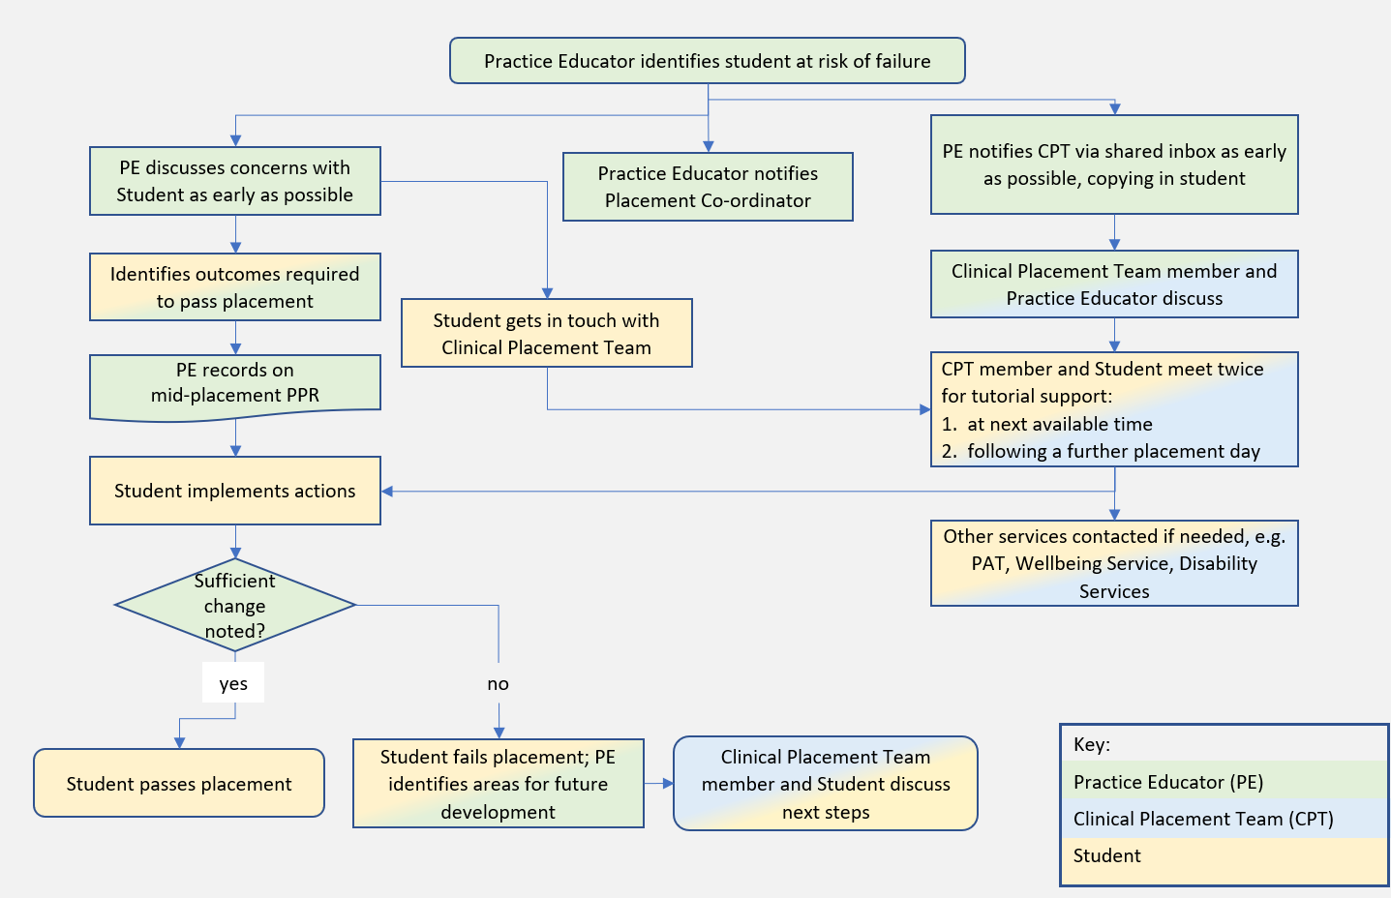
END OF HANDBOOK

