

# Toolkit for Validation and Review: EDI, Decolonising, Sustainability

Introduction  
  
This toolkit is a resource produced by the Learning Enhancement and Academic Development Centre (LEAD) in consultation with other QMU colleagues. The materials are intended to support the course validation and review process and to embed the three strands of social, racial and climate justice that align with the [QMU Student Experience Strategy.](https://www.qmu.ac.uk/about-the-university/quality/committees-regulations-policies-and-procedures/regulations-policies-and-procedures/student-experience-strategy/#:~:text=The%20QMU%20Student%20Experience%20Strategy%20is%20concerned%20with,students%20at%20our%20partner%20institutions%20around%20the%20world.) These are:

* Equality, Diversity, and Inclusion (EDI)
* Decolonising the Curriculum
* Sustainability

It is important to acknowledge that these areas are diverse and complex, that they overlap, have no agreed definition, and have different disciplinary perspectives. To that purpose, this toolkit has been designed to reduce workload and potential anxiety for colleagues. The aim is to suggest practical and focused questions alongside links to further resources to ensure the programme under consideration meets sector-wide benchmarks and institutional requirements and advocates for social justice in learning, teaching, and assessment. A second important objective is to support constructive cross-disciplinary dialogue and provide opportunities to share good practice across the University.

For each strand, this toolkit consists of:

* Overview
* Rationale
* Key questions for validation and review panels
* References and further reading

This toolkit can be used as a stand-alone resource or complement existing resources and practices. Validation and review panel members and programme teams may find that they have specialist knowledge in one area and would benefit from support in others.

There is no such thing as a neutral educational process. Education either functions

as an instrument that is used to facilitate the integration of the younger generation

into the logic of the present system and bring about conformity to it, or it becomes

"the practice of freedom"….’

Shaull in Friere, P. (1970). Pedagogy of the Oppressed. London: Penguin, p.16

‘

Authors: Vikki Hill, Paola Tisi, Dawn Martin, Mike Pretious.   
The LEAD Centre thanks staff and students who have contributed to the development of this resource.

# Support for Embedding Equality, Diversity, and Inclusion

## What is EDI?

Equality is about ensuring everybody has access to equal and fair opportunity, and ensuring that individuals, or groups of individuals, are not treated less favourably because of their “protected characteristics” or background. Diversity is about recognising, respecting, and celebrating the differences between people and groups of people. Inclusion is about creating an environment where everyone feels valued and a sense of belonging as their authentic selves, and where a diversity of perspectives and differences is welcomed and encouraged.

|  |
| --- |
| The following are the legally protected characteristics, under The Equality Act 2010:  Age Race  Disability Religion or belief  Gender reassignment Sex  Marriage and civil partnership Sexual orientation  Pregnancy and maternity |

Under the Public Sector Equality Duty, the University must have due regard to the need to:

1. Eliminate unlawful discrimination, harassment, and victimisation.
2. Advance equality of opportunity by having due regard to removing or minimising disadvantage, meeting the needs of a particular group that are different from the needs of others and by encouraging participation in public life; and
3. Foster good relations by tackling prejudice and promoting understanding.

It is important to consider an intersectional approach. Intersectionality recognises that people's lives and experiences are often shaped by many factors, rather than just one. Many people have multiple protected characteristics, meaning they may experience discrimination in more or different ways.

## Why does it matter?

Embedding or “mainstreaming” equality, diversity, and inclusion into the core of all aspects of QMU’s work and day-to-day activities is one of the ways in which the University meets its legal requirements to the Equality Act. The importance of EDI activities, however, goes far beyond complying with our legal duties. EDI contributes to widening access to education and creating a better society through education, research, and innovation and by providing a supportive and creative learning environment in which all students and staff can thrive. Welcoming and encouraging diversity of perspectives brings value and enriches our programmes, communities, and culture, and considering EDI in our learning and teaching practices ensures better accessibility and encourages active participation of all students.

## Key question prompts for teams and validation and review panels

The following questions have been added to the validation and review checklists to allow panel members to support programme teams to review and reflect on progress in embedding or mainstreaming EDI into the course. Teams preparing for validation and review will also want to reflect on these questions when designing their programme.  
  
The overarching question included in the checklists is:

*Does the Programme centre Equality, Diversity, and Inclusivity with an intersectional lens across programme and module materials, learning outcomes, curriculum content and assessment design?*

Some indicative follow-up question prompts for both Teams and Panels to consider are suggested below:

|  |  |  |  |  |
| --- | --- | --- | --- | --- |
|  | Yes | No | Protected characteristics / intersectional | Where? |
| Is a wide definition of disciplinary specific EDI acknowledged across indicative content? |  |  |  |  |
| Are any potential exclusionary aspects of the programme addressed? |  |  |  |  |
| Is EDI knowledge and practice mainstreamed for the whole cohort experience? |  |  |  |  |
| Are there any approaches/ practices/ examples that could be shared across QMU? |  |  |  |  |

## References and further reading

* The [Inclusive Learning, Teaching and Assessment SharePoint](https://qmu.sharepoint.com/sites/InclusiveLearningTeachingAssessment) site is a developing space for QMU staff to share resources and contributions
* [QMU Equality Policy](https://www.qmu.ac.uk/media/8d890b79e7bc1f6/equality-policy.pdf)
* [QMU University Mainstreaming Equality Reports](https://www.qmu.ac.uk/about-the-university/equality-and-diversity/mainstreaming-report-equality-outcomes-and-employee-information/)
* [Equality Act 2010](https://www.legislation.gov.uk/ukpga/2010/15/contents)
* [Public Sector Equality Duty](https://www.equalityhumanrights.com/en/advice-and-guidance/public-sector-equality-duty)
* [AdvanceHE Embedding Equality, Diversity and Inclusion](https://www.advance-he.ac.uk/knowledge-hub/embedding-equality-diversity-and-inclusion-curriculum-programme-standard) Guidance

# Support for Embedding Decolonising the Curriculum

## What is Decolonising?

Decolonising has different interpretations and can be understood in different ways. Decolonising involves interrogating institutional and structural legacies of colonialism and challenging their impact on knowing and being. Decolonising involves readdressing cultures of exclusion and taking action to change Eurocentric perceptions.

‘To decolonise is to fundamentally transform knowledge production. It means that the unquestioned value systems that govern what knowledge is, how it is produced and who is allowed to be a knowing and knowledgeable agent must be radically reshaped.’

Emejulu, A. (2019), p. 204

## Why does Decolonising matter?

Decolonising is the process of deconstructing existing hierarchies, exploring multiple knowledge systems and ways of knowing and being. By amplifying underrepresented voices and considering knowledge within cultural, historical, and geographical contexts, decolonising the curriculum can support all students and staff to feel a sense of belonging. Decolonising the curriculum is considered a transformative approach across higher education to address inequitable experiences and awarding differentials (or attainment gap) that persist between Black, Asian, and Minority Ethnic students and White students whilst at the same time benefiting all students.

This information has been amended from the [QMU Decolonising SharePoint site](https://qmu.sharepoint.com/sites/DecolonisingQMU), which houses resources and toolkits that are disciplinary specific.

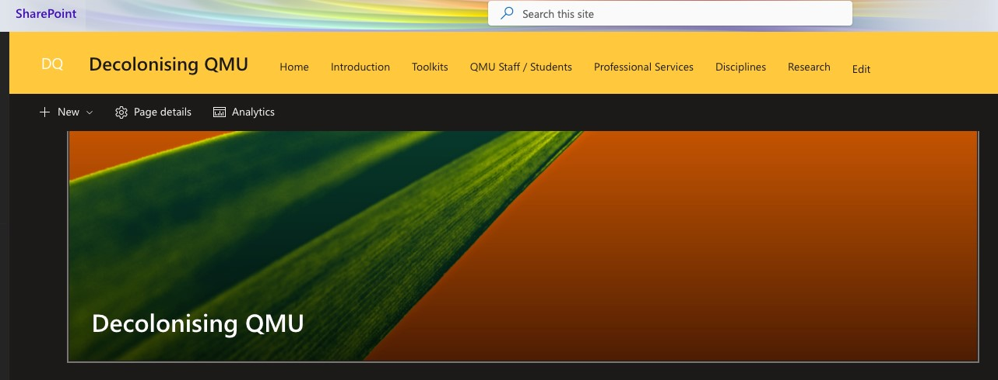

## 

## Key question prompts for teams and validation and review panels

The following questions have been added to the validation and review checklists to allow panel members to support programme teams to review and reflect on progress in embedding or mainstreaming EDI into the course. Teams preparing for validation and review will also want to reflect on these questions when designing their programme.

The overarching question included in the checklists is:

*Does the Programme offer opportunities to examine and explore the impact of colonialism and work in partnership with students to embed non-Western histories, perspectives, and practices?*

Some indicative follow-up question prompts for both Teams and Panels to consider are suggested below:

|  |  |  |  |
| --- | --- | --- | --- |
|  | Yes | No | Where? |
| Is the impact of colonialism on the discipline acknowledged across programme and module materials and learning outcomes? |  |  |  |
| Do reading lists include sources from the Global South and reflect non-Western perspectives? |  |  |  |
| How is a commitment to decolonial practices encouraged through pedagogy and curriculum design? |  |  |  |
| Are there any approaches/ practices/ examples that could be shared across QMU? |  |  |  |

## References and further reading

* A range of resources are hosted on the [Decolonising QMU SharePoint site](https://qmu.sharepoint.com/sites/DecolonisingQMU).
* Bhambra, G.K., D. Gebrial and K. Nişancıoğlu (eds.) (2018) *Decolonizing the University* (Pluto Press: London)
* Dei, G. (2016). Decolonising the University: The Challenges and Possibilities of Inclusive Education. *The Journal of the Society for Socialist Studies*. 11 (1) p. 23-61.
* Emejulu, A., (2019). Can political science decolonise? A response to Neema Begum and Rima Saini. *Political Studies Review*, 17(2), pp.202–206.

# Support for Embedding Sustainability

## What is Sustainability?

The concept of sustainability is widely contested across cultures, disciplines, historical and political contexts. At its most basic level, it is about the capacity to preserve ways of doing and being, but emphasis is also placed on the interactions of human, economic, social, and environmental concerns. Education for Sustainable Development (ESD) offers opportunities to explore practices, research and values that support our staff and students to work actively towards peace and prosperity for people and the planet, for now and the future. UNESCO (2021) defines ESD as:

‘…the process of equipping students with the knowledge and understanding, skills and attributes needed to work and live in a way that safeguards environmental, social and economic wellbeing, in the present and for future generations.’

## Why does Sustainability matter?

Sustainability requires us all to be participants by urgently reducing inequality, eradicating poverty, improving health and education, tackling climate change, and preserving our environment. To this end, the 17 Sustainable Development Goals (SDG’s) developed by the United Nations offer a framework to review curriculum design and provision. The SDGs are below, and you can read more about each goal at the [United Nations Sustainable Development website](https://sdgs.un.org/goals).

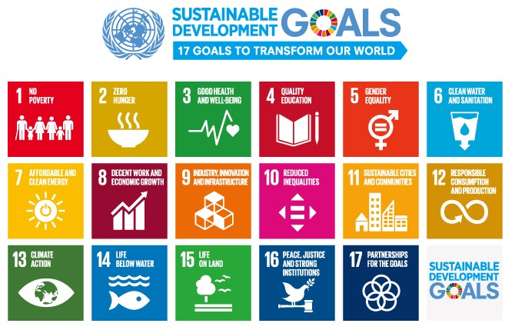

## Key question prompts for validation and review panels

The following questions have been added to the validation and review checklists to allow panel members to support programme teams to review and reflect on progress in embedding or mainstreaming EDI into the course. Teams preparing for validation and review will also want to reflect on these questions when designing their programme.

The overarching question included in the checklists is:

*Does the Programme develop a wide range of sustainability practices, theories, and opportunities (with a focus on Sustainable Development Goals) in the programme and module materials, assignment briefs, learning outcomes, curriculum content and assessment design?*

Some indicative follow-up question prompts for both Teams and Panels to consider are suggested below:

|  |  |  |  |  |
| --- | --- | --- | --- | --- |
|  | Yes | No | SDG/s | Where |
| Is a wide definition of disciplinary specific sustainability acknowledged across indicative content? |  |  |  |  |
| Is sustainability clearly connected to the discipline in the programme materials? |  |  |  |  |
| Will the whole cohort be able to demonstrate application of sustainability practices and theories? |  |  |  |  |
| Do teaching practices display the need for a change in behaviour away from extractive practices towards sustainability? |  |  |  |  |
| Are there any approaches/ practices/examples that could be shared across QMU? |  |  |  |  |

## References and further reading

* [Sustainability Exchange Delivery by the EAUC](https://www.sustainabilityexchange.ac.uk/learning_and_teaching_)
* [Education for Sustainable Development at the University of Sheffield](http://drive.google.com/file/d/1AN0C5Em_HxzdoGLBstQCE2uRBndRmqpo/view?usp=sharing) (The Five-Step Framework for ESD) which has links within it to further resources (p.24 and throughout).
* [AdvanceHE Education for Sustainable Development in Higher Education](https://tinyurl.com/4s5u4f6n)
* A range of resources are hosted on the [Sustainability in Learning, Teaching and Assessment QMU Sharepoint Site](https://qmu.sharepoint.com/sites/SustainabilityinLearningTeachingAssessment)