School/Department/Unit: |  | Work activity:
Assessment completed by: |  | Date completed: | Review Period: N/A
DrumCussac Overall Risk Rating: | Who might be harmed:
This risk assessment should be periodically checked before travel to ensure all the information is current and accurate. Travel approver must be informed immediately if the risk level increases.
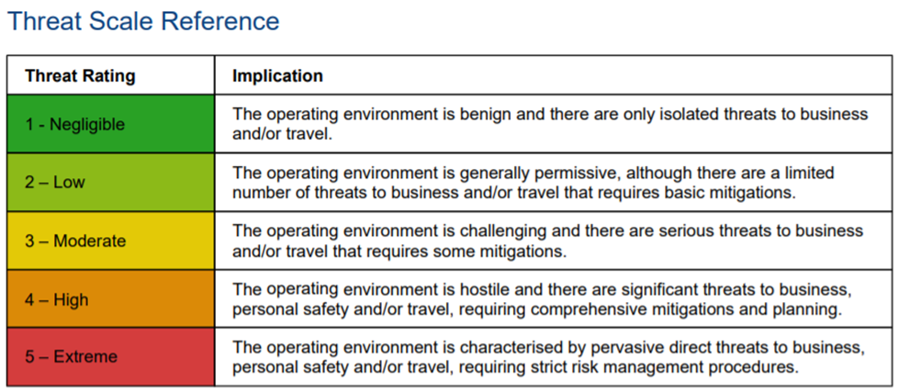

TRAVEL REFERENCE DOCUMENTS
1 | TravelHealthPro | Add webpage reference
2 | DrumCussac Country Report | Attach a PDF copy of the country report
PROPOSED TRAVEL ARRANGEMENTS
 | Departure Location | Date/Time of Departure | Mode of Travel | Arrival Location | Date/Time of Arrival | Airline/Train Ref
1
2
3
4
PROPOSED ACCOMMODATION DETAILS
 | Name of Hotel/Apartment | Address | Tel No. | Website | Check-in Date | Check out Date
1
2
3
COMMUNICATION AND SUPERVISION ARRANGEMENTS
Agree on a reasonable and practicable line of communication for daily/weekly check-ins. Who will you contact and what is your agreed escalation process in the event of an emergency? If a family member is acting as your point of contact, they must be provided with the contact details of your line manager or appointed member of staff at QMU. These arrangements should be detailed here.

 |  | Severity |  |  |  | Risk Level | Action Category | Description
Likelihood |  | LOW  (Minor) | MEDIUM  (Major) | HIGH  (Fatal) |  | LOW | Acceptable  (Monitor) | No further actions needed
 | HIGH  (Almost Certain) | MEDIUM | HIGH | HIGH |  | MEDIUM | Tolerable  (Manage) | Implement and manage the control measures to eliminate or reduce the risks.
 | MEDIUM  (Quite Likely) | LOW | MEDIUM | HIGH |  | HIGH | Unacceptable  (Take Action) | Stop the activity immediately and take action to implement suitable control measures.
 | LOW  (Not Very Likely) | LOW | LOW | MEDIUM |  | Likelihood (L) x Severity (S) = Risk Level

 | Risk Area | Control Measures | Any further action required? | Likelihood (L/M/H) | Severity (L/M/H) | Risk Level
SECURITY
1 | Use DrumCussac report to identify security hazards. |  | - Ensure the Global Risk Manager App is downloaded and trialled before travel.  - A modern smartphone capable of running the GlobalRiskManager App should be carried and kept fully charged.  - Complete the Drum Cussac E-Learning on the Travel Prepare website:  https://travelprepare.drum-cussac.net/login/self-registration.php
POLITICAL
2 | Use DrumCussac report to identify political hazards.
INFRASTRUCTURAL
3 | Use DrumCussac report to identify infrastructural hazards. |  | - GlobalRiskManager App can be used to track your movements and allow you to check in and out.  - Carry additional water and first aid kit in your hire car in case of accident or breakdown in a remote area.
ENVIRONMENTAL
4 | Use DrumCussac report to identify environmental hazards. |  | - Ensure you carry a copy of our emergency contact numbers and a mobile phone with a full battery and suitable network coverage and data.
MEDICAL
5 | Use DrumCussac and Travel Health Pro reports to identify medical hazards. | - In the event of an emergency whilst travelling, call IMG for advice and assistance. This service is operated by a team of multi-lingual coordinators at IMG in the UK, who can be contacted 24 hours a day, 365 days a year. IMG will assist you with your requirements and decide on the most appropriate course of action to help you through an emergency. Should you need to use this service whilst travelling, the contact details are:  Tel: +44 (0)2920 662425  E-mail: UMAL@global-response.co.uk  Reference: UMAL/174  Contact IMG before incurring any substantial medical expenses or being admitted as an inpatient at any hospital, clinic or nursing home. Do not arrange repatriation without the prior approval of IMG. Medical expenses over £300 and any repatriation expenses will not be covered without the prior approval of IMG. | - Consider carrying a travel first aid kit and receive the necessary training to become competent.  - Download the CitizenAID App to help deal with emergency incidents.
ACCOMMODATION
6 | Are there any hazards relating to your accommodation? |  | - Travel door locks are available to increase room door security.
TRAVEL DOCUMENTATION
7 | Ensuring the appropriate passports, visas, permits and travel insurance is in place.
PERSONAL HEALTH AND WELLBEING
8 | While travel can be enjoyable, it can sometimes be challenging. There are clear links between mental and physical health, so looking after yourself during travel and when abroad is important. Information on travelling with mental health conditions is available in our guidance page. Further information is also available from the National Travel Health Network and Centre (NaTHNaC). |  | - Any pre-existing physical or mental health conditions which may impact the traveller’s ability to travel safely should be discussed with their line manager and finance. This will ensure adequate travel insurance can be provided and the appropriate control measures are in place to protect the traveller’s safety.
FIELDWORK
9 | Detail specific fieldwork-related hazards here e.g. Equipment use, working in remote or hostile areas, inherently dangerous activities (climbing, diving, caving, digging).

TRAVEL PREPARE E-LEARNING
I have completed the following modules (All mandatory except female traveller security):
Basic Travel Security Awareness | ☐ | Natural Disasters | ☐
Natural Disasters | ☐ | Information Security Abroad | ☐
Avoiding Bribery and Corruption when Travelling | ☐ | Kidnap for Ransom | ☐
Female Traveller Security | ☐

TRAVEL APPROVAL
I am fully aware of the hazards related to my travel and this risk assessment details the reasonable and practicable steps I have taken to control the risks.
Traveller Name: |  | Signature: |  | Date:
Line Manager/Supervisor Name: |  | Signature: |  | Date:
HoD Name (>3.5 Risk Rating) |  | Signature: |  | Date:
Dean Name: (>4.5 Risk Rating) |  | Signature: |  | Date:

