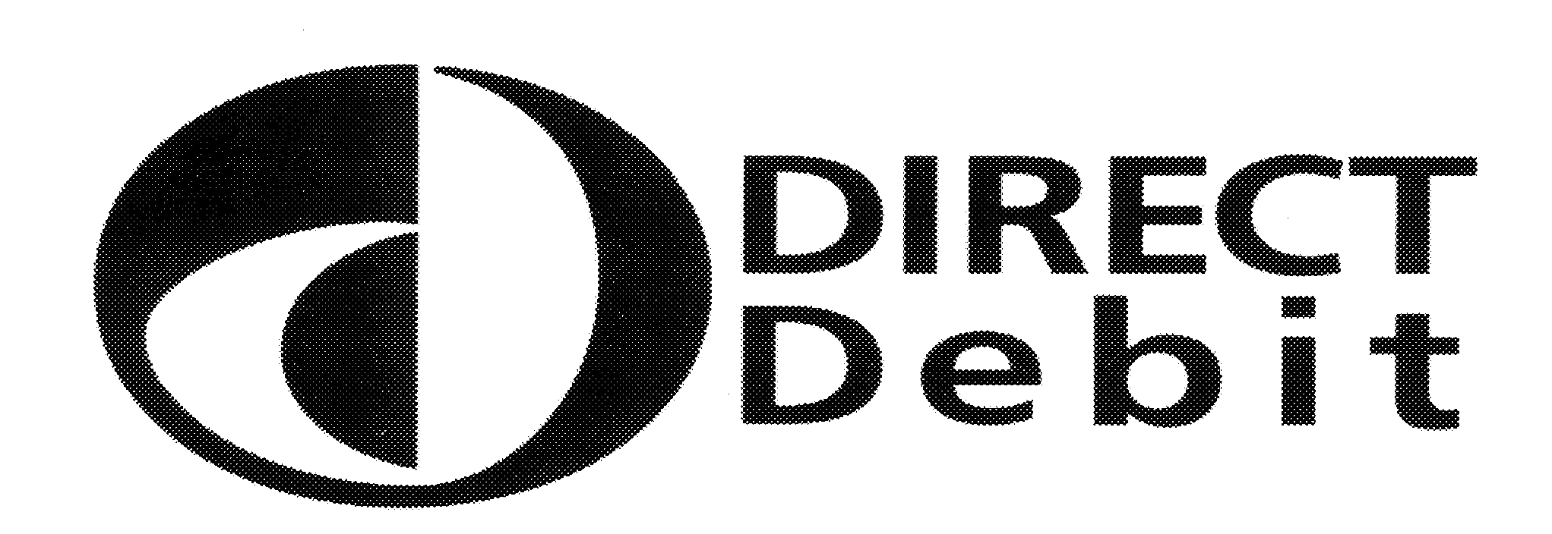
Instruction to your Bank or Building Society to pay by Direct Debit
Please fill in the whole form using a ball point pen and send to:
Membership Type:-
Student / Staff / Public / Concession
Monthly Sports Membership fee £…….…
Originator’s Identification Number
8 | 0 | 9 | 1 | 6 | 9

Sports Department
Queen Margaret University
Queen Margaret University Drive
MUSSELBURGH
EH21 6UU

Member Name
Instruction to your Bank or Building Society
Please pay Queen Margaret University Direct Debits from the account detailed in this Instruction subject to the safeguards assured by the Direct Debit Guarantee.
I understand that this Instruction may remain with Queen Margaret University and, if so, details will be passed electronically to my Bank/ Building Society.
I agree that by submitting this form I am becoming a paying member of your facilities until I advise you otherwise.

Member Address
Address
Postcode

Account Holder(s) Name

Please note the minimum membership period is 3 months, after which your membership can be cancelled by giving notice in writing to the above address. You will be required to provide us with 1 further payment after advising us of your cancellation.

Any missed payments will result in your membership being stopped immediately and will be reinstated once payments have been brought up to date.
Memberships will run continuously until cancelled.
Bank/Building Society account number

Branch Sort Code

Name and full postal address of your Bank or Building Society
To: The Manager Bank / Building Society
Address
Postcode

Sign

Date

----------------------------------------------------------------------------------------------------------------------------------------------------------------------------------------------
This guarantee should be detached and retained by the payer.
The
Direct Debit
Guarantee
This Guarantee is offered by all banks and building societies that accept instructions to pay Direct Debits
- If there are any changes to the amount, date or frequency of your Direct Debit Queen Margaret University will notify you
- 5 working days in advance of your account being debited or as otherwise agreed. If you request Queen Margaret University to collect a payment, confirmation of the amount and date will be given to you at the time of the request.
- If an error is made in the payment of your Direct Debit, by Queen Margaret University or your bank or building society, you
- are entitled to a full and immediate refund of the amount paid from your bank or building society - if you receive a refund you are not entitled to, you must pay it back when Queen Margaret University asks you to
- You can cancel a Direct Debit at any time by simply contacting your bank or building society. Written confirmation may be required. Please also notify us.

