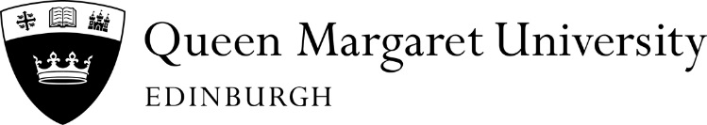  Please fill in the whole form using a ball point pen and send to: |  |  |  |  |  |  |  |  |  | Instruction to your Bank or Building Society to pay by Direct Debit
Finance Department  Queen Margaret University  Queen Margaret University Drive  MUSSELBURGH  EH21 6UU |  |  |  |  |  |  |  |  |  | Please enter the full ACCOM FEE less your £250 prepayment – if this has already been paid to QMU  Accommodation £…………..  Tuition £…………..  (ONLY REQUIRED IF YOU ARE SELF FUNDING)  Plan A or B ……………  See over for details  Originator’s Identification Number
 |  |  |  |  |  |  |  |  |  | 8 | 0 |  | 9 |  | 1 |  | 6 |  | 9
Student Name |  |  |  |  |  |  |  |  |  | Student Matriculation Number
Name (s) of Account Holder(s) |  |  |  |  |  |  |  |  |  | Instruction to your Bank of Building Society
Bank/Building Society account number |  |  |  |  |  |  |  |  |  | Please pay Queen Margaret University Direct Debits from the account detailed in this Instruction subject to the safeguards assured by the Direct Debit Guarantee.
 |  |  |  |  |  |  |  |  |  | I understand that this Instruction may remain with Queen Margaret University and, if so, details will be passed electronically to my Bank/ Building Society.
Branch Sort Code
Name and full postal address of your Bank or Building Society |  |  |  |  |  |  |  |  |  | Signature(s)
To: The Manager Bank / Building Society

Address
Postcode |  |  |  |  |  |  |  |  |  | Date

Banks and Building Societies may not accept Direct Debit Instructions for some types of accounts – ie Savings Accounts

You will require a UK Sterling Current Account to set up a Direct Debit

OCTOBER 2024 – MAY 2025

This guarantee should be detached and retained by the Payer.

The
Direct Debit
Guarantee
This Guarantee is offered by all Banks and Building Societies that accept instructions to pay Direct Debits.

- If there are any changes to the amount, date or frequency of your Direct Debit Queen Margaret University will notify you 5 working days in advance of your account being debited or as otherwise agreed. If you request Queen Margaret University to collect a payment, confirmation of the amount and date will be given to you at the time of the request.
- If an error is made in the payment of your Direct Debit Queen Margaret University or your bank or building society, you are entitled to a full and immediate refund of the amount paid from your bank or building society – if you receive a refund you are not entitled to, you must pay it back when Queen Margaret University asks you to.
- You can cancel a Direct Debit at any time by simply contacting your bank or building society. Written confirmation may be required. Please also notify us.

Completed DD Mandates should be returned to the Finance Office a MINIMUM of 15 working days before the Collection Date, preferably as early as possible.

PAYMENT DATES

PLAN A PLAN B

9th October 2024 31st October 2024
8th November 2024 29th November 2024
9th December 2024 31st December 2024
9th January 2025 31st January 2025
10th February 2025 28th February 2025
10th March 2025 31st March 2025
9th April 2025 30th April 2025
9th May 2025 30th May 2025

