Turnitin allows submissions to be made electronically. This means that you do not need to submit your assessment on paper. Instead the submission is made through the Hub module area though a Turnitin Drop-box, created by the School Office.
Important note
This guide is in reference to your final submission drop-box. A ‘Similarity Checking Tool’ is also available in the Plagiarism & Referencing area of each Hub module area for checking draft assignment referencing. Drafts files in the Similarity Checking Tool are considered as drafts and are not marked by academic staff. For final submission, please follow the below instructions.
- Save your assignment as a file in one of the following formats .doc, docx or .pdf
- When saving the file ensure you name it with only your Student ID number and module code e.g. 0123456- N1234.doc
- Login to the Hub at https://hub.qmu.ac.uk/
- Select the module from your ‘My Courses’ list
- In your module area, select Assignments in the left-hand navigation menu (in some modules this maybe named differently e.g. Assessments)
- You should see a link the QMU assessment regulations and instructions. Read the instructions relating to your submission and then select the Mark Reviewed button immediately underneath.

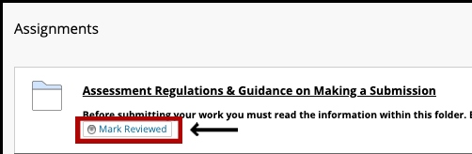

- Click the assignment drop-box link
- Select View/Complete
- The Turnitin assignment opens
- Please read the assignment instructions provided by your tutor.
- The current Status, Start Date and Due Date for the assignment are displayed.
- The Post Date is when your marks and feedback will be available if your tutor marks your assignment online.
- Click Submissions Inbox to see any previous submissions you've made (if your tutor has set up the assignment so that you can overwrite your submissions until the due date)
- Click the blue Submit button to start a new submission.

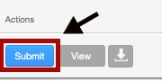
- You will find that the name boxes are automatically populated. In the Submission title box please type only your Student ID number:
- Select ‘Choose from the computer’ and in the following prompt select your final submission file saved previously. We recommend you submit your submission as a .doc or .docx
- Select the blue Upload button
- A loading screen will then appear while the file uploads
- Once uploaded a confirmation screen will appear
- You MUST select the blue Confirm button to complete your submission

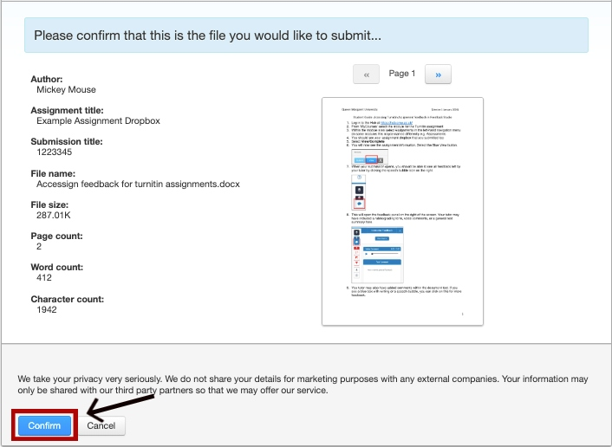
- You will now see a digital receipt to confirm your submission.
- You will also receive an email to your QMU email account with your receipt details. Ensure you keep this as this, as proof of submission, the School Office may request the information contained within it.
Important note:
Electronic submission of your assignment should be completed prior to the deadline set to ensure your submission is accepted. Leave yourself plenty of time to upload the document and submit.

After the submission deadline the Dropbox will close and another drop-box will be available for Late submissions, Extensions and ILPs. The submission process for this is the same. Should you need further help regarding the assessment process please contact schooloffice@qmu.ac.uk

