Feedback Studio is a tool to mark Turnitin Assignments electronically. This means that you do not need to collect a physical copy of your feedback from the school Office. Instead the feedback is made available by the School office once the Module tutors have completed marking. This allows for easy access and prompt release of your feedback, which can help you in your future submissions.

- Log in to the Hub at https://hub.qmu.ac.uk/
- From ‘MyCourses’ select the module for the Turnitin assignment
- Within the module area select Assignments in the left-hand navigation menu (in some modules this maybe named differently e.g. Assessments)
- You should see your assignment drop-box that you submitted too
- Select View/Complete
- You will now see the assignment information. Select the Blue View button.

- When your submission opens, you should be able to see all feedback left by your tutor by clicking the speech bubble icon on the right.

- This will open the feedback panel on the right of the screen. Your tutor may have included a rubric/grading form, voice comments, or a general text summary here.

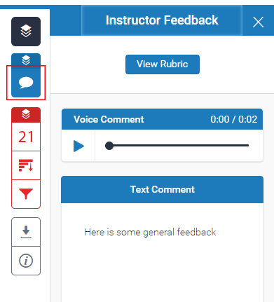

- You tutor may also have added comments within the document text. If you see a blue box with writing or a speech bubble, you can click on this for more feedback.

- You can click the information icon in the panel on the right to see how many comments your tutor has left. This reveals all feedback left by your tutor.

Other types of feedback that you might see are explained below:
- QuickMarks are blue boxes containing text. Hover over them to get more detailed feedback. A speech bubble icon indicates text comments and a speech bubble with a grid icon means that your tutor has linked the feedback to a rubric or grading form.
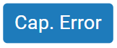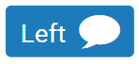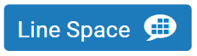
- Bubble comments are blue boxes containing speech bubble icons. Hover over them to get more detailed feedback. A speech bubble with a grid icon means that your tutor has linked the feedback to a rubric or grading form.
- ​Inline Comments appear as italic blue text on your submission.
- Strikethrough text. Your tutor may have used the strikethrough feature to let you know that parts of the document are unnecessary or need more work.
- Text Comments are located on the right panel of Feedback Studio and often provide a summary of the feedback and a comment on the submission as a whole.
- Voice Comments appear above the text comments on the right of Feedback Studio. Click the play button to listen to the feedback.
- Rubrics and Grading Forms. If your tutor has used a rubric or grading form to mark your work, you can access this by clicking the speech bubble icon in the panel on the right of Feedback Studio, then View Rubric.

