MSc Speech and Language Therapy

POSTGRADUATE PRACTICE PLACEMENT HANDBOOK

CONTACT INFORMATION

All Speech and Language Therapy practice placements are organised by the Placement Team which includes academic and administrative staff. The team uses two generic email addresses for all communication:

SLTSemesterPlacements@qmu.ac.uk for correspondence related to within semester practice placements

SLTSummerPlacements@qmu.ac.uk for correspondence related to summer practice placements

Practice Educators and students are encouraged to contact the placement team through the appropriate generic email address if they have any queries or concerns. The mailbox is checked daily Monday-Friday and we try to respond to emails as quickly as possible.

CONTENTS
1 | CONTEXT | 5
1.1 | Design and structure of the programmes | 5
1.1.1 | RCSLT Core Capabilities | 5
1.1.2 | Programme Structure | 6
1.2 | Overview of the Professional Practice Strand | 6
1.2.1 | Level 1 | 6
1.2.2 | Level 2 | 6
1.3 | Structure of Practice Placements | 7
1.4 | Additional Guiding Documentation | 7
2 | ORGANISATION | 8
2.1 | Locations | 8
2.2 | Offers | 8
2.3 | Allocations | 9
2.4 | Expenses | 10
3 | PLACEMENT GOVERNANCE | 10
3.1 | Verification of Student Identity | 10
3.2 | Declaration of Disabilities | 10
3.3 | The PVG Scheme | 11
3.4 | Professional Indemnity Insurance | 11
3.5 | Health Checks | 11
3.6 | Fitness to Practice | 11
3.7 | Self-Declaration of Knowledge and Understanding | 12
3.8 | Record of Attendance | 12
3.9 | Assessment | 12
3.10 | Extended Absence | 13
3.11 | Raising Concerns | 13
4 | STUDENTS’ RESPONSIBILITIES | 13
4.1 | Pre-requisites | 13
4.2 | General Professional Expectations | 13
4.2.1 | Attendance | 13
4.2.2 | Punctuality | 13
4.2.3 | Uniform | 14
4.2.4 | Identification | 14
4.2.5 | Communication | 14
4.2.6 | Documentation | 14
4.3 | Prior to placement | 15
4.4 | First Day of placement | 15
4.4.1 | Placement Pack | 15
4.4.2 | ID Check | 15
4.4.3 | Student Information Form | 15
4.5 | Clinic Organisation and Administration | 15
4.6 | Managing Data | 15
4.6.1 | Confidentiality | 15
4.6.2 | Client Records | 16
4.7 | Placement Activities | 16
4.7.1 | Session Plans | 16
4.7.2 | Reflection | 17
4.7.3 | CPD | 18
4.7.4 | CPD Diary | 18
4.7.5 | CPD Activities | 18
4.7.6 | CPD Days | 18
5 | ASSESSMENT | 18
6 | FINAL DAY OF PLACEMENT | 18
6.1 | Assessment and feedback | 19
6.2 | Attendance Form | 19
6.3 | Gifts | 19
6.4 | Evaluation | 19
7 | THE PRACTICE EDUCATOR’S ROLE | 20
7.1 | Induction | 20
7.2 | Inclusive Learning | 20
7.3 | Managing workload | 20
7.4 | Availability | 20
7.4.1 | CPD Days | 21
7.5 | Support students’ acquisition of clinical skills | 21
7.6 | Assessment | 23
7.6.1 | Practice Placement Report | 23
7.6.2 | Midway review | 23
7.6.3 | Concerns about Student Development and Performance | 23
7.6.4 | Final day review | 24
7.7 | Awarding a grade band | 24
Appendix 1  Appendix 2  Appendix 3  Appendix 4  Appendix 5  Appendix 6  Appendix 7 | Structure of the Undergraduate Programmes  RCSLT Practice-based Learning Roles & Responsibilities Framework  Flowchart to support raising and escalating concerns  Session Plan guidance and proforma  Reflective Writing  Suggested CPD activities  Health and Safety | 25  26  29  30  38  39  47

Setting the context for slt practice placements at QMU
This handbook provides an overview of the QMU Speech and Language Therapy programmes and the processes involved in practice placement provision. The handbook is intended for students, Practice Educators (PEs) and organisations who host practice placements.

Practice-based learning is a vital part of SLT students’ training and, as recognised by RCSLT in the Practice-based Learning Roles and Responsibilities Framework (RCSLT 2020), quality practice-based learning is dependent upon successful engagement and interaction between HEIs, Service Managers, Placement Coordinators, Practice Educators and students.

Design and structure of the programmes

RCSLT Core Capabilities
The design of the SLT programmes at QMU is guided by the RCSLT curriculum guidelines (2018) using the structure provided by the core capabilities, which serve to provide a thematic coherence across all years of the programme. These capabilities are:
- Communication
- Partnerships
- Leadership and lifelong learning
- Research and evidence-based practice
- Professional autonomy and accountability.
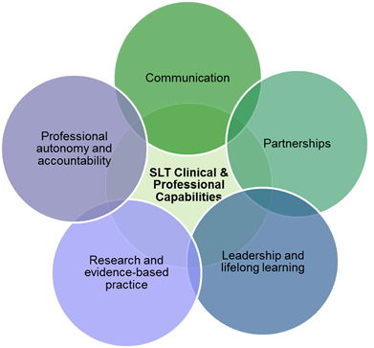

RCSLT (2018) states that “these core capabilities act as a guide from the start of becoming an SLT, through to the newly qualified period and as an ongoing reference point for shaping the lifelong learning of the speech and language therapy practitioner as part of their CPD.” Therefore, the capabilities have also been used to provide structure to the assessment of students’ performance on their practice placements.

Programme Structure
SLT practice is underpinned by the integration of knowledge and understanding drawn from a wide range of disciplines, including linguistics, biological and medical sciences, sociology and psychology, as well speech and language pathology. The curriculum content therefore aims to strike a balance between the need for a strong applied scientific basis that draws on all of these disciplines to underpin the unique role of the SLT and a sound skills base, in line with expectations of all HCPC registrants.
To reflect this balance, all the SLT programmes at QMU have four strands:
- Foundations for SLT
- Research
- Speech and Language Pathology
- Professional Practice
Successive modules serve as building blocks within each strand, whilst the programmes demonstrate a clear shift from the initial foundational modules to a strong focus on professional practice as students near graduation. The full programme structure of each programme can be found in Appendix 1.

Overview of the Professional Practice strand by programme level
The Professional Practice Strand, which includes all the practice-based learning experiences and associated teaching, focuses on the development of professional skills to prepare the students for SLT practice.

Level 1
Professional Practice in Level 1 commences with the introductory module Professional Practice: Clinical and Professional Capabilities. This serves to introduce students to the RCSLT Core Capabilities; the HCPC Standards of Conduct, Ethics and Performance; and the HCPC Standards of Proficiency which form the foundations of teaching and practical experience throughout the programme. Additionally, as part of this module, students will complete the pre-placement passport of mandatory training activities, this learning is shared as part of the IDEAL strand. They will also be introduced to the continuing professional development (CPD) diary, which is based on the format of the RCSLT CPD diary. Practice based learning experiences also begin in Level 1 Semester 1 with a Peer-enhanced Electronic Placement (PEEP) and a Community Partnership Placement (2022 entrants onwards), a voluntary elective placement in a third sector organisation. In Semester 2, students undertake their first assessed clinical placement, followed by an experiential placement in the summer between years 1 & 2.

Level 2
In Level 2 of the programme, students undertake a further 2 assessed semester placements and an experiential summer placement at the end of the programme. Running alongside this are Professional Practice modules on “Training and leadership” and “Applied clinical decision making” both of which are designed to cement the autonomous and reflective thinking skills that will be required of students when they graduate and commence on the NQP competency framework. Additionally, Professional Practice module “Delivering services that reflect diversity” and gives students the opportunity to reflect on the application of theory to practice in the development and delivery of SLT services that meet the needs of those from culturally, linguistically and socially diverse backgrounds.

Structure of Practice Placements
The content and structure of the professional practice strand ensures that, on completion of the programme, students will have met the mandatory placement hours required by RCSLT. These comprise a minimum of 100 sessions (350 hours) of practice placement under the direct supervision of a qualified SLT, of which at least 30 sessions must be with paediatric and 30 with adult client groups. In addition, a further 50 sessions (175 hours) are required which may include: further SLT supervised practice placement sessions; placements in alternative settings; practice placement related activities; and experiences.

Practice placements occur as follows:
Level 1: 20 sessions of within semester practice placement
30 sessions of summer block practice placement
Level 2: 40 sessions of within semester practice placement
30 sessions of summer block practice placement
Total: 120 sessions

*In Scotland, a session equates to 3.75 hours.

The remaining 30 sessions are completed as part of the Community Partnership Placement, Peer-enhanced electronic placement (PEEP) and other campus-based activities.

Additional Guiding Documentation
In addition to the RCSLT Curriculum Guidelines (2018), development of the practice placement structure, content, documentation and policies is guided by the following resources:
- HCPC Standards of Conduct, Performance and Ethics
- HCPC Student Standards of Conduct and Performance
- HCPC Standards of Education and Training (SETs)
- HCPC Standards of Proficiency (SOPs)
- RCSLT (2020) Practice-based Learning Guidance
- RCSLT (2020) Practice-based Learning Roles and Responsibilities Framework (See Appendix 2)
- RCSLT Continuing Professional Development Diary

Organisation of practice placements
At QMU, practice placements are all organised through the placement team in consultation with local Placement Coordinators (PCs). PCs are SLTs nominated by individual health boards to oversee the local management of student placements and are responsible for requesting and collating placement offers from their SLT team(s) in accordance with the Practice Placement Agreement (PPA). Additional roles of the PC vary between health boards to accommodate local policy, practice and need.
To preserve the integrity of the process, students should never make direct contact with a PC or individual SLT to seek a placement.

Locations
Practice placements which take place during the semester are based within the local catchment area of the Borders, Fife, Forth Valley, Lothian and the closer parts of Tayside, to facilitate feasible travel demands.

The majority of summer practice placements take place both within local catchment and in some more distant parts of Scotland including Dumfries and Galloway, Grampian, Highland, Orkney, Shetland and the Western Isles. Students should be aware that it is generally difficult to source placements in areas of England, Wales, Northern Ireland and Eire that already have a commitment to provide placements for local SLT programmes, so students cannot typically expect to be placed in parts of the British Isles beyond Scotland.

Sometimes a summer placement can be sourced in a student’s home country by special arrangement. Some practice placement providers outside of Scotland require a bespoke legal contract to be signed regarding liability. This applies particularly, but not solely, to placements in North America and Australia, and limits the feasibility of seeking placements in these areas, as the QMU legal team advise that there is a high risk of QMU being unable to underwrite the conditions of the contract.

Offers
Planning for the practice placement cycle commences in February each year and continues until February/March of the following year, ending when summer practice placements have been secured for all students. Services that offer practice placements are asked, via PCs, to make their offers for the year ahead to allow for timely allocations across the year.

At QMU, both ongoing placements (on individual days per week) and block placements (4-5 days per week for several weeks) are sought in order to provide students with a range of learning opportunities. In addition, alongside the traditional 1:1 model of student supervision, RCSLT supports a range of models of practice placement including: peer; long-arm; role emerging; and interprofessional placements. We are keen to work with placement providers to develop models of practice placement that are of benefit to both the students and the hosting services and students may experience a range of placement types over the duration of their studies.

Allocations
Placement availability is dynamic and complex and services are changing rapidly, therefore it difficult to predict the exact pattern and nature of placements that will be available throughout a student’s programme of study and it is not necessarily possible to accommodate individual students’ preferences for location or clinical group.

The allocation process is based on a set of guiding principles, developed to ensure equity of placement provision and experience. These include:

- Fairness to each student/cohort in the allocation process
- Ensuring that every student exits the programme with a well-rounded placement profile that meets the RCSLT requirements
- Consideration of previous placement locations and experiences
- Extenuating/special circumstances, including specific caring responsibilities
- Capacity of practice areas.

Due to the geographical dispersal of placements, it is expected that every student will complete placements involved significant daily travel and/or in the case of summer placements, moving into temporary accommodation. It is acknowledged that some students may have particular needs which in exceptional circumstances can only be supported by the student undertaking their practice placement(s) in a specific location. This may apply to:

- Students with young/school age children, or with other significant family responsibilities such as being the sole carer of a disabled relative
- A disabled student as defined by the Equality Act (2010) who requires a placement within daily travelling distance. This will be specified in their Individual Learning Plan (ILP) agreed with the QMU Disability Advisor.

In such circumstances, the placement allocation is based on the principles of approximately no more than 80 miles daily travelling from term time address. However, this remains dependent on placement availability and cannot disadvantage other students with regards to their required placement balance.

The predictability of the offer/allocation model also enables better balance of individual student experiences across the year. In addition to ensuring that students meet the balance of client group experience required by RCSLT, the allocation model supports students to experience a range of different service models and locations, thus better preparing them for variations in clinical practice. Given the above constraints on allocations, it is not possible to offer students free choice regarding practice placement location or clinical group. However, wherever possible, student preferences for location of their final year and/or summer practice placement are considered as part of the allocation process.

Once a specific placement has been allocated this becomes part of the curriculum offered to the student. Students cannot contest their placement allocations on the grounds of time, travel or financial resources as the placement team cannot make a judgement on one student’s needs being greater than another. Occasionally there may be last minute alterations to allocations due to changes in Practice Educator availability. In such circumstances, the placement team do all that they can to minimise the impact on the student/students.

Allocations for Semester 1 are typically released in August once a student’s progression to the following academic year has been confirmed by the meeting of the Board of Examiners.

Allocations for Semester 2 are typically released to all students in November/December with summer placement allocations following in February/March. Typically, this means that students and practice educators have at least a month’s notice of their upcoming allocation and are therefore able to be prepared for the experience. The placement team will alert PCs and students where any delays to the usual schedule are anticipated.

Travel and accommodation expenses
Students should consider the cost of practice placements as being a necessary element of the programme and should plan for this in advance. Undergraduate students may be able to claim back placement expenses from the Student Awards Agency Scotland (SAAS).
Further information regarding this is available from the SAAS website: http://www.saas.gov.uk/index.htm

The Student Finance Service at QMU administers two discretionary funds provided by the Scottish Government. These are the Childcare Fund which is available to students who incur childcare costs whilst studying and the Hardship Fund for students who find themselves facing exceptional financial difficulties. Students can contact studentfunding@qmu.ac.uk for information on how to make an application.

Placement Governance
This section summarises the range of checks and documents in place to support systematic placement governance. Further information on roles and responsibilities with regards to their completion and submission can be found in later sections of the Handbook.

Verification of Student Identity
This aims to ensure the safety of students, staff and service users by confirming the identity of the student on the first day of placement. PEs should check the student’s identity against their QMU student card. Identify Check Forms are no longer required except for international students when on summer placement, as this forms an important part of the governance regarding their United Kingdom Visa and Immigration (UKVI) status.

Declaration of Disabilities/Individual Learning Plan
Queen Margaret University, supported by policies from RCSLT and HCPC, is committed to equality of opportunity and believes in a culture of diversity and inclusion. Some students on our programme may have a disability and/or medical need that requires support by means of an Individual Learning Plan (ILP). The ILP suggests a package of recommended academic and personal reasonable adjustments adapted to meet a student’s individual needs.

Students with an ILP in place at QMU should be aware that current legislation prevents any member of university staff disclosing this information to PEs in advance of placement, unless the student specifically requests them to do so. It is the student’s decision and responsibility to disclose such information, they are not obliged to do so. However, HCPC advises students to discuss their individual learning needs in full with Practice Educators (PEs) as soon as possible and the Student Information Form provides a structured means by which to do this. Students who are concerned about disclosing such information can seek support from the placement team, their PAT and/or the Academic Disabled Student Coordinator (ADSC) prior to the placement.

The ILP is designed to summarise the range of appropriate reasonable adjustments that may be required to support students to access learning experiences and be assessed equitably. Due to the varied and practical nature of practice placements, how these adjustments can be applied in a particular placement setting can only be determined in discussion between the student and PE. Non-disclosure of this information will impact on the PE’s ability to make any required adjustments. This may in turn affect the student’s ability to access the learning experiences, and therefore place them at risk of being unable to demonstrate their knowledge and skills sufficiently to pass the placement.

The Protection of Vulnerable Groups (PVG) Scheme
QMU retain the legal responsibility for ensuring all students are adequately cleared for placement, which includes a satisfactory PVG certificate. Students are supported to complete and submit the necessary paperwork for their PVG application soon after their arrival at QMU.

Under the management of the Pre-Placement Support Officer (PPSO), there is a robust institutional process in place to monitor this, with a range of risk assessment procedures available to manage any issues arising. No student will arrive for placement without a PVG in place.

Please note: Students should not be expected to show their PVG certificate when they arrive on practice placement. The Protection of Vulnerable Groups (Scotland) Act 2007 and Part V of the Police Act 1997 prevents compulsory sharing of the PVG certificate with anyone other than the authorised counter-signatory and student.

Professional Indemnity Insurance
Due to professional requirements, students on the SLT programme are required to hold professional indemnity insurance as a pre-requisite to progressing to placement. This is most easily gained by joining RCSLT and information on this is provided during induction to the programme. The Placement Passport held by QMU contains evidence of the student’s personal RCSLT membership number.

Health Checks
In 2008 the Scottish Government agreed that all new healthcare workers who have direct contact with patients must undergo a Standard Health Clearance Check before they take up post or, in the case of students, before they are permitted to go on placement (Scottish Government, 2008).

Health Clearance Checks take place on site at QMU. Students are assessed and screened for Tuberculosis (TB), Hepatitis B and Mumps, Measles and Rubella (MMR). Initial Health Clearance Checks and any subsequent follow-up appointments are co-ordinated by the PPSO. Attendance at the Health Clearance Check is compulsory and the cost may need to be covered by the student. Students cannot progress to placement without having attended their Health Clearance Check.

Self-Declaration of Health, Wellbeing and Fitness to Practice

Students self-certify their knowledge and understanding of what is required to be fit for practice and assert their own fitness to practice. They indicate their understanding of the need to inform the University if there is a change in fitness to practice status or factors which may indicate a possible change relating to this. This mirrors the Fitness to Practice Statement all SLTs must sign when renewing HCPC membership. All students will complete this statement in every new academic year they embark upon.

Self-Declaration of Knowledge and Understanding

The QMU Speech and Language Therapy programmes require students to undertake and self-certify key areas of knowledge and understanding prior to commencing their practice placements, aligned to the mandatory requirements of the Practice Placement Agreements for each Health Board. Learning opportunities are delivered through a variety of methods depending on the topic of study and may include e-learning modules, course attendance and scrutiny of policy documents. Learning mirrors core learning that SLTs have to complete to maintain their HCPC registration and includes:
- Professionalism and ethical behaviour
- Information governance/data security awareness
- Child protection
- Adult protection
- Infection control and prevention
- Management of violence and aggression
- Manual Handling
- Fire Safety
- Basic Life Support
- Whistleblowing

A certificate of completion is recorded in the Placement Passport. The Placement Passport is a dynamic document, responsive to the requirements of NHS Scotland Health Boards’ Practice Placement Agreements. Students complete the Placement Passport at the start of the programme and are alerted to any required updates by the QMU Placement Team at placement induction sessions. Students are also encouraged to review and revise their learning throughout their time on the programme.
Students should take evidence of their completed Placement Passport to their first day of placement. Some health boards now ask to see these as part of the induction process. The Placement Passport can also be used by students and PEs as a tool to aid discussion about key professional issues.

Record of Attendance
The attendance form is a formal record of the student’s attendance at placement. It ensures that the student’s record accurately reflects the number of placement sessions which a student has completed and it contributes to the evidence held by QMU that the student has met the RCSLT practice placement requirements.

Supporting students who are resitting a placement
Students must pass a placement in order to progress to the next level of practice placement. If a student fails a practice placement then the placement must be repeated until it is passed. In accordance with QMU regulations, students may have a maximum of three attempts. RCSLT recommends that when a student is undertaking a resit placement, the PE should be informed so that they can best support the student in developing their skills.

Supporting students with extended absence from placement
For a variety of reasons, students may find themselves returning to placement after an extended absence. In these circumstances, RCSLT requires that students are supported to maintain their knowledge and skills. The placement team will provide activities and tutorial support to help the student to prepare. Students are required to engage with this learning and support before returning to placement.

Raising Concerns
If a student has concerns about the safety or well-being of service users or carers during their practice placement, they have a duty to report this. Concerns should be reported to both the PE and the QMU placement team in the first instance where possible, following the steps in the flowchart in Appendix 3. Raising concerns can feel stressful and difficult, but students should be assured that they will not be penalised in any way for raising concerns whilst on a practice placement.

Students’ responsibIlities
To enhance students’ professional development, we support them to take responsibility for a range of practice placement-related preparatory and administrative activities.

Pre-requisites for attending any practice placement
Before commencing their practice placement, students will have:
- The appropriate level of PVG clearance
- Joined RCSLT as a student member
- Professional Indemnity Insurance in place (via RCSLT membership)
- Attended any appropriate Health Checks
- Completed/updated their Placement Passport
- Declared themselves Fit to Practice

General Professional Expectations

Attendance
Students are expected to attend all placement days.
If a student is unable to attend a placement day (e.g. due to illness), they should inform both their Practice Educator and the placement team as soon as possible. The absence must be recorded via the Student Portal and students should also ensure that it is recorded on the Attendance Record form.
Students should be proactive in discussing arrangements with their PE for the remainder of the placement in order to still achieve the required number of placement days and should inform the placement team of the agreed plan. Any alteration to the format of the placement (e.g. requiring them to attend more than one day a week or on a day not specifically designated for placement) should be discussed with the clinical placement team to ensure that it will not impact on other learning opportunities or requirements.
Should exceptional circumstances arise for a student which will impact on his or her attendance at placement, the student should first contact the placement team at QMU to discuss this. The team will then correspond with the PE directly about this.

Punctuality
Punctuality is a key professional requirement for all placements.
Students are required to maintain a degree of flexibility with regards to the time they may be expected to arrive and leave placement, according to the needs of the client/s being seen on a specific day. This will be determined by the PE and students will be advised of any changes from normal.
All students, regardless of the setting, are expected to begin and end sessions on schedule to ensure the smooth running of the service.

Uniform
Students should submit their uniform measurements when requested by the pre-placement support team. They will then be issued with a uniform prior to commencing placement. Whilst it is recognised that for some environments a uniform may not be appropriate, the default is that students are expected to wear their uniform on placement, unless advised otherwise by their PE. Wearing their uniform supports students by ensuring that their clothing for placement meets Health and Safety requirements; does not disadvantage students who may face financial challenges in buying clothes specifically for placement; makes students easily identifiable as such to service users and other professionals. Students are advised to check in advance with their PE whether local infection control policies apply to the placement site which require them to change in to uniform only when on site. In the exceptional circumstances that a uniform is not considered appropriate to the placement, students should adhere to the dress code advised by their PE.

Identification
All students should wear identification in the form of their QMU matriculation card or QMU name badge when on placement, depending on the requirement of the practice setting. Additional site-specific identification may be provided in some cases and students must ensure that this is returned on leaving. Some settings also require all visitors to register on entering and leaving a building.

Communication
Communication is a key aspect of the profession, and SLTs are able to modify and adapt theirs appropriately to the situation. This demonstrates an understanding of the social and cultural context, the appropriate register or tone to demonstrate professionalism, and the level of complexity to support understanding.

Both written and verbal communication should therefore be clear and professional. Language continually evolves, and much online written communication now mirrors informal spoken language. As sophisticated users of language, it is important that SLT students recognise the difference between more and less formal written registers.

In emails to other professionals therefore, students should avoid less formal written language, such as slang, internet abbreviations, or emoticons. The first interaction SLT students will have with their PE is through email, and this is an opportunity to demonstrate interest in and enthusiasm for the placement and to present as a developing professional.

Documentation
Wherever possible, students are required to take responsibility for the documentation relating to their practice placement. Documentation must be submitted to the Canvas course site in a timely manner in order for students to successfully complete the placement module. The submission of placement documentation provides some evidence that students are able to meet the standards set out in HCPC’s Standards for Conduct, Ethics and Performance. Therefore, students who do not meet the Learning Outcomes in this respect will be required to undertake a further piece of written work to demonstrate knowledge and understanding in this area.

Prior to the start of a practice placement
Students should make prompt contact with their confirmed PE/s (or PC if appropriate), as soon as they receive their placement allocation. This is a matter of professional courtesy and allows the student to introduce themselves and gather specific information about the placement including any preparatory work as recommended by the PE. PEs and students are also advised to discuss the best way of notifying each other in the event of a last-minute emergency.
The QMU Placement Team provide a practice placement induction session before every placement. All students are expected to attend and must notify the Module Coordinator if they are unable to, so that they can make up the session.
In addition to completing any preparatory work that their PE has requested, students should also prepare the Student Information Form, ready to discuss with their PE on their first day of placement.

On the first day of a practice placement

Placement Pack
All documentation is now available on the QMU Speech and Language Practice Based Learning webpage QMU Speech and Language Therapy

ID Check
On arrival, students will need to show their matriculation card so that PEs can verify their identity.

Student Information Form
As part of the placement induction, students should be prepared to discuss their Student Information Form with their PE, highlighting their learning objectives and discussing any reasonable adjustments to support their learning.

Clinic organisation and administration
Students must make themselves aware of, and abide by, protocols covering service delivery in their placement setting and establish with their PE their appropriate role within that setting. Discussion will typically cover the PE’s recommendations about duties such as:
- answering the telephone
- writing clinical notes
- filing
- keeping clinical statistics
- other administrative duties

Managing Data

Confidentiality
Students are advised that it is essential to respect the confidentiality of people with whom they come into contact when on placement. Information which could lead to the identification of a client or other people with whom the student is interacting on placement (children, carers, placement hosts, other associated professionals) should never be mentioned in any discussion which could be overheard.

Similarly, any written work produced by students on placement including in paper copy or in electronic format (e.g. on hard drive, memory stick, Dropbox, Google Drive and other cloud based storage) must not contain any confidential information. It is important that you do not write anything that could identify an individual in any way. This includes, but is not limited to, information such as: names; date of birth; address; clinical location. There are practical ways to record such information (e.g. use of pseudonyms in place of names, chronological age instead of date of birth, ‘primary school’ instead of the name of the primary school etc). Students should consider recording only the information that is deemed important. Due consideration should be given to the possibility of ‘jigsaw’ identification, in which information provided may cumulatively lead to identification of an individual (e.g. medical diagnosis – especially if rare, occupation, date of hospital admission etc.) Where pseudonyms are used, these should not be the initials of an individual. All pseudonyms must be clearly marked as such. It is not sufficient to ‘Tipp-Ex’ out or cover over information in order to anonymise it.

Further details are provided in the NHS Code of Practice on Protecting Patient Confidentiality booklet which has been provided by NHS Scotland.
http://www.wdhscp.org.uk/media/1256/revised-code-of-confidentiality-final.pdf
Modules on information governance, data security and confidentiality are included in the Placement Passport students complete before all clinical placements.

Client Records
Client records, or parts thereof, should never be removed or copied without permission from the PE. Information obtained from clinic files is confidential and must be appropriately anonymised prior to leaving the clinical setting.

If a student is struggling with any aspect of their placement at any time, they should discuss it with their PE if possible and/or contact the QMU placement team as soon as possible in order to receive appropriate support and advice.

Placement Activities
The duty of care for all clients lies with the PE, who holds full responsibility for case management. Students undertake assessment and treatment only under the direction of the PE. It is therefore inappropriate for students to take decisions regarding admission, discharge or referral of clients to other agencies, other than in consultation with the PE. However, students are responsible for preparing for and undertaking all clinical activities as directed by their PE.

Session plans
Within the professional practice teaching strand, students are supported to learn how to develop aims and session plans. On placement, students are expected to prepare written plans for each intervention in which they will be involved and to discuss these with their PE before the session begins.

Current SLT models of practice mean that an intervention may involve direct 1:1 assessment or therapy with a client, but may equally involve delivery of an indirect, universal or targeted approach. The student should complete a session plan wherever possible, irrespective of the nature of the intervention, to demonstrate their understanding of the session aims, as well as their ability to plan, identify appropriate contingencies and evaluate the session.

Guidance on the standard QMU structure for session plans is provided in Appendix 4. However, we also recognise that individual PEs may feel that a different approach is better suited to the particular type of service delivery or to a particular student’s learning needs. Students are advised to seek guidance on which type of plan the PE recommends and be aware that their PE might suggest changing formats as the placement continues, to meet the student’s developing learning needs. Students should be adaptable to this and embrace the learning opportunity that this offers to expand their experience. Students should be proactive in developing session plans and in sharing them with their PE for feedback.

Students should be aware that any academic submissions based on clinical work (e.g. assignments which include session plans) will always need to include the basic academic requirements outlined in class (and Appendix 4). This is particularly applicable if the student has learned other ways of session planning on placement which omit some of the core requirements.

Reflection
Reflection is an integral part of professional practice. The theory and practice of reflection is embedded throughout the professional practice strand of the programmes to support students in their development of this skill. A range of reflective tools are explored to enable students to identify those which best match their learning style. Reflection can be a deeply personal process, exploring complex emotions and situations, therefore students are not required to share their reflections with QMU staff or with their PE. However, students are required to complete a minimum of two reflections per placement – one exploring a challenging situation and one in which they experienced a sense of pride or success. Appendix 5 provides guidance on reflective writing.

Continuing Professional Development (CPD)
From the beginning of the programme, we want to foster in students the desire to be life-long learners, whereby professional maturity is achieved through both the work itself and the opportunity to reflect on the learning that has taken place.

CPD Activities
To support students in establishing the practice of CPD and to provide structure to their development, students are required to demonstrate that they have completed a minimum of two CPD activities on every placement. The student should discuss with the PE the activities that they will undertake to meet this requirement. These may be activities that occur naturally as part of the working day, such as report writing, or may be activities which the PE advises as being appropriate to support development of the student’s knowledge and skills in a particular area of practice. Appendix 6 provides examples of some appropriate activities.

Activities should be described in detail and any relevant evidence attached. The student should complete the learning cycle with a short written piece evaluating and reflecting on their learning and the impact it will have on their practice. Students should be proactive in presenting their work to their PE for review and should then update their work and evaluation to reflect any amendments proposed by and agreed with the PE.

CPD Days
Occasionally, it may not be possible for PEs to provide the full number of days required on a placement and they may not be able to arrange alternative activities or supervision for the student. In this instance, the student can spend up to the equivalent of one day (2 sessions) of placement undertaking additional CPD activities. Students should present their completed work to their PE on the next placement day, unless an alternative arrangement is agreed in advance.

CPD days can only be offered at the discretion of the PE and planned in advance. Students should not request, nor can they take, a CPD day on the same day as any sickness (or other) absence.

Assessment of Development and performance
Assessment should be a dynamic and shared process. In developing professional autonomy, students should be proactive in engaging in the process of assessment rather than simply recipients of feedback.

Students should familiarise themselves with the Practice Placement Report (PPR) and use it as the basis for self-monitoring of their learning and development. The student and PE can also use the report as a framework for supervision and feedback throughout the placement. The PPR is used formally at two points during the placement, at the midway review and on the final day of placement.

Prior to the midway and final reviews, students should complete a copy of the document themselves to self-assess their development and performance. Any differences between the student’s self-assessment and the PE’s review of their development and performance can form a useful basis for discussion. On completion of the midway review, students should ensure that they request a copy of the form so that they can use it to guide their learning and objectives for the remainder of the placement.

On the final day of placement

Assessment and feedback
The final day of placement should involve discussion between the student and their PE of the PPR. This is the final opportunity for students to receive feedback on their development and performance during the placement. It is also an opportunity for the student and PE to identify possible learning and development objectives for the student’s next placement or first job, depending on their stage of study.

On completion of the placement and the final review, students should ensure that they have a completed copy of the PPR signed and dated by the PE, which they should then upload to Canvas no later than one week after completion of the placement.

Attendance Form
Students should complete the attendance form as part of the PPR to reflect the true pattern of attendance at placement, so dates of any absences should be noted as well as the dates on which they attended. On the last day of placement, the student should ask their PE to sign and date the form as verification that it is a true record.

Gifts
Students often wish to give PEs a token of their appreciation for the support that they have received during their practice placement. However, in line with NHS and QMU policy and procedures, QMU asks that students do not give gifts to PEs. Students are however welcome to write a card for their PE, expressing their thanks, should they wish to do so.

Evaluation
HCPC standards require that students complete an evaluation following completion of their placement. This will be provided by the Placement Team via an electronic link. It is intended that student evaluations are considered as a whole body of feedback in the continual monitoring of the programme’s practice placement provision. Individual PEs or services may also ask for the student’s feedback on the placement; students are encouraged to provide this after completing the placement and receiving their final report.

The practice educator’s role

Induction to the Practice Placement
PEs are asked to provide the student with an induction to the placement. It is helpful for students to understand the model/s of service delivery they will encounter and the opportunities and experiences likely to be available on the placement. The induction is an opportunity to make students aware of specific requirements of the placement and direct them to any additional service specific policies that they need to read. The placement induction should also include health and safety information appropriate to the setting (appendix 7).

Inclusive Learning
PEs are asked to have a discussion with the student in order to ascertain the student’s learning goals and objectives for the placement. Students at later stages of the programmes may be able to articulate this independently, whilst less experienced students may require the PE’s support to get the most benefit from the discussion. The Student Information Form should be used as a guide for this discussion.

Students with identified disabilities are encouraged to share this information with the PE at the beginning of the placement in order to explore the reasonable adjustments available that the student may find helpful during the placement. The QMU placement team are available to support PEs who have any queries about this.

Managing workload
Practice placement is also an opportunity for students to develop skills in balancing clinical tasks with wider workload. There is an understanding that students will be completing placement-related tasks while not at placement. This may be continually negotiated throughout the duration of the placement between the student and PE to ensure that demands are not excessive, but that sufficient preparation is being carried out. Where there is more than one PE, the student and PEs are asked to maintain open lines of communication so that all parties are aware of the range of demands on the student.

Practice Educator Availability
Wherever possible, PEs are asked to adhere to the prescribed structure and duration of the placement. We recognise that sometimes additional learning opportunities, such as specialist assessment clinics or training sessions, may be available on days other than a placement day and that PEs may want to make this opportunity available to the student, or that a PE’s availability may become more restricted than anticipated and that they may wish to negotiate an alternative model of provision. In order to ensure that changes do not impact negatively on other aspects of the student’s learning, PEs are asked to discuss any such changes with the placement team before agreeing them with the student.

In the event of a planned PE absence, the student can be permitted to carry out any activity which reflects the work of a Speech and Language Therapist (SLT) provided that the PE feels that this is not putting the client, the student or any other people with whom the student is interacting, at risk. What is appropriate for a student in their final placement may not be appropriate for a less experienced student. The student should be provided with clear, written information about who on the premises they can contact in case of difficulties. Where possible the designated contact person should be another SLT. However, another qualified professional who has knowledge of the client and/or knowledge of procedures that apply in the setting would be appropriate (e.g. teacher; day centre manager). Where the site is spread over several buildings, the student should be able to request assistance without having to leave a potentially dependant client on their own and that assistance should be able to reach them quickly.

Please note: It is inappropriate for students to carry out home visits on their own (i.e. in the absence of a qualified professional) at any stage of the programme.

CPD Days
Occasionally, it may not be possible for PEs to provide the full number of days required on a placement. This issue may arise for a variety of reasons (e.g. staff absence, building closure). PEs are asked to consider whether it is possible to host the student in one of the additional available placement weeks or perhaps arrange for the student to spend time with another colleague. If this is not possible, it may be appropriate for students to have up to a maximum of one CPD day on the placement.

In this time, the student should work on some additional CPD activities, not necessarily on the placement site. The CPD day should be recorded clearly on the Attendance Record and the Practice Educator should ask to see the work the student has completed on the next day of placement. For this reason, it is not possible for a student to have a CPD day as the final day of placement, without first contacting the clinical placement team and arranging a clear way for the Practice Educator to review the work that has been completed on this day.

CPD days can only be offered at the discretion of the PE and planned in advance. Students should not request, nor can they take, a CPD day on the same day as any sickness (or other) absence.

Supporting Students’ Acquisition of Clinical Skills

Throughout the Professional Practice strand, lectures, workshops and seminars on campus support the student to develop relevant clinical knowledge and understanding. Placement is the opportunity to translate that knowledge and understanding into practice with the guidance and support of the PE.
The role of the PE is key to fostering the student’s growing confidence and development as an SLT in a safe and supportive environment where ‘mistakes’ are viewed as part of the learning journey.

Every placement will offer different opportunities and every student will have differing strengths and needs. However, all students will benefit from their PE:

- Supporting the student’s confidence by providing a period of observation followed by a gradual inclusion of the student in an increasing direct role in clinical activities.
- Supervising, as appropriate, the student’s direct assessment and intervention with clients and/or others.
- Reading and discussing the student’s session plans and other requested preparatory work, including providing verbal feedback on the CPD activities completed during the placement.
- Discussing the student’s observations and conclusions and providing feedback about the student’s interaction with clients and/or others.
- Supporting the student’s acquisition of clinical administration/management techniques including all aspects of record keeping.
- Providing some opportunity for discussion of specific issues in client management, case prioritisation, time management, clinical effectiveness, models of service delivery and professionalism as relevant to the setting.
- Supporting the student in the development of a professional relationship with the various members of the service delivery team.
- Introducing students to the administrative procedures of the setting, for example, for managing requests for assistance, referrals on to other services, reports and letter writing, ordering equipment, discharging and statistics.
- Supporting them to evaluate the session and their own performance. Discussions regarding evaluations of the session and the student’s performance are a key part of the development of clinical skills. Please note however that these evaluations are different to a student’s reflection on their feelings about a session, which students should not be required or expected to share.

Depending on their level of study, students may have a related piece of academic work to complete based on a placement experience. In these instances, the PE is asked to provide only the kind of guidance and support that they would for any other placement experience. The PE should not be involved in providing comments or direct guidance on the planned submission.

Assessment of a Student’s Development and Performance
The learning outcomes for the Professional Practice Strand reflect the RCSLT Core Capabilities; HCPC Standards of Conduct, Ethics and Performance; and HCPC Standards of Proficiency. The learning outcomes for practice placements are competency based and assessed by Practice Educators. All graded practice placements are marked as pass/fail, in line with RCSLT guidance. The learning outcomes of each placement reflect the progression between placements and therefore enable the student to demonstrate development and the ability at the end of the programme to meet the requirements of a graduate SLT.

Practice Placement Report
The Practice Placement Report (PPR) is based on the competencies described in the RCSLT core capabilities and provides a guide for students and PEs about the capabilities a student should be aiming to achieve and a record of the student’s development on placement. The PPR should be used throughout the placement as a basis for discussion between the PE and student. Students should use the PPR to self-evaluate their capabilities at both the midway and final points of the placement and to share this evaluation with their PE as part of the assessment and feedback discussion.

The PPR should be used to provide feedback at both the midway and final points of the placement. It provides guidance to the PE on determining the outcome of the placement based on the competences the student has demonstrated.

The new PPR was launched in September 2023, both the form and some video guidance on its use are available on the QMU Speech and Language Practice Based Learning webpage QMU Speech and Language Therapy

Midway review
At the midway point of the placement, PEs are asked to provide students with formal feedback on their progress. PEs are asked to ringfence some time to complete this. The PPR should be used to indicate the student’s level of development in the target competencies. Objectives for the remainder of the placement should be mutually agreed and recorded. Students and PEs should sign to indicate they have taken part in the midway discussion and objective setting for the remainder of the placement. Students should be provided with a copy of the full PPR after the midway review to support them to take ownership of their objectives for the remainder of the placement.

Concerns about Student Development and Performance
In the event of PE concerns that a student is struggling and/or that they may be at risk of failing the placement, or receiving only a borderline pass, then the PE should contact the practice placement team at QMU as soon as possible. It is not necessary to wait until the midway review to do so, contact from concerned PEs is welcomed at any time in the placement cycle as it ensures prompt action is then taken to support the student. It is also essential that the PE informs the student of their concerns and that QMU have been/will be notified.

Where the student is at risk of failing, the PE must give the student written guidelines about which PPR competencies are causing concern and require to be addressed before the placement can be passed. For reasons of governance, the PE should also tick the midway section of the PPR to indicate that risk of fail has been clearly discussed with the student. The practice placement team can support students and PEs to determine an appropriate action plan for the remainder of the placement, which may include tutorial support in QMU.

The placement team acknowledge the challenges in offering this type of difficult feedback to students and are available to support these discussions. PEs are encouraged to use very clear language (e.g. “you are at risk of failing this placement”) and avoid any ambiguity (e.g. “you may not reach the required level for this placement”) to support students in their ability to understand the implications and take ownership of the action plan.

Final day review
At the end of the placement the PE completes the PPR, indicating whether the student has passed or failed the placement.

The PPR should be discussed with the student during a final meeting. The completed PPR should be checked and signed by both the PE and the student as a record of the discussion. Students are responsible for submitting copies of the completed PPR and the Attendance Record to QMU (via Canvas drop boxes) immediately upon completion of the placement. Therefore, students need to leave the placement site after the final review with either an electronic or hard copy of their completed and signed PPR.

Placement evaluation
Should a PE wish to receive feedback from the student, the student should be invited to provide this only after the final day review has been completed and the student has received confirmation of having passed/failed the placement.

END OF HANDBOOK

APPENDIX 1: STRUCTURE OF THE UG PROGRAMMES

Semester 1 | Semester 2
LEVEL 1
Foundations for SLT: Linguistics 1 | Foundations for SLT: Linguistics 2
Foundations for SLT: Biological and Medical Sciences 1 | Foundations for SLT: Lifespan
Professional Practice: Clinical and Professional Capabilities | Professional Practice: Lifespan placement
 | Research for SLT 1: Psychology and Research
LEVEL 2
Foundations for SLT: Biological and Medical Sciences 2 | Speech and Language Pathology: Specific Speech Impairment
Foundations for SLT: Linguistics 3
Speech and Language Pathology: Developmental Disorders of Language and Communication | Speech and Language Pathology: Developmental and Acquired Dysphagia
Professional Practice: Practice-Based Learning 2 | Research for SLT 2: Cognitive Sciences and Research Methods
LEVEL 3
Speech and Language Pathology: Physical, sensory and intellectual impairment | Professional Practice: Delivering Services to Reflect Diversity
Speech and Language Pathology: Organic Speech Impairments and Voice Disorders | Speech and Language Pathology: Acquired Language and Neurogenic Communication Impairments
Professional Practice: Practice-Based Learning 3
Research for SLT 3: Investigative Methods
LEVEL 4
Speech and Language Pathology: Hearing Impairment & Deaf Culture | Professional Practice: Applied Clinical Decision Making
Professional Practice: Training and leadership
Professional Practice: Practice-Based Learning MSLT 4
Research for SLT: Research Project

APPENDIX 2: RCSLT – Practice-based Learning Roles and Responsibilities Framework 2020
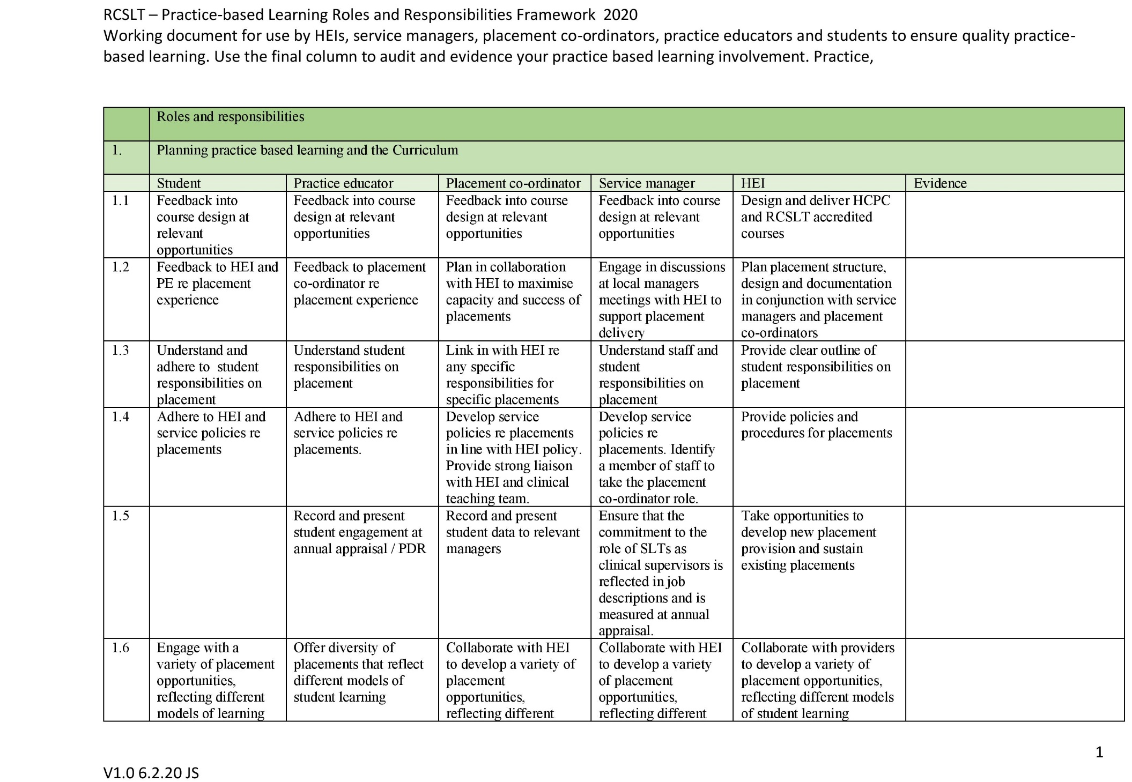

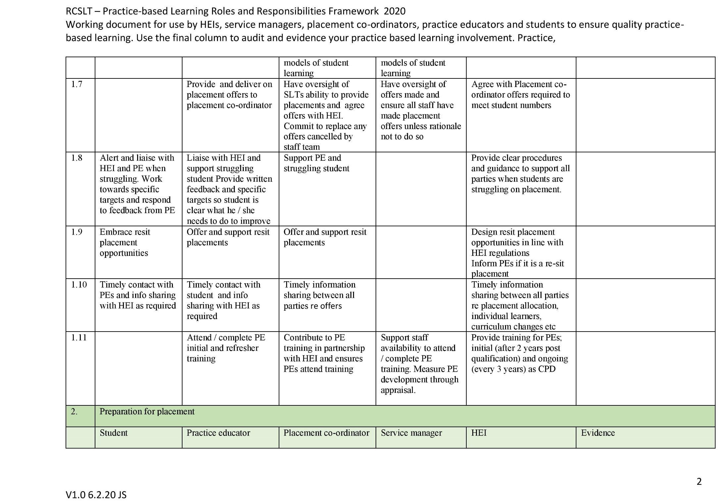

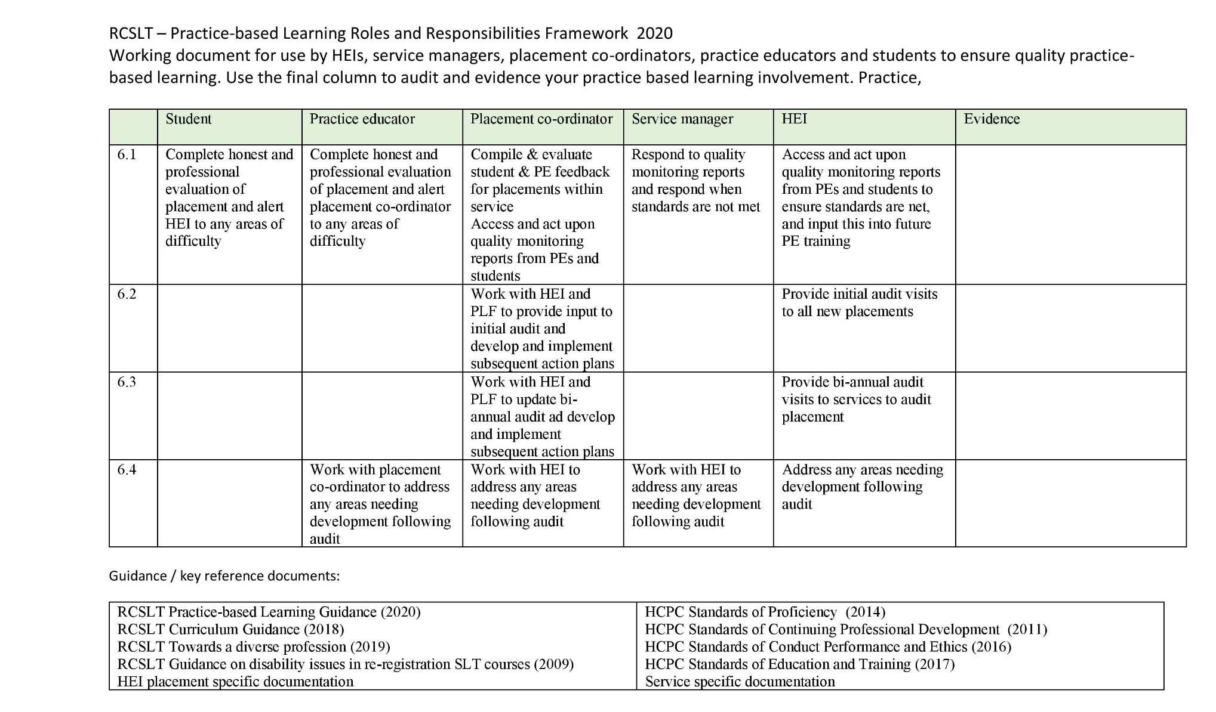

APPENDIX 3: FLOWCHART TO SUPPORT PROCESS FOR RAISING CONCERNS

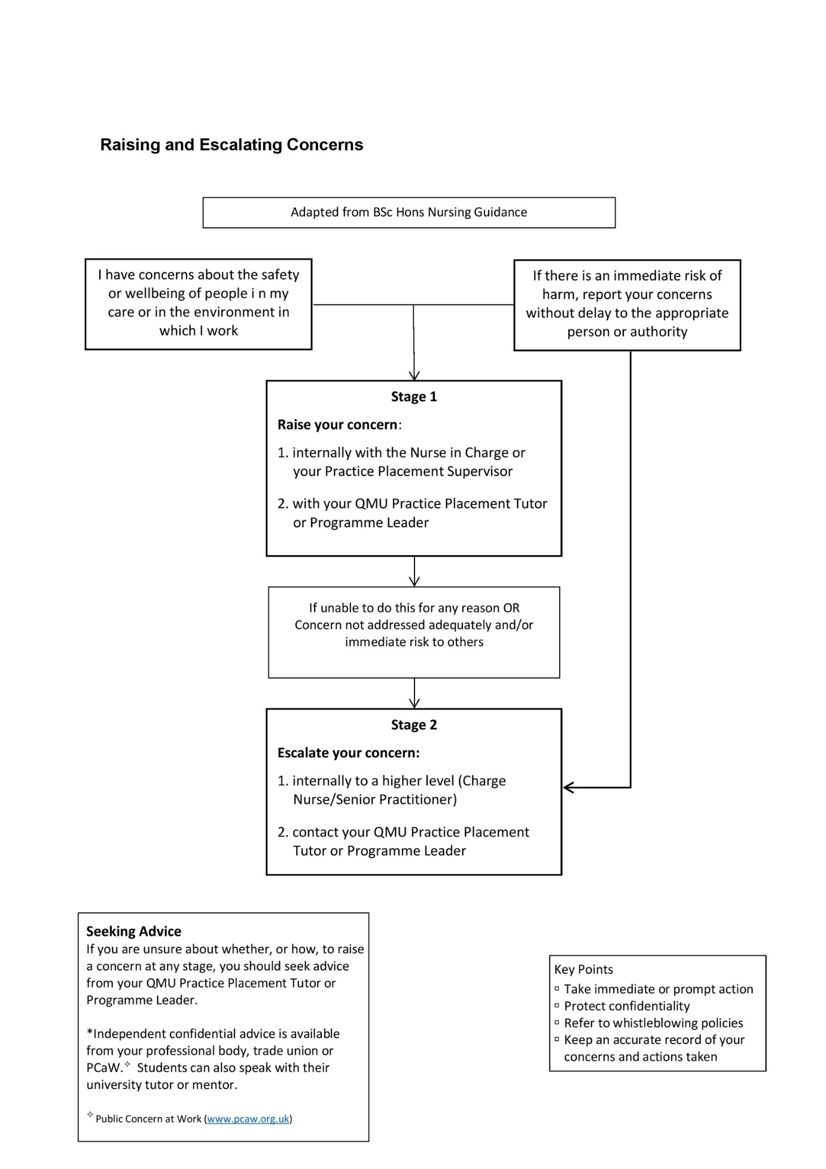

APPENDIX 4: SESSION PLANS
QMU SLT students on semester placements are required to produce a session plan for every intervention that they have been asked to undertake. Students are expected to have these ready to show the PE on the day of placement, or by other arrangement as indicated by the PE (e.g. in some cases PEs may ask their student to email these in advance). In some circumstances, for example if a session is very closely based on a previous session, a student may not be required to produce another plan, though this is at the discretion of the PE.

An overview of terminology
Key terminology in this handbook has previously referred to a session as a ½ day in the placement setting (i.e. a morning session/an afternoon session). However, the same term is in common use to describe a specific time period in which a client is seen. When we refer to a ‘session plan’ we are referring to the latter: a time limited encounter with a client or clients (e.g. a group session) or a time limited encounter with another person who is supporting the client or clients indirectly e.g. carers, class teachers - please note the PE can also ask a student to submit an outline plan for other types of activity such as preparing to deliver a training session, or for a case meeting.

Students may also find that there is a range of terminology to discuss the intended purpose of a session e.g. aims, goals, objectives. Whilst there may be a good argument for subtle differences in the meaning of these words, the QMU view is that the use of the term ‘aims’ is appropriate to cover all of these, though students should adapt if different terminology is required from the PE. It is accepted across the profession that there are a range of different types of aims available to us when working with clients, which will be discussed in the section “Writing Aims” overleaf

What is a session plan?
A session plan is a written description of the ingredients required for a successful session. The session plan usually starts with basic administrative details on the client (with confidentiality observed at all times). This highlights a range of key background details appropriate for ensuring a holistic understanding of the client e.g. Name (a pseudonym only); chronological age; diagnosis (and/or reason for referral if a new client); relevant medical factors; sensory factors; mobility; social factors; other professionals involved.

The session plan then progresses to offer:

- a full and detailed outline of the range of long term, short term and session aims for the client (in ‘Writing Aims’ section below)

- further details on how the student will set about achieving the aims, involving:

  - detailed descriptions of tasks and activities that will be used to achieve the aim
  - how each specific task and activity could be increased in difficulty (stepped up) or decreased in difficulty (stepped down) throughout the session to maximise client success
  - explicit consideration of the range of demands each of the planned tasks would place on a client e.g. cognitive, linguistic; physical.
  - the range of therapeutic techniques that will incorporated in each task, including (but not exclusive to) how the client will be encouraged, motivated and given feedback
  - any environmental features that need to be modified or taken into account e.g. seating, noise, lighting; time of day.

A session plan may also include space for the SLT student to also record the client’s performance on each task and evaluate how effective the session has been in achieving the aims set out for the session.

Writing aims
Planning for a successful session starts with a clear understanding of its purpose. Writing aims is an important way of communicating the purpose/s of a specific session. In order to begin learning how to write aims, student should learn to focus first and foremost on the question “why am I seeing this client?” rather than “what will I be doing in this session?”. It is important to adopt a professional outlook focused on the needs of the clients and the rationale for the specific session, rather than the specifics of what will be taking place in the session on a particular day. Arguably, this is one of the biggest mistakes students make when writing aims: confusing aims with activities, tasks and/or strategies and making the important switch to see the purpose of the session for the client, rather than for the SLT student. While this is an easy mistake at first, it is crucial to gain a clear understanding of the distinction. Some examples of these types of errors are given later in this document.

Different types of aims

It is generally accepted that there are range of different types of aims used by SLTs: long term aims; short term aims and session aims.

Long term aims
Long term aims give SLTs and clients the opportunity to reflect on the overarching aims of speech and language therapy for that client. The period of time the long term aims cover can vary from client to client, influenced by a range of factors e.g. client preference, SLT preference, perhaps determined by local service provision. For some clients, long term aims may be set over a time limited block of intervention (e.g. ten weeks, four months or even one year). At all times, the long term aim/s for a client focus entirely on the question “Why am I seeing this client?” or “Why am intervening?”

Example
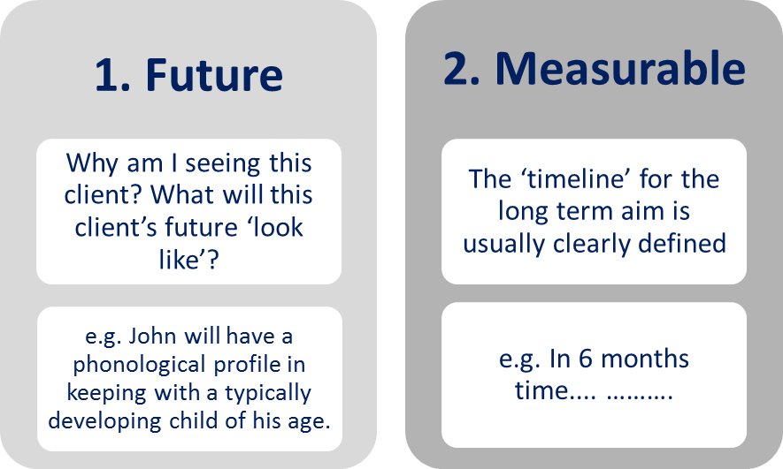
Consider the case of John (pseudonym) who is 6 years old and has been diagnosed with a phonological delay. His SLT has noted he has consistent velar fronting of /k/ and /g/ in all word positions. He also has some difficulties with /r/. The SLT has decided to begin a block of intervention focused on this. The long term aim set by the SLT is: “In 6 months’ time, John will have a phonological profile in keeping with a typically developing child of his age”.

It is generally accepted that long term aims focus on why the client is being seen, with attention to the intended future skill/s the client will have. Although variations in practice may occur, it is common to associate long term aim/s with a specific and defined timescale to support intervention planning.

X A long term aim such as “John will complete a block of speech and language therapy intervention for his phonology” or “The SLT will deliver a block of therapy to target John’s phonology” does not give any information on the intended purpose of the overall period of intervention, nor the timescale involved. It is focused on the task, rather than why the intervention is taking place.

Short term aims
Short term aims are used to give SLTs and clients the opportunity to reflect on the specific aims of speech and language therapy for that client within a specific window of time within the overall timescale. Again, the period of time the short term aim/s last will dependent on a range of factors related to the client, the SLT’s clinical decision making and service delivery model. In general, short term aims help break down the long term/s aim into clearly grouped targets. These could be seen as aims which help pave the way to achieving the ultimate long term aim/s. At all times, short term aim/s continue to focus on why the intervention is taking place. Sometimes, a long term aim can be broken down into several short term aims. In this case, SLTs may be working towards achieving one of the short term aims at a time with the client, though there are no rules to say a SLT and client cannot work on more than one short term aim at a time.

Example
Let’s go back to the case of John (pseudonym). The SLT’s block of intervention has now started. To re-cap, the long term aim is “In 6 months time, John will have a phonological profile in keeping with a typically developing child of his age”.

The agreed short term aim set by this SLT reads as: “John will spontaneously produce velars contrastively in word initial position during structured tasks 100% of the time”

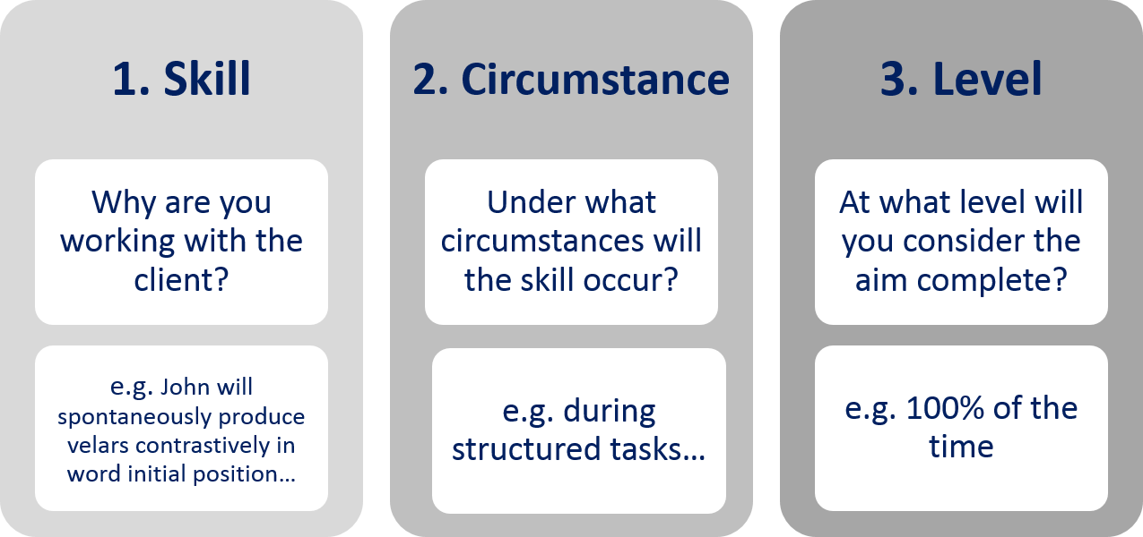
Important: It is clear that this short term aim is a stepping stone towards the long term aim of the child having a normal phonological profile for a child of his age. When this short term aim is achieved, it is possible that that the SLT may have to establish further short term aims to support John to achieve a phonological profile in keeping with other children of his age e.g. the SLT may have to intervene to support John with contrasts in other word positions, in less structured tasks and/or conversational exchanges. In this case, it is also quite clear that the short term aim is not likely to be something that can be achieved in one session, rather likely requiring a series of sessions, each with a range of aims to help John achieve the short term aim.

It is generally accepted that short term aims focus on why the client is being seen (the intended skill), with focus on the circumstances under which the skill will occur and at what level the client needs to manage this in order for it to be viewed as a success. Although variations in practice may occur, it is common to see these three key areas mentioned in short term goals.

X A short term aim such as “John will take part in therapy exercises focused on velar contrasts “ does not give any information on the specific intended purpose of this episode of intervention in sufficient detail, nor the timescale involved. Again, it is focused on the task, rather than why the intervention is taking place. No aim should begin “to……..” as these are generally activities and tasks rather than client centred aims. Well written aims are usually written from the perspective of the client. In addition, it would be difficult to measure whether the short term aim had been met as the level at which he should manage this task is not clear i.e. how many times does John have to produce the contrast to be classed as having succeeded – what if he managed it only twice? Would that be enough to say he had achieved this short term goal? Whilst it is not always easy or appropriate to offer a specific quantitative target or decide the level at which the client should reach, these can support SLTs to effectively measure whether the aim/s has/have been met.

Session aims
Session aims are used to give SLTs and clients the opportunity to focus on the specific purpose of each session. Session aims support SLTs and clients work towards successful attainment of the short term aim/s and ultimately the overall long term aim/s of speech and language therapy. You may find there are a few session aims for one individual session, or indeed there could be only one. This is entirely dependent on the abilities and needs of the specific client as determined by the PE and student. Session aims always focus on the ‘why’ of the session, not the ‘how’.

Example
Let’s go back to John. To re-cap, the long term aim is “In 6 months’ time, John will have a phonological profile in keeping with a typically developing child of his age” and the short term aim is “ John will spontaneously produce velars contrastively in word initial position during structured tasks 100% of the time ”.

The specific session aims (in this case for the 1st session of intervention) are:

1. John will discriminate between WI velar and alveolar minimal pairs produced by the SLT in a structured task with 90% accuracy
2. John will produce velar and alveolar minimal pairs contrastively during a structured task with 50% accuracy

Note that there are two session aims for this client (this may vary from client to client). Both are worded from the perspective of the client and clearly articulate the purpose of the session.

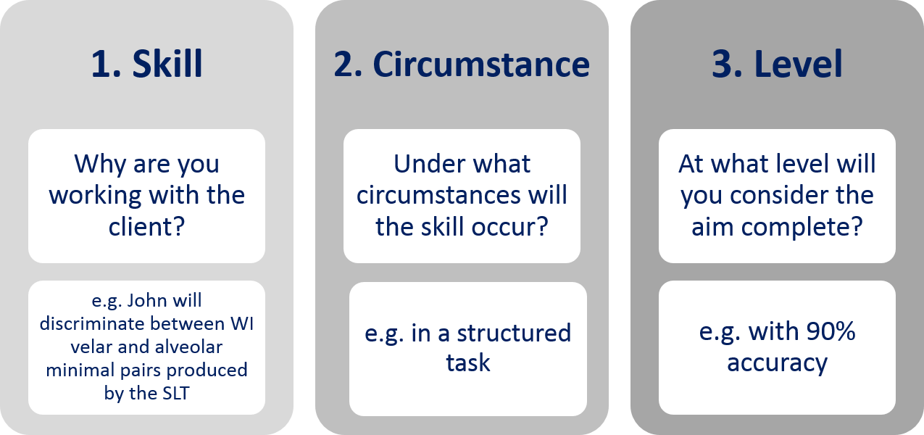

Like short term aims, session aims focus on why the client is being seen (the skill) , with focus on the circumstances under which the skill will occur and at what level the client needs to manage this in order for this to be viewed as a success. Although variations in practice may occur, it is common to see these three key areas mentioned in session aims. Note the similarity to short term aim writing, in the focus on the ability to measure the level at which the client is attaining. To re-iterate, whilst it is not always easy or appropriate to offer a specific quantitative target or decide the level the client should reach, these can support SLTs to effectively measure whether the aim/s has/have been met.

X Session aims such as “John will complete a discrimination exercise to…..” or “SLT will give John a pictures to…..” do not give any information on the specific intended purpose of this episode of intervention in sufficient detail nor the specific measurement details. Importantly, it is yet again focused on the task, rather than why the intervention is taking place. To re-iterate, no aim should begin “to……..” as these are generally activities and tasks rather than client centred aims. There is space later in the session plan to document the specific tasks and activities the SLT will introduce to support the client to achieve the aims of the session.

Aim writing quick tips

- Aims are traditionally written from the point of view of the client, not from the perspective of the SLT
- Aims should ideally begin with the client’s name e.g “John will…….”
- In some cases, there are occasions when an aim can feasibly begin with “SLT will…...” E.g. “the SLT will have a fuller understanding of Mary’s strengths and weaknesses in conversational interaction in order to determine and decide upon the best course of intervention” (where Mary is a pseudonym)
- Try to avoid beginning with “to……….” – these types of aims tend to be activities e.g. “to complete the STAP…..…” is simply the task you/the client is completing. It focuses on ‘what’ is being done, rather than ‘why’ it is being done. “To model…….” This is the strategy used, not the aim. “To improve…….” - this is too vague. Think about using specific action verbs e.g. “John will? produce/? articulate/? write/ ? exchange/? demonstrate/? use/? offer……….”
- Aims should be written in positive language and seek to avoid the use of negative (removal) terminology. Aims should positively reinforce the idea that the client is striving to gain rather than ‘lose’ something e.g. avoid constructions like “John will stop using the wrong contrast in structured tasks …”
- An aim of any kind should be stated in some kind of measurable terms and be specific and easy to understand by the client (or family/carers) and others. Measurability allows for: tracking client progress through the treatment process; provision of information regarding the effectiveness of the treatment plan; allowing the client to see what they have accomplished through the treatment process.

What are SMART aims?

SMART is an acronym used in a range of settings when discussing issues to do with setting aims. It stands for Specific, Measurable; Achievable; Realistic and Time-Bound. It is generally viewed as the gold-standard for well written aims.
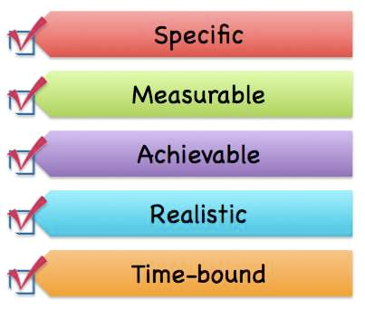

What else is required in a session plan?
There is more to the session plan than just the aims, though these provide the key information on the specific purpose/s of the session and the context of this in terms of the overall purpose of speech and language therapy intervention. Students then have opportunity to give detailed descriptions of tasks and activities that will be used to achieve (each of) the aim/s; details on how each specific task and activity could be increased in difficulty (stepped up) or decreased in difficulty (stepped down) throughout the session to maximise client success; explicit consideration of the range of demands each of the planned tasks would place on a client e.g. cognitive, linguistic; physical; the range of therapeutic techniques that will incorporated in each task, including (but not exclusive to) how the client will be encouraged, motivated and given feedback; any environmental features that need to be modified or taken into account e.g. seating, noise, lighting; time of day.

SESSION PLAN PRO FORMA

Administrative/Background Details

Name (NB for student notes this must always be a pseudonym and stated as such)

Age (NB date of birth not appropriate in student notes as impinges on confidentiality)

Diagnostic Statement

Relevant Medical Factors

Sensory Factors

Mobility factors

Social factors

Other professionals involved

Current setting (eg Nursery, Secondary School, Day Care Centre, Acute Hospital)

SESSION PLAN
Long term aim/s

Short Term aim/s
People present

Session Aims
(1)
(2)
(3)

Task 1
- Description of task/activity
- Materials required
- Environmental adjustments required
- Therapeutic techniques used (e.g. modelling, positive reinforcement etc.)
- Task demands on the client (i.e. what they have to be able to do to attempt the task you might find it easier to break this down in to motor, linguistic, cognitive, sensory)
- Step-up activity (to continue with useful purpose should the client find the planned activity easier than expected)
- Step-down activity (to continue with useful purpose should the client find the planned activity more challenging than expected)

Effectiveness/Outcome measures – how will you know if your session has been effective?

Repeat for any other task/activity planned.

Relevant supporting literature

Hierarchy of Prompts
Scaffolding
An approach where a more skilled other, such as a therapist or teacher, is aware of a pupil’s current skills, and uses this knowledge to support and encourage their learning of new skills.
ELICITED IMITATION
Encouraging a pupil to copy speech, language or a social act that the pupil has observed.
Enhancing the Salience
Highlighting a chosen aspect of the pupil’s speech, language or communication to make it more prominent for the pupil, and therefore potentially easier to learn.
Metalinguistic and METACOGNITIVE Techniques
Explicitly describing aspects of language, communication and thinking, and encouraging the pupil to reflect on these.
PHYSICAL MANIPULATION
When speech and language therapists use physical manipulation they place parts of the pupil’s body into the correct position to enhance their speech, language or communication.
Modelling
Providing a practical illustration or explanation by example, from which a child can learn.
Providing Feedback
Information about any behaviour that may influence or modify further performance in order to help pupils acquire aspects of speech, language and communication.
Practising
Repeating a performance for the purpose of acquiring skill or proficiency in the area of speech, language and communication.
Prompting and Cueing
Reminding, encouraging or providing a signal that helps a pupil to produce a desired response in order to help them acquire aspects of speech, language and communication.
Reproduced with permission from the CIRCLE Collaboration. CIRCLE Collaboration© (2009). Therapy Manual: Speech and Language Therapy. City of Edinburgh Council, Queen Margaret University and NHS Lothian: Edinburgh, © CIRCLE Collaboration, all rights reserved.

APPENDIX 5: Reflective writing
The following pages demonstrate a published framework that may be used to support reflective writing, by Gibbs (1988). Students may wish to use this or other models/style of reflection, based on personal preference from experiences they develop throughout their studies.

Reflective writing can be a personal and private experience, so students are not required to show their reflections to the PE unless it would be useful to discuss the experience to which it relates in more detail or receive some informal feedback on reflective writing style.

GIBBS REFLECTIVE CYCLE (1988)

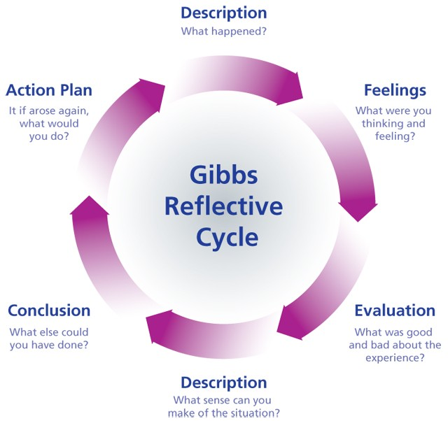

Gibbs’ reflective cycle encourages individuals to think systematically about the phases of an experience (i.e. a situation, event or activity), using a range of key headings

It supports individuals to reflect on all aspects of the experience and considers moving forward from the learning experience in a positive and productive way.
CHAPMAN (2006)

APPENDIX 6: CPD Activities

The activities suggested below are designed to directly reflect the type of work that one might expect to come across in the clinical setting and should be completed within 500-1500 words unless otherwise specified. In recognition of the introduction of the RCSLT eating, drinking and swallowing (pre-registration) competencies, the list has been expanded to incorporate activities which could contribute to sign-offs for both hours and competencies. Alternative activities, of equivalent value can be done, if recommended by the PE.
Students should always discuss and agree the activity to be undertaken and show the PE the completed activity prior to the end of the placement.
- Note the additional information (excluding that from further assessment) which it would be useful to obtain about a client with which you are involved, linking your ideas to the information which you already have. Write a plan of action to obtain the information (for example, interview / phone call with parent / carer / school / colleague / College Adviser / other professional, letter to the Bulletin). Carry out your plan (in part or whole) and write a summary of the information you have gained.

- Write a draft report on a case you have seen following their initial assessment. Bear in mind that the report will be sent to the referring agency and other relevant parties, including carers/parent. They will require an overview of your findings to date, a clear statement about future management intentions and, where appropriate, the aims of any further intervention.

- Write a draft report on a client who has completed a course of treatment. Include a summary of response to therapy so far and a clear statement about future management. Where appropriate include an advice sheet which can act as a reminder for the carers about the suggestions and activities which you have already discussed to promote continuing progress.

- Carry out a literature search which will support the management of a case selected by your clinician. Provide a brief bibliography of not more than 6 references (including authors, title of the article, journal/book, volume and page numbers) and summarise the points which could contribute to the future management of the case.

- Write a request for materials necessary for a therapy session you have planned, including sufficient detail to allow them to be prepared by a Speech and Language Therapy Assistant. Bear in mind that you must try to eliminate any possible ambiguities in your request and consider how much initiative you are requiring of the SLTA (eg a general request for 12 pictures of household objects versus a detailed list of specific objects which have particular relevance to the case). Evaluate how successful the material proved when you used it in practice and suggest any modifications which could have improved the efficacy of the session.

- Make an audio/video tape of yourself carrying out a formal assessment with a client. Note and evaluate the information you have gained from the assessment itself and comment on the usefulness of the additional information you have derived from the taped record (including your own conduct of the session).

- Many people/carers/parents now have access to the internet. Carry out an internet search on a topic that has arisen in clinic and summarise the information which was obtained in this way. Write a brief critique of the usefulness of this resource for both client and clinician highlighting any useful or misleading information it generated. Consider what response you could give if presented with the results of such a search by a client, taking into account the need to support professional credibility.

- Discuss a service offered at the clinic (for example, specific client group or age group) which your clinician feels would benefit from extra resources. Prepare a ‘wish list’ for the clinic, recommending 4 items of equipment/books which would be a useful addition to meet this need. Include all the information necessary to comply with Trust (or other employing agency) procedure for applying for resources, (e.g. name, catalogue/ordering/ISBN number, price, whether requires VAT) and give a brief rationale to support your choices.

- Devise an ‘observation sheet’ for use in evaluating any change in behaviour which is being targeted during a group you are helping to run. Carry out the observation, after noting your decisions about the following issues:
- the feasibility of conducting the observation during a session or from a video recording
- the length of the observation time (i.e. a whole session or a sample time/s within a session)
- are you observing change over the course of the session or between two sessions
- inter-rater reliability
Comment on the usefulness of your findings and note any changes you would like to make to the protocol following the experience.

- Devise a method of obtaining information about the level of language to which a client is exposed during a regular part of their life (for example, a session at a day centre or during a college school class). Carry out your plan and from your knowledge of your client’s strengths and weaknesses comment on any difficulties which your client might experience in this setting.

- Evaluate the level of language¹ in two reading/subject text books which form part of the curriculum which your client is accessing in an education setting. Comment on any problems that they might present given your knowledge of the client’s strengths and weaknesses. Using bullet points, devise an information/advice sheet for education staff involved with the client.

- Prepare a short report outlining the information which you have gained from conducting both a formal assessment and from carrying out and analysing a language sample from the same client. Comment on the usefulness of each procedure in contributing to a profile of the client’s strengths and weaknesses.

- SLTs are often asked to contribute to training days for other professionals (eg Health Visitors, school staff) or carers groups. Discuss a possible invitation, focusing on one topic, that your clinician might receive (e.g. service provision, appropriate referrals, case histories, specific client groups) and plan four overhead slides which could be incorporated into a short talk.

- If invited to a study session/day prepare a 2/3 page report reviewing the day which would usefully disseminate the information you have gathered to colleagues who were not able to attend.

- What resources (including services and other professionals) are available to your clinician when faced with a bi– or multi-lingual client? To what extent are the resources confined to certain languages? Give a bullet point list of information you would need to know if, after starting a new job, you are faced with a client who has a first language with which you are not familiar.

- For a client who requires (or uses) an Augmentative and Alternative Communication (AAC) approach: Prepare a survey prioritising which aspects of the client’s environment require inclusion in an AAC system (or could be added to an existing system).

- For a client who requires (or uses) an Augmentative and Alternative Communication (AAC) approach:
(a)Design an evaluation sheet listing pertinent factors when evaluating a new piece of AAC technology
Or
(b) Prioritise, giving your rationale, which aspects of the client’s environment require inclusion in their AAC system (or could be added to their existing system).

- Carry out an observation session of a client in a situation which is difficult for the client, briefly noting down any social skills weaknesses or other difficulties. Gather any other information which may be used as background for writing a Social Story (this may be information from clinician or other members of multidisciplinary team and/or information contained in the client's case notes).

- Devise a questionnaire to be sent to carers/family of a patient in order to obtain personal vocabulary you are going to introduce in a low tech communication book/chart.

- Devise a template for a communication passport for a child who is using AAC strategies to communicate for the child to take with him to a new school.

- Outline the top five resources you would recommend to a department wanting to purchase AAC equipment for Stroke patients. Explain your rational behind each selection and identify exact name of resource, price and where available.

- Identify specific vocabulary for a client going into hospital. Once vocabulary identified, make up a communication board which can be easily used in a hospital situation with nurses.

- Identify the team around the client including the natural supports within their environment. Outline and discuss role/responsibility of each. Identify the strengths of a multidisciplinary team working with the client.

- Make up information sheets and other training sheets necessary to carry out a 45 minute training course with family members on introducing a specific voice output communication aid. This might include information on programming, managing the device and vocabulary selection.

- Identify and describe five different voice amplifiers giving advantages and disadvantages for each. Outline the different types of client groups who might benefit from using voice amplification.

- Design a partner assisted scanning alphabet/phrase chart for a patient with a degenerative condition to be used at home with family and carers.

- Identify four community activities in which a young adult with a learning disability might take part. Devise a chatboard for each with a maximum of ten vocabulary phases. Make up the boards using Boardmaker.

- Research and identify communication aid resources/centres in Scotland that work with adult clients. Identify the services they provide. Make up a leaflet to be handed out to colleagues on the information you obtained.

Activities below have been linked to specific pre-registration EDS competencies, and successful completion of the related CPD activity can equate to one ‘sign-off’ on the student held record for each linked competency.

Activities in green are linked to ‘priority’ placement EDS competencies.

Competencies in italics are existing examples from the Practice Placement Handbook which have been/could be tweaked to cover dysphagia
- Note the additional information (excluding that from further assessment) which it would be useful to obtain about a client with which you are involved, linking your ideas to the information which you already have. Write a plan of action to obtain the information (for example, interview / phone call with parent / carer / school / colleague / other professional). Write a summary of the information you require and why it is necessary. Competency 3

- Write a draft report on a case you have seen following their initial assessment. Bear in mind that the report will be sent to the referring agency and other relevant parties, including the service user and/or their carer/family. They will require an overview of your findings to date, a clear statement about future management intentions and, where appropriate, the aims of any further intervention.
Competency 13

- Prepare a short report outlining the information which you have gained from conducting a clinical bedside swallow assessment with a service user. As part of this report you should synthesise information on psychological, social, and biomechanical factors with assessment findings to formulate a diagnosis.
Competency 15

- Prepare a report outlining the information which you have gained from conducting a clinical bedside swallow assessment with a service user. As part of this report you should synthesise information on psychological, social, and biomechanical factors with assessment findings to develop a person-centred and evidence-based SLT intervention plan. Your report should include reference to the published evidence base underpinning the intervention plan you have chosen.
Competency 16 Competency 12

- Make up information sheets and other training sheets necessary to carry out a training session with a service user/family members/carer on introducing specific swallow strategies, manoeuvres or exercises. This should include a rationale for the intervention and if an exercise programme, details on dosage and how to record or monitor adherence.
Competency 13

- With reference to a specific service user you have been involved with during your placement, summarise both the positive and negative impacts of SLT interventions you have observed which have involved modifying aspects of their EDS process. State what these interventions were, how the EDS process was modified, and then the potential pros and cons of each modification.
Competency 6

- With reference to a specific service user you have been involved with during your placement who has had a nasogastric tube, RIG, PEG, or other form of non-oral feeding, describe the indications for and against non-oral supplementation of nutrition and/or hydration in their specific case.
Competency 7

- Summarise the signs and symptoms of dysphagia you have observed during a dysphagia assessment session with a service user carried out by your PE and formulate a diagnosis based on the findings. Include a rationale/justification for your diagnosis. Competency 8

- Summarise the signs and symptoms of dysphagia you have observed during a dysphagia assessment session with a service user carried out by your PE and formulate possible intervention options based on the findings. Include a rationale/justification for your choices with reference to the published evidence base.
Competency 11 Competency 12

- With reference to a case you have seen during your placement, identify relevant outcome measures that could be used to monitor the service user’s progress with the SLT intervention, and summarise how use of these would support review scheduling. Competency 17

- With reference to a case you have seen during your placement, identify relevant outcome measures that could be used to monitor the service user’s progress with the SLT intervention, and summarise how use of these would support identification of an appropriate discharge point.
Competency 18

- With reference to a case you have seen during your placement, write a short report summarising and discussing the ethical issues associated with their specific EDS presentation and management.
Competency 19

- With reference to a person you have seen during your placement who has been for end of life care, write a short, patient friendly report on how family can help make the patient comfortable in terms of eating and drinking and the rationale behind these decisions.
Competency 13 Competency 16

- Families often ask what kind of foods and meals they can prepare for people with dysphagia if they are on a modified diet. Create a personalised document for a patient you have seen on your placement giving details of the kinds of foods and meals that they could try and internet page/links to appropriate sites (E.g. Graying with grace, Eating with dignity, Wiltshire farm foods etc).
Competency 13

- Prepare aphasia friendly patient information for some of the exercises/postures used when working with patients with dysphagia which can be left at their bedside (e.g. chin tuck, Masako, Shaker, tongue exercises etc).
Competency 13

- Research a progressive neurological condition, summarise the associated symptoms and consider how this may impact on the individual’s eating drinking and swallowing (considering physical, functional, cognitive and social factors). Use this information to develop a template for case history discussion for use in an initial assessment.
Competency 3

- Research the various eating, drinking and swallowing difficulties experienced by individuals with dementia. Reflect on how a hospital admission may exacerbate these issues and develop information to share with ward staff about how to optimise the environment for safe and effective eating, drinking and swallowing.
Competency 13

- Develop a leaflet for Nursing Home staff that explains the signs of symptoms of dysphagia and how best to support residents to eat and drink safely. This should include what to consider when optimising the environment to promote safe eating and drinking.
Competency 13

- Research the evidence base for currently used dysphagia therapy exercises/programmes/techniques and write a brief summary about each one you have chosen. Consider if they are rehabilitative or compensatory and discuss specifically how this will aim to improve an individual’s swallow function. You should also include any contraindicating factors listed or reflect on physical/cognitive/psychological/social factors which may impact on the appropriateness of each therapy.
Competency 11 Competency 12

- Research and reflect on service users’ eating and drinking with acknowledged risk to improve their quality of life. Consider how this may be complicated if someone does not have capacity to make informed decisions and what the Speech and Language Therapist’s role is in shared decision making/supporting someone to make an informed choice.
Competency 19

- Devise a mealtime observation checklist for a service user with dysphagia.
Competency 8

- What would be the basic information you would need to include in a training session on dysphagia for Healthcare Support Workers and how would you structure the training?
Competency 16

- The IDDSI system ( www.iddsi.org ) is used internationally to classify and describe food and fluid textures. Think about the pros and cons of using this system with service users with a learning disability.
Competency 6

- Following assessment of eating, drinking and swallowing with someone with a learning disability, which other members of the community learning disability team might need to be involved and why?
Competency 13

- What are environmental and social factors that might impact on a service user with a learning disability’s eating, drinking and swallowing and what adjustments could be suggested to mitigate this in the setting of their supported accommodation?
Competency 16

- What equipment is available for service users you are working with on your placement who have difficulty with eating, drinking and swallowing? How might different equipment be helpful (or not) depending on the nature of the problem?
Competency 6

- Many people with dysphagia will be on medication. Discuss some of the more commonly prescribed medications for service users on your placement with your PE, research them and identify what impact they may have on eating, drinking and swallowing.
Competency 4

- Compare the approach you might take when carrying out an EDS assessment with a service user with a learning disability in a day centre versus in an acute medical ward in hospital.
Competency 10

- Summarise the considerations, additional information and other people who should be involved during discussions with a service user who is not following Speech and Language Therapy EDS recommendations.
Competency 16 Competency 19

- Create a guide on how to use thickener successfully for a service user’s care staff or family.
Competency 6

- APPENDIX 7: HEALTH AND SAFETY
All PEs have a responsibility to ensure that students on placement are aware of the health and safety regulations for each setting that they attend.

Many health and safety issues can arise within the clinical setting, with some more likely to be associated with certain client groups. Students need to be aware that they may be faced with situations that require careful consideration and that in all clinics a high standard of hygiene must be maintained. Students who have questions about health and safety matters should contact their PE or the clinical placement team.

General Health and Safety for Clinical Placement
- The professional in charge at the setting (e.g. the PE, school, social care or other clinical staff) should be informed immediately in the event of an injury or accident involving the student or any person with whom the student is dealing. This will include the legal requirement to complete an incident report form.
- Students should consult the following guidance regarding dress code and laundering (e.g. in the case of blood spill): http://www.gov.scot/Resource/0039/00398324.pdf.
- Students must ensure that recent cuts and grazes, especially those on the hands or arms are covered with a plaster or dressing.
- Students should seek and comply with advice about dress code given for the placement setting. This may include suggestions which are motivated by health and safety issues or issues specific to the needs of the client group. Students are reminded that tongue piercings are not considered appropriate for speech and language therapy students on placement, for a range of reasons relating to the nature of the work of SLTs. Students should be aware that some people are significantly sensitive to perfumes/aftershaves or specific food substances.
- Students may encounter a request to assist with an element of personal care for a person (e.g. nose blowing, teeth cleaning or toileting). This is not part of a Speech and Language Therapist’s duties but in the absence of a carer or other responsible person students should use their discretion as to whether any such request is appropriate. Students should discuss with their PE the likelihood of this type of experience during the placement and the most suitable way of responding.

Hand Washing, Oral Examination and Intra-Oral Exercises
- It is imperative that an appropriate hand-washing regime is observed before and after contact with clients. The PE should advise on specific requirements for each placement. Students will also have also completed modules in this area as part of their studies in the Scottish Infection Control and Prevention Education Pathway as part of their Placement Passport.
- Surgical gloves should be worn for any oral examination or intra-oral exercise programme.
- Students should seek and comply with advice on the management of non-disposable equipment (e.g. feeding utensils, prostheses, PNF brushes, and tympanometry seals).
- Students should seek and comply with local policy and procedure on the management of disposable equipment (e.g. gloves, spatulas, gauze, tissues, feeding utensils).

Lifting and Positioning
- Students may be expected to assist with minor re-positioning adjustments of clients, related to the individual’s Speech and Language Therapy management. In these cases students should keep within the manual handling guidelines of the host setting with supervision and support at all times. Students should not be involved with manual handling procedures which require special training, nor should they undertake any controversial techniques. Students should only undertake manual handling tasks in line with the training delivered at QMU. If a student has concerns, they should speak to their PE in the first instance. Following this, students should contact the SLT Clinical Placement team who will seek advice.

Administration of Rectal Valium
Students will not be expected to assist with this procedure which may be used with people who have epilepsy. It is carried out by people who have been trained in the procedure.

Dysphagia – Eating and drinking
Assessment and management of eating and drinking skills is a part of many Speech and Language Therapists’ roles with certain client groups.
- As part of undergraduate training, students may be expected to participate in helping with eating or drinking under supervision at all times.
- The level of participation is decided by the PE.
- Teeth cleaning is sometimes regarded as an extension of mealtime oral training with some client groups. Students may be requested to assist with this as part of a therapist led programme.

Immunisation: Tuberculosis, Hepatitis B, Rubella, MMR
QMU students are required to attend the Standard Health Clearance Check. This takes place at the QMU campus. Students are assessed and screened for Tuberculosis (TB), Hepatitis B and Mumps, Measles and Rubella (MMR).

There is no statutory obligation for Speech and Language Therapists to be appropriately immunised. However, some Speech and Language Therapy Managers may advise that it is appropriate for SLTs to be immunised in certain clinical settings. Students should seek their GP’s advice in the event of any concerns.

In discussing ‘language ’ you may wish to consider one or more of the following aspects: vocabulary level, grammatical complexity, degree of inferencing required.

