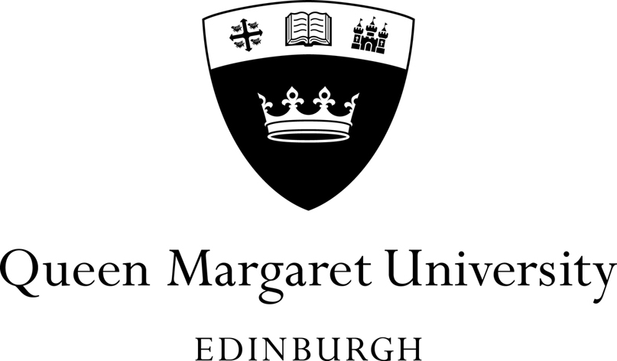

Annual High Level Statement (2020) to University Court on Compliance with the Concordat to Support Research Integrity 2019

Members are asked to NOTE the QMU Annual Statement.

Research and KE Development Unit
September 2020

Annual High Level Statement (2020) to University Court on Compliance with the Concordat for Research Integrity 2019

- Background
The revised Concordat to Support Research Integrity was published on the 25th October 2019. This updated version of the Concordat responded to recommendations set out in the UK Government Science and Technology Committee's report on research integrity, published in July 2018.
One of the key problems identified by the Committee was the absence of publicly available information on research integrity, including named points of contacts and annual statements published by research organisations and presented to their Governing Body.
When the Concordat was published, the signatories of the Concordat agreed that there should be a 12-month period of implementation for the revised Concordat to support research integrity. The signatories indicated that this meant that employers of researchers, such as universities, must be able to demonstrate their commitment to the new Concordat by 25th October 2020.
- Concordat Principles
This Concordat seeks to provide a national framework for good research conduct and its governance. As signatories to the Concordat to Support Research Integrity, we are committed to:

- Upholding the highest standards of rigour and integrity in all aspects of research.
- Ensuring that research is conducted according to appropriate ethical, legal and professional frameworks, obligations and standards.
- Supporting a research environment that is underpinned by a culture of integrity and based on good governance, best practice, and support for the development of researchers.
- Using transparent, timely, robust and fair processes to deal with allegations of research misconduct should they arise.
- Working together to strengthen the integrity of research and to review progress regularly and openly.

- Annual High Level Statement 2020

  - Summary of actions and activities that have been undertaken to support and strengthen understanding and the application of research integrity issues.

There is now an explicit statement and reference to our commitment to Research Integrity in our REF 2021 Environment templates and Scottish Funding Council (SFC) University Outcome Agreement.

Support and strengthening understanding of the application of research integrity issues is a key objective in our 2020-2022 Concordat for Researcher Development Action Plan

In 2019 we became a member of the UK Office for Research Integrity Office (UKRIO) and in May delivered a QMU/UKRIO Research Integrity training workshop in support of the Concordat to Support Research Integrity. UKRIO training and awareness materials are actively promoted throughout the campus and on our web and intranet sites. UKRIO monthly training webinars are actively promoted to all staff and research students.

We are members of the Scottish Research Integrity Network (SRIN) led by the University of Dundee and University of Edinburgh, attending sector best practice events and contributing to discussion.

  - Statement to provide assurance that the processes the institution has in place for dealing with allegations of misconduct are transparent, timely, robust and fair, and that they continue to be appropriate to the needs of the organisation.

Enhanced webpages and intranet sites to promote the Concordat to Support Research Integrity with:

- A named contact point who will act as a first point of contact for anyone wanting more information on matters of research integrity, and ensure that contact details for this person are kept up to date and are publicly available on the institution's website.
- A named contact point or recognised an appropriate third party to act as confidential liaison for whistle-blowers or any other person wishing to raise concerns about the integrity of research being conducted under their auspices.
Participation in the Culture, Employment and Development in Academic Research Survey 2020 (CEDARS) with:
- Investment in the detailed and robust analysis of QMU research staff views and experiences of Research Integrity in CEDARS 2020 to obtain feedback on:
  - Institutional compliance and awareness of the Concordat and issues relating to research integrity within our research culture and environment.
  - Providing greater knowledge of the views and experiences of research leaders.
  - Providing progress measures over time and confidential comparisons with groups of institutions or national results.
- Commitment to participate in CEDARS 2021.
- Integration of above to continuously improve the implementation of the Concordat.
- 73.1% of QMU research staff reported awareness of the Concordat to Support Research Integrity in CEDARS 2020.

  - High-level statement on any formal investigations of research misconduct that have been undertaken, which will include data on the number of investigations. If no formal investigation has been undertaken, this should also be noted.
There have been no formal investigations of research misconduct by a research student or a member of staff in Session 2019/20.

  - Statement on what the institution has learned from any formal investigations of research misconduct that have been undertaken, including what lessons have been learned to prevent the same type of incident re-occurring.

There have been no formal investigations of research misconduct by a research student or a member of staff in Session 2019/20.

  - Statement on how the institution creates and embeds a research environment in which all staff, researchers and students feel comfortable to report instances of misconduct.

Hard copies of the Concordat to Support Research Integrity are issued to all new research staff (pre lockdown) and distributed at research and innovation inductions, training events and meetings.

Through collaboration with the University of Dundee, training modules are available to all staff to support understanding of research integrity and compromised integrity issues and to instil a culture of good practice. Responsible and Ethical Practice in Research is an online video-based training course designed to promote researcher awareness and engagement with research integrity issues. Available on the Staff Hub the course covers:

• Plagiarism and recycling of text and research outputs
• Authorship and collaborative research and data management
• Peer review and publication ethics and general issues such as research misconduct and questionable research practice.

Additional training resources are also available via QMU’s membership of UKRIO and the QMU research integrity intranet page.

Implementation and awareness of the Concordat at local level is monitored via Research Centre Annual Reviews.

Proposal to align governance of activity relating to the Concordat for Researcher Development and the Concordat to Support Research Integrity by expanding the remit of our Concordat for Researcher Development Steering Group. (Membership includes research staff, contract researchers, technical staff, professional services, PGRs, research managers and Trade Union reps).

Commitment to run Wellcome Trust Café Culture events in November 20202 to gain further insight into our research environment/culture including an enhanced understanding of issues relating to research integrity.

Research and KE Development Unit
September 2020

